ESA Colorado Oct 2026 | Volume 80 | Issue 12
Golden Lamp

Nancy Cameron
Colorado State President
2026-2027

Editor’s Corner

We had such a wonderful time at the Fall Fest in Akron! Kudos to all three
chapters in Akron for hosting such a fun event! I am not alone in feeling
excited about this new board! I predict this is going to be an awesome year!

Have you checked out Birdies’ Bazaar? This is President Nancy’s project this year. It is a chance to donate items for sale with all proceeds going to St Jude. Check out the article inside. Soon, you will be able to access it on the website. It will be updated with each Golden lamp Issue. If you have anything you want to sell, send me a picture and information.

If you haven’t attended a convention lately, I recommend that you make plans
to attend the State Convention in May.

Karen Addison, Golden Lamp Editor
Message from the President 

HELLO THERE - WE’RE FLYING HIGH!

FALL FEST last weekend was Great! Hostesses - Alpha Nu, Delta Chi and Gamma Omicron, really know how to host a meeting. The Hay Ride and information on bee keeping by Jessica Filla drew many to attend Friday night! The weather and a full moon were beautiful, food and facilities perfect. Thank you so much, ladies!!

ROCKY MOUNTAIN REGIONAL ROUNDUP held at the NRA Whittington Center in Raton, New Mexico just a month before was attended by 8 CO members. This event was created for members to relax, enjoy members from other states and the different beautiful Rocky Mountain locations!
However, we do cover business items - IC Convention, ESAMC information as well. Vickie Chavers-Bruso, President 2024-2026 presided at the short meeting, and installed the new officers for the next two years - and yes! Kept us laughing!
New officers are Carol Priest - Utah, Leslie Stevens, CO - Vice President /Secretary/Parliamentarian, and Cleoria Glenn, UT - Treasurer.
The weather and FULL MOON made for an awesome retreat.

IC CONVENTION in Norfolk, VA was an experience in itself! ALL-LL-LL the way to the East Coast! It’s these various locations for conventions and meetings that have been so special to me in my ESA life!
Convention was shortened to 4 days this year, so things were kept on the go. We were able to cover the expected events with some creative thinking. All in all, it was exciting and we all had a great time.

Colorado’s Purse of Gift Cards to auction for ESA Foundation amounted to $500!! That’s fantastic. Thank you all who contributed. I do not know yet how much it brought when auctioned. Too many things going on that night!

Many new objectives are being presented from ESAMC and the IC Council. Read all the publications sent out and the CSC will try to help you know how to use it to your members’ & chapters’ benefit. Do not hesitate to call on us to get the facts!

TAKE OFF AND SOAR TO NEW HEIGHTS!!
Nancy Cameron, President
(& Birdie)

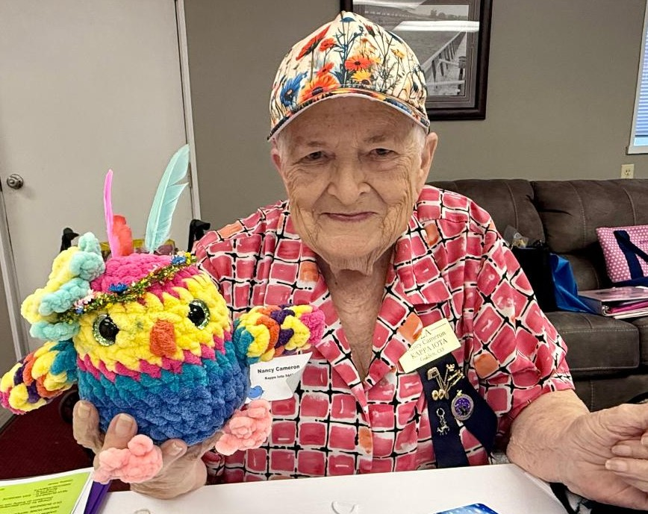
Rocky Mountain Regional Roundup
NRA Whittington Center, Raton New Mexico
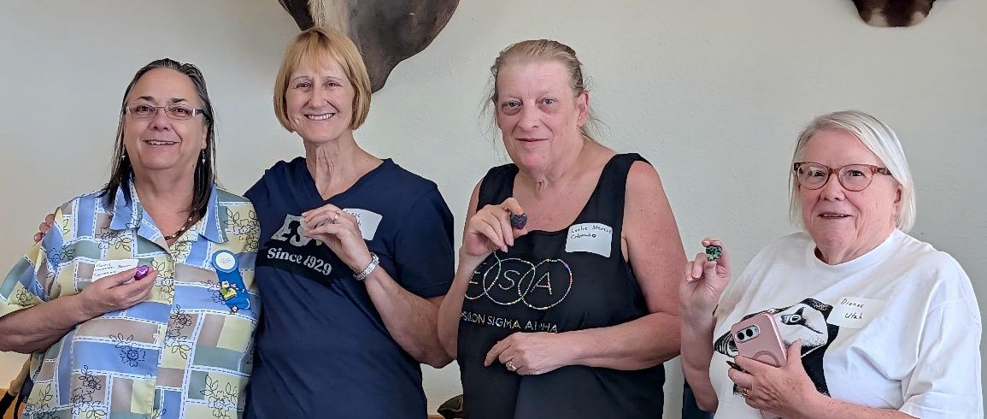
Outgoing President Vickie Chavers-Bruso CO, Incoming President Carol Priest UT,
Vice President/ Secretary/Parliamentarian Leslie Stevens CO, and Patricia Preuit standing in for Treasurer Cleoria Glenn ID
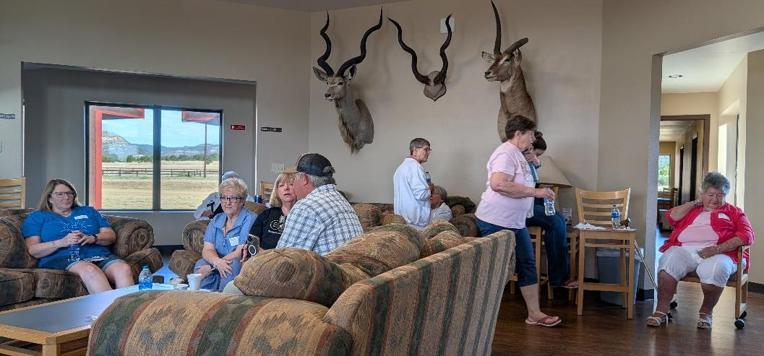
RMRR is always a much more casual atmosphere than the other conventions.
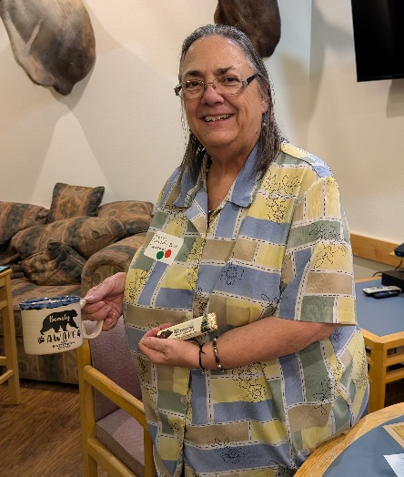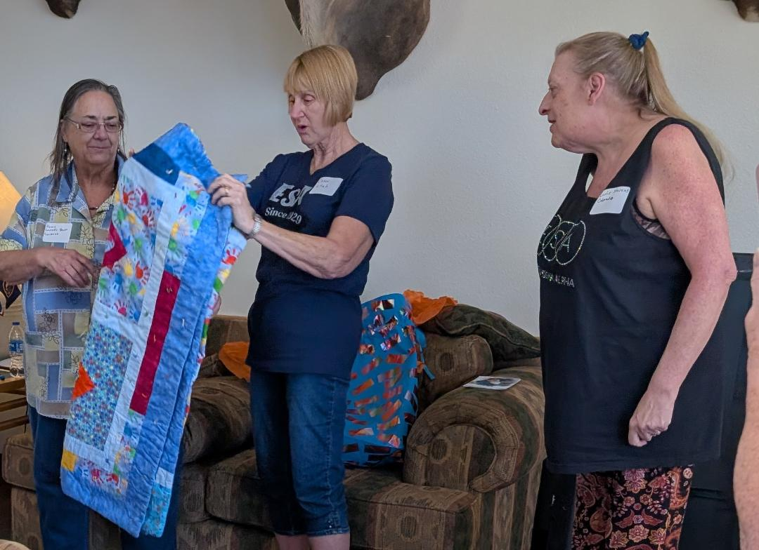
President Vickie Chavers-Bruso gifts Vickie gives incoming President Carol Priest a quilt
International Convention Norfolk, Virginia
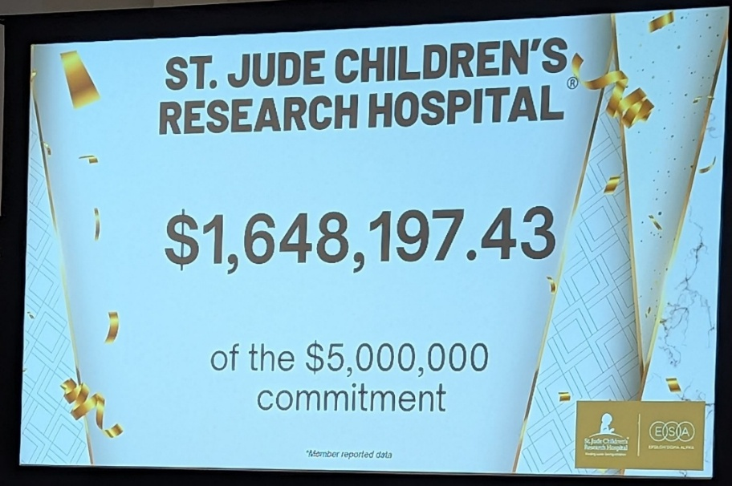

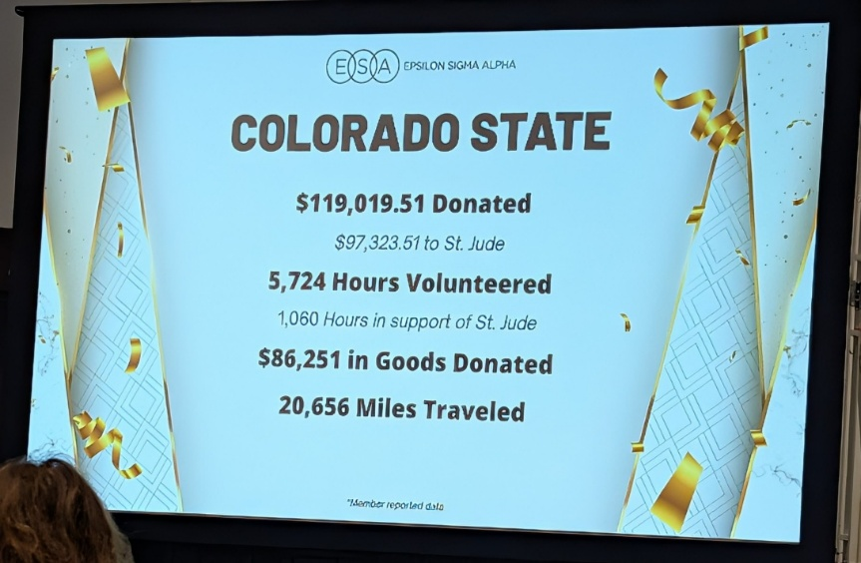

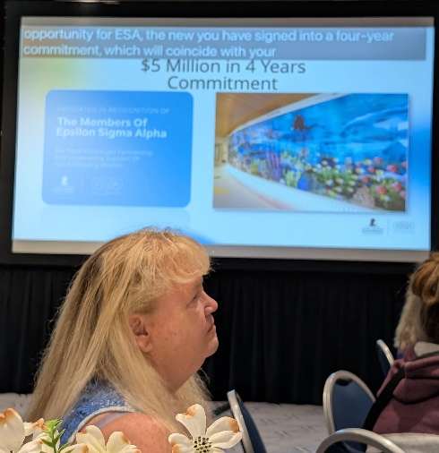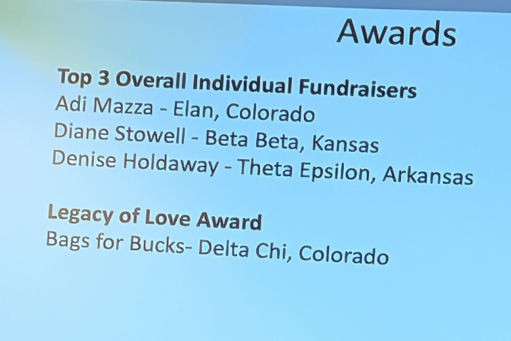
ESA Foundation 2026-2027 
There were 119 scholarships awarded totaling $97,850.00 for the year 2026.
There are 291 scholarships available this year!!! Please assist the Foundation Counselors in getting the word out to public high schools, private high schools, community colleges, colleges, universities, trade schools and anyone interested in continuing their education at the next level. Anyone who will be attending a higher education school next fall may apply such as high school seniors, current college students at any level, and those choosing to enter higher education at any age. www.epsilonsigmaalpha.org/scholarships
ESA Foundation Voting Process
This message is for ALL ESA Foundation members in good standing regarding the upcoming election of Three new Directors to the ESA Foundation Board. On December 7, you will be receiving an email from the ESA Foundation through a program called Election Runner. This email will provide a link to the election site where you will have the opportunity to vote electronically for the three candidates. This link will be available for ONE week. The Election will close on December 11, 2026 @ 12:00 Midnight Mountain Time. When you receive a voter ID and voter Key, you will not have to enter those to get into your ballot if you use the link provided in the email. It is possible that some email servers will not accept certain emails or consider them spam. If you don't receive it, please check your spam/junk/promotion emails first and if you still do not get it, please contact Tammy Akines immediately (@ tsakines@yahoo.com) to receive your ballot manually if you are the main contact for an entity (State Presidents group, chapter, state council, region, or business, etc.).
Please ensure your contact information is up to date with Headquarters: contact Mackeigan Bickel (Mackeigan@epsilonsigmaalpha.org ) with changes. Entity contact will receive one ballot email for your personal vote and another ballot email for the entity vote. Please be careful and vote accordingly when casting these votes as they cannot be changed after they have been submitted.
If you have any questions please contact me.
Sandy Alexander, ESAF Coordinator 2026-2027
Hope for Heroes 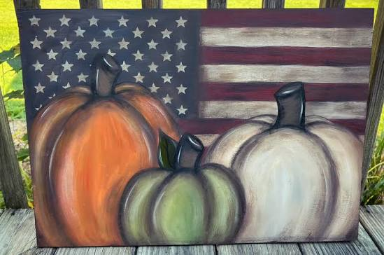
Hello to ESA Colorado
If you missed our Fall Festival in Akron, you missed a REALLY FUN time! Special thanks to all the members who made the weekend so special—we had such a good time, from sharing meals to a hay ride, followed by s’mores and a Honey Educational along with our business meeting. Loved every minute of the time we spent together.
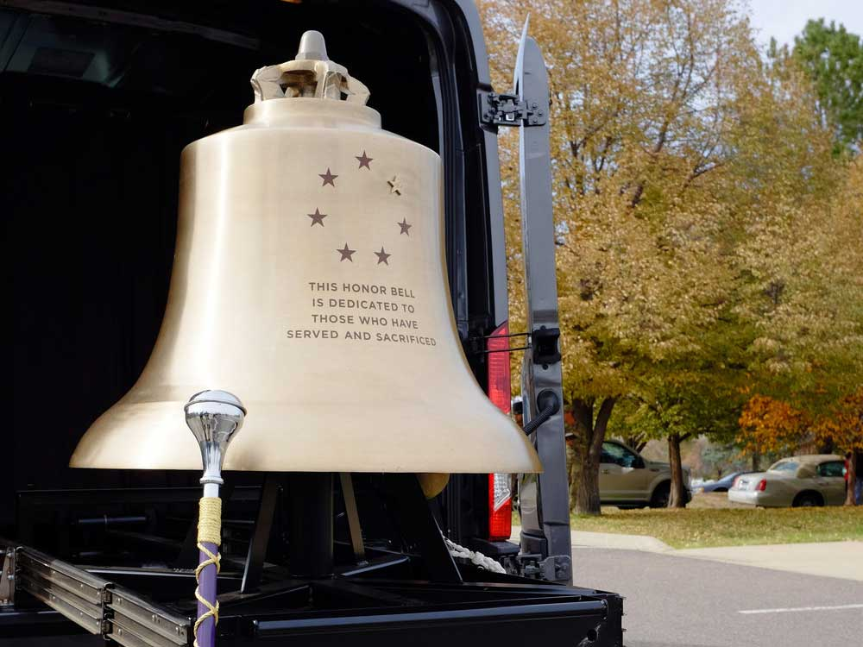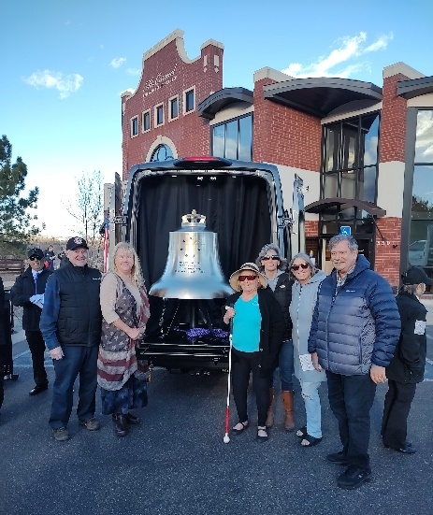
Colorado ESA’s HOPE for HEROES 2026-2027 Project is our Colorado Honor Bells. We helped get the Pikes Peak Honor Bell funded in 2024-2025 and this year we will be raising money to become a Bell Honors Sponsor for the maintenance and care of Colorado’s two Honor Bells. We started our campaign at Fall Festival with total donations of $221.00; thank you to everyone for such a great kick-off. If you would like to donate, you may send donations to me directly at this time OR I will soon have information on how to “tag” your donation as related to Colorado ESA. When I have this information, I will share it so you will have the option to donate directly to the Honor Bell Foundation if you prefer.
Below is some information from the Honor Bell website: honorbell.org

Pay It Forward: Sponsor Bell Honors
The Honor Bell tolls at veteran funerals and memorials at no cost, honoring the service and sacrifice of our military members. This recognition is deeply valued by their families, fellow service members, and the community.
Our all-veteran, all-volunteer Bell Guard performs Bell Honors every day, regardless of the weather. They rely on the support of individuals and organizations like yours to ensure these honors continue. From outfitting the Bell Guard with uniforms to maintaining the Bell Transport Vehicle housing the Honor Bell, tolling requires resources.

Sound Your Support Today by Becoming a Bell Honors Sponsor
Sponsors will have the opportunity to toll the Honor Bell at a service — either themselves, if they are a veteran, or any veteran from their organization. That veteran will receive a commemorative challenge coin, as will the sponsoring organization, along with a certificate of recognition.
You can sponsor one service member’s Bell Honors for $50, a day of Bell Honors for $250, or a week’s tollings for $500
I will share more donation opportunities during the next couple of weeks! (Keep an eye out for a flyer sometime in October) Have a great Fall---and take time to share your thanks with any Veterans you may meet!
Susan Bloss, Hope for Heroes Chair, 2026-2027

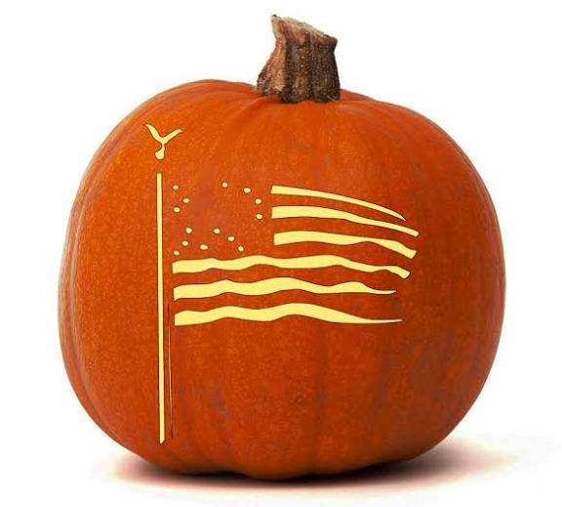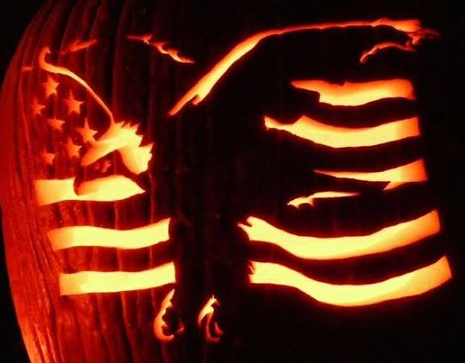
St. Jude Chair

ESAMC announced The Grateful Hearts Gathering in Memphis, TN. This is an ESA Exclusive Event February 11-13, 2027. To get all the information Click here and log in
login - Epsilon Sigma Alpha (ESA) - An International Service Organization

Your $195 registration helps make this full weekend of special experiences possible, with additional support from ESAMC and St. Jude Children’s Research Hospital®. Your registration includes:
- An elegant Welcome Reception (dinner included) at The Peabody Memphis
- Two days of inspiring, mission-focused programming hosted by St. Jude
- Guided St. Jude campus tours and special experiences created for ESA members
- Meals provided on campus throughout the St. Jude programming
- Private transportation between The Peabody Memphis and St. Jude on both programming days
- Dedicated time to reconnect with ESA friends and celebrate more than 50 years of partnership with St. Jude
- Grateful Hearts T-shirt and special event extras
- Special ESA room rate at the Peabody Hotel: $189/night + taxes and fees

It was so great to see everyone at fall board! Emily Westphal won the St. Jude sunflower basket, and we were able to raise $169.00 at fall board. We will have another basket at Spring board meeting.

If your chapter fundraises for St. Jude this year, please send us all the details so we can share it with everyone!!! If you have any questions or comments, please reach out. We would love to hear from you.
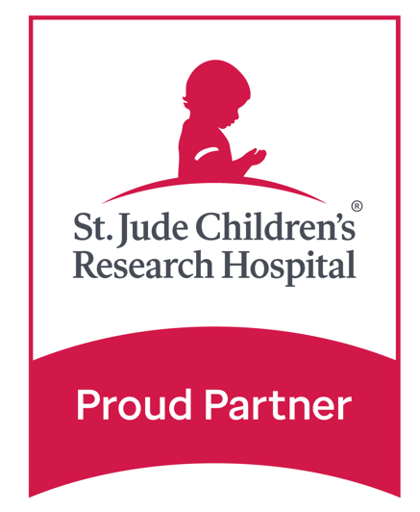
Jenniffer and Adi Mazza
2026-2027 St. Jude Chair Coordinators
jenniffercarlson@gmail.com
(719) 221.9947


Adi’s Fundraising for St. Jude Children’s Research Hospital.

Adi is still fundraising for 2026 and has raised around $32,000 of her $75,000 goal. She will fundraise through December 31st.
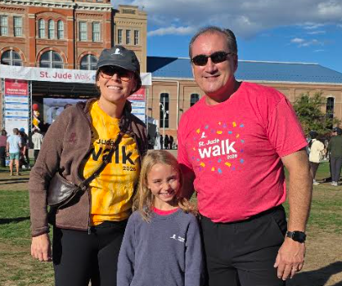
On September 19th we walked in the Denver St. Jude 5K walk. Thank you to everyone who donated and joined to be on her team. This was the 1st year it didn’t say Team of 1(lol) Adi was one of the top fundraisers, this was her 6th 5K walk, and this one was the best year. Maddie and the rest of the team do an amazing job every year. We met Martin Hand at the 5K walk; he is the Chief Development Officer at St. Jude. Him and his wife are the sweetest and we were really excited to meet him
We are really excited to announce that Adi will be having a Spaghetti Dinner at High Country Beverage in Johnstown, CO on November 7th. Biaggi’s Restaurant – Loveland, CO will be making and donating all the food. If you would like more information, please check out the spaghetti tab on her website.

https://adiscookiestand.wixsite.com/cookies
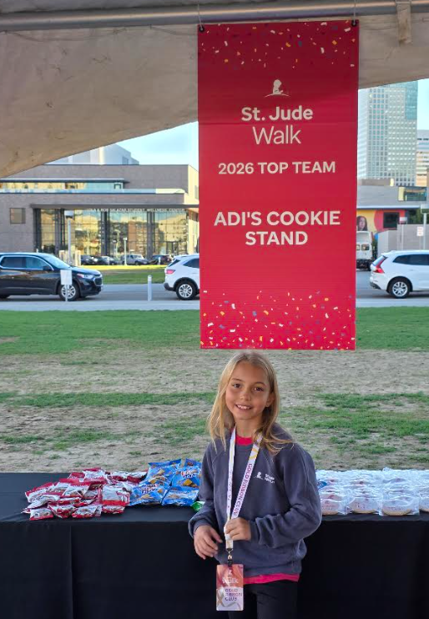

We want to thank everyone for their continued support with her fundraising. She couldn’t do this without people like you in her corner. Unfortunately, after talking with ESA headquarters Adi is not old enough to attend the Grateful Hearts Gathering in Memphis. We knew she wasn’t old enough to tour the hospital, but apparently, she must be 16 years old to attend the whole weekend.

Past President/Awards Chair 

Let’s Talk Awards for Colorado!
I hope everyone had a wonderful summer! I hope it was filled with camping, fishing, hiking, sightseeing, exploring, and lots of time with family and friends.
Oh, and by the way - I measured a cucumber that was 12” long - yes 12” long and 6” wide. It tasted delicious in the salad. We made zucchini bread and have been using fresh basil.

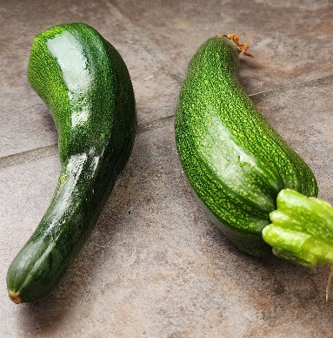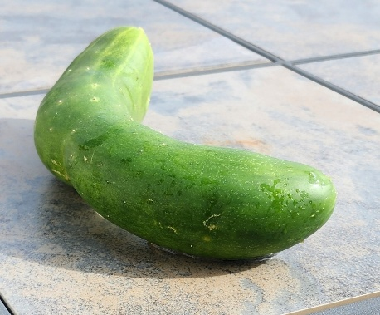
Eric and I had a busy and fun summer. We traveled to Rochester, Minnesota, in June for a family reunion and then headed to Chicago in July. We had a great time, but now it’s time to get back to what we really love—ESA! 😊
Another year of volunteering, serving our communities, making memories, and spending time with our ESA friends is ahead of us. I’m looking forward to seeing what wonderful things our chapters accomplish this year!
As your Awards Chair, we would like to give everyone a little reminder and encouragement—to think about awards from the very beginning of the year!
We all know how quickly the ESA year goes. Before we know it, we’ll be wondering, “Where did the year go, and what did we do?” Trust me, you will have done A LOT!
So, please keep these important dates in mind: Don’t be late, we know the date!
- April 1: Deadline for all Award Applications to be received for judging.
- May 1: Deadline for other award submissions.
- Chapters and members must be in good standing with the Colorado State Council. CSC dues must be paid on time to participate in any contest.

Spring will be coming before we know it.
One of the best things you can do right now is start a simple “Awards” folder—paper or electronic, whatever works best for you.
Throughout the year, tuck in those little things that you might forget about later:
- Photos from chapter activities
- Service projects
- Chapter accomplishments
- Newspaper articles and publicity
- Special events
- Fundraising activities
- Fun memories
- Those wonderful stories that remind us why we do what we do!

Just jot down a few notes and save the information. When April rolls around, you’ll be so glad you did!
And remember, Awards aren’t just about chapters—they’re about our members, too!
There are so many ESA members who quietly give their time, energy, talents, and hearts to their chapters and communities. Please take the time to recognize those special people. Nominating someone for an award is a wonderful way to say:
“We appreciate you, and we are thankful for you!”

And Now for My Second Job…
As your Awards Chair, I have one more request… 😉
Let’s start thinking about the 2028 Convention!
Hotels and venues often book events a year or more in advance, so it’s not too early to start talking about where we might gather next year.
Maybe one chapter would like to host. Here’s another idea - maybe two chapters could team up and host together! Just something to think about.
It would be wonderful to have a hosting chapter or chapters lined up early so we can start looking forward to another great Convention in 2028.
So, as we begin another ESA year, let’s make it a year of service, friendship, recognition, and fun!
Take lots of pictures. Save those newspaper articles. Write down those special moments. Celebrate your members. And most of all, enjoy what you’re doing! Thank you for everything you do for ESA and for the communities you serve. I’m looking forward to another great year with all of you! Love in ESA! ❤️
Thank you,
Lori Anderson Havelick
CSC Past President / Awards Chair 2026–2027
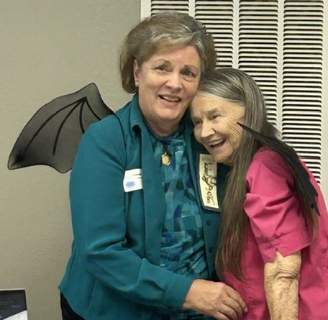
Colorado Web Team

esacolorado.org

Along with our CSC President’s theme of “Wings,” the web team would like to announce it has been flying with its wings and soaring for the last 25 years. In celebration of our 25th anniversary, we send virtual “Kisses” to all of you to thank you for your participation and support through these many years. Without YOU, we wouldn’t have a useful site for our members.
Currently, the site is being updated to reflect 2026-2027 information, and you will notice a message stating such on the home page.
Our CALENDAR page has already been populated with upcoming events. We look forward to receiving more items throughout the coming year. This is also where the GENERAL INFORFMATION section shows what is due, when, and to whom is located.
The current CSC yearbook is available in its entirety as well as by section on the YEARBOOK page. Any section of the yearbook containing member addresses/phone numbers has been password protected.
Directions to obtain the IC Recognition forms have been added to the FORMS page.
For a roadmap showing what can be found on the CSC website, be sure to click on SITEMAP on the left margin of the Home page of www.esacolorado.org
Let us know if you have any questions, concerns or ideas.
Continuing to “wing along,”
The CSC Web Team
Bonnie Gillmore & Candie Patino 
Birdie’s Bazaar 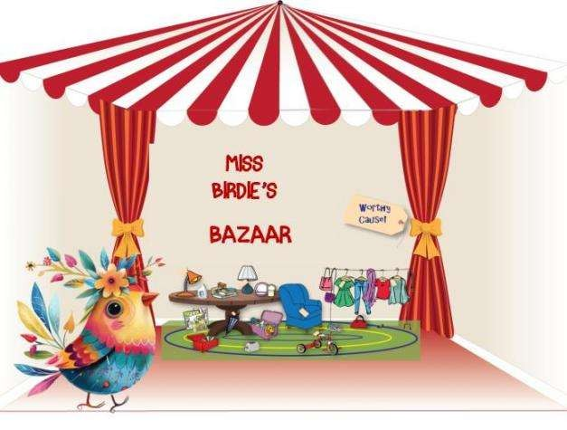
Birdie’s Bazaar is a way to raise $$ for the ESA/St Jude $5 Million in 4 Years event – The Colorado State President’s philanthropic project.
ESA members can collect (buy) posted items or post (donate) items listed in the Golden Lamp issues on a DONATION BASIS.
Items go to the first person to contact the donor by phone, text or email. Delivery of items is arranged between the buyer and donor.
Donation payment for the item is to be sent to the “Birdie’s Bazaar for St. Jude” project. This will be a donation to St Jude’s by the buyer.
Please send checks to Nancy Cameron to forward to Birdie’s Account until further notice. (Portal for sending payment to this project is still under construction. Notice will be published as soon as completed.)
Listing items - Send photo, brief description and your contact info to Karen Addison -
Thank you from Birdie & Nancy for supporting the St Jude Kids!!
Here are some items that can be purchased. Contact Nancy to purchase items.
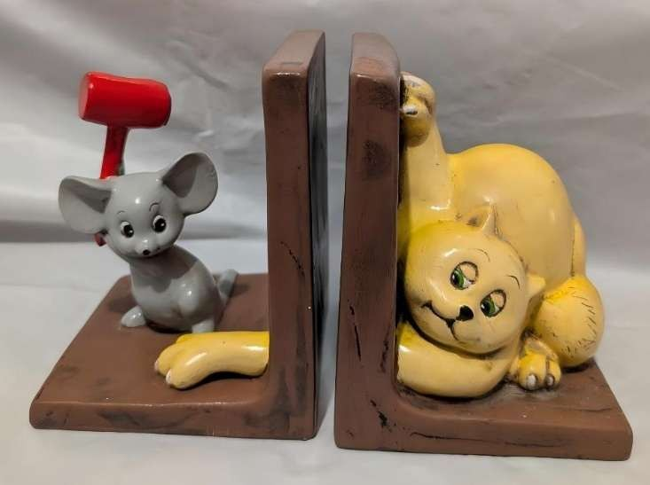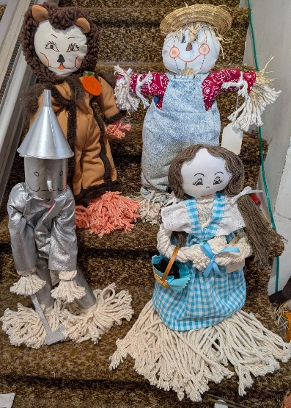

Cat and Mouse Bookends Wizard of OZ Figures

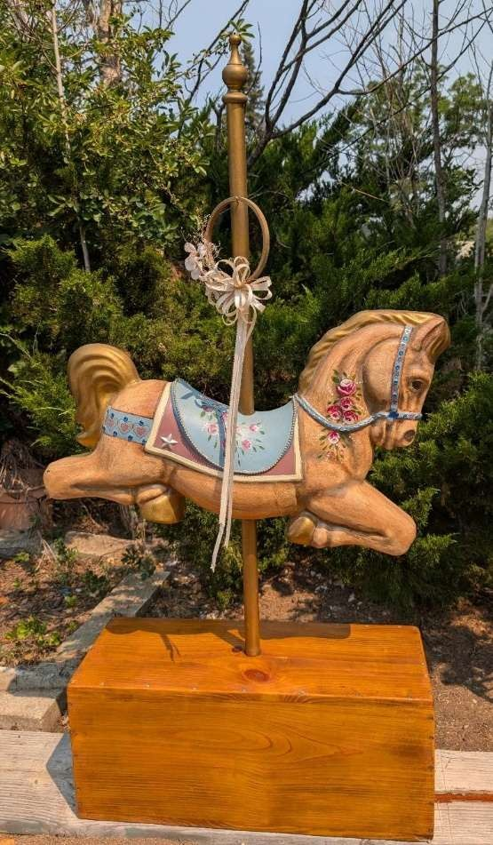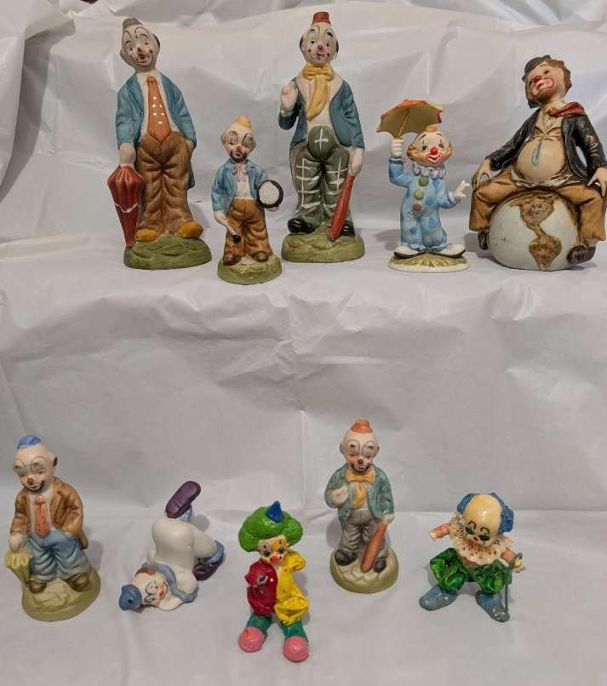

Carousel Horse Clown Figurines


Floral Vase Ceramic Plate
From our Fall Fest Hosts

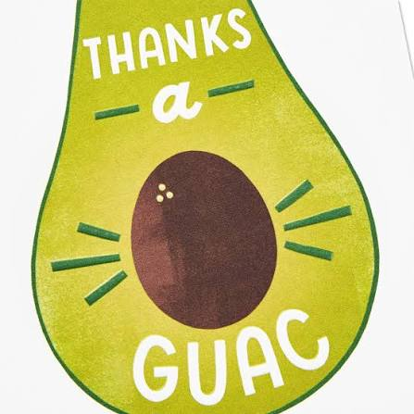
Hello everyone. From Alpha Nu, Delta Chi, and Gamma Omega, we absolutely LOVED having all of you in Akron for Nancy’s Fall Fest. It’s a humble place and we appreciate you all making the journey to come out to the Eastern Plains. We know you didn’t have the amenities that you may have access to in the city so thank you for your small-town patience. Hopefully you learned a little about agriculture and gained some great ESA information. Thank you for all your kindness. Each part of our 2-day program was so much fun. You are all lovely, truly!
SO MUCH FUN VISITING WITH YOU ALL!!!!!!
Please come back and see us…. anytime.
LOVE IN ESA,
Alpha Nu, Delta Chi, and Gamma Omega

Pictures from Fall Fest 2026 in Akron CO
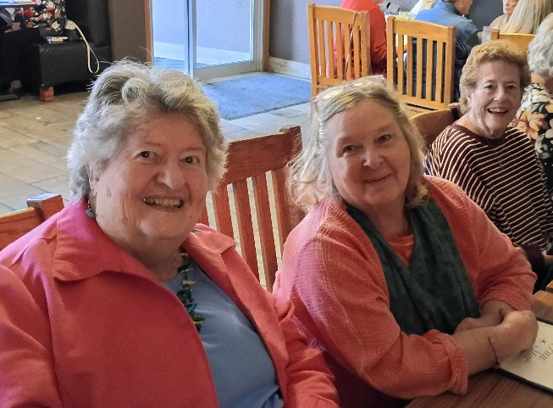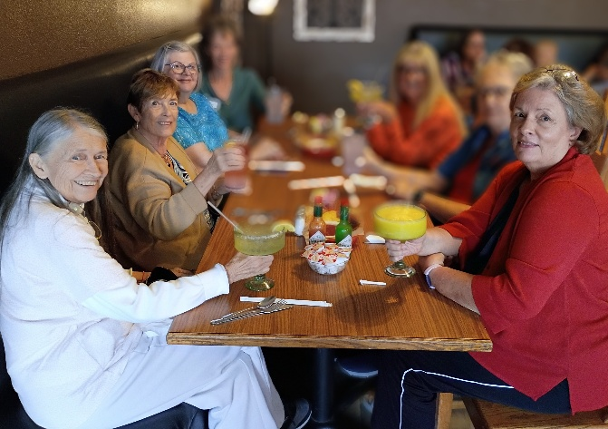
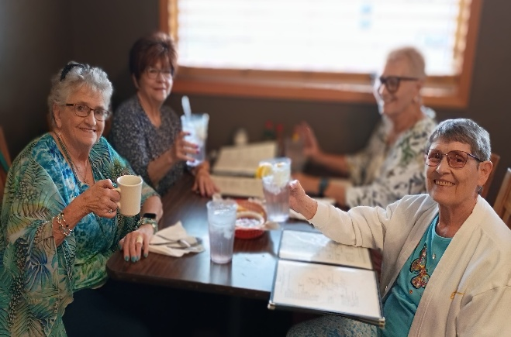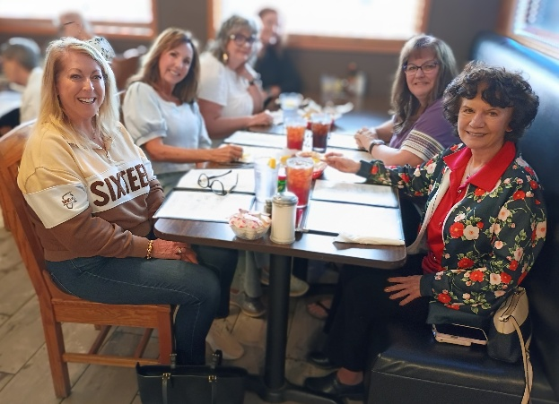
Friday Night - Dinner with friends, then a visit to the Bee Farm
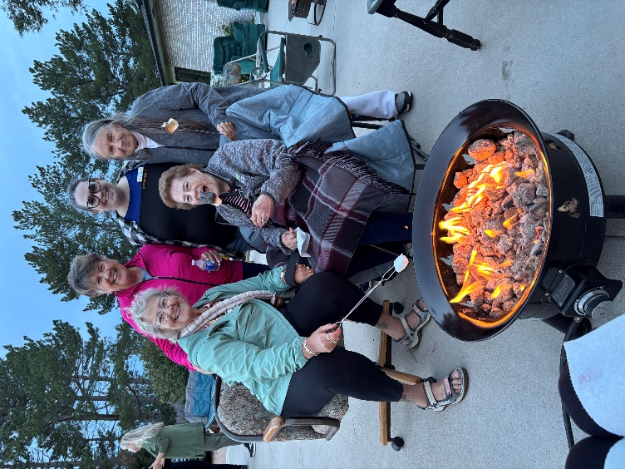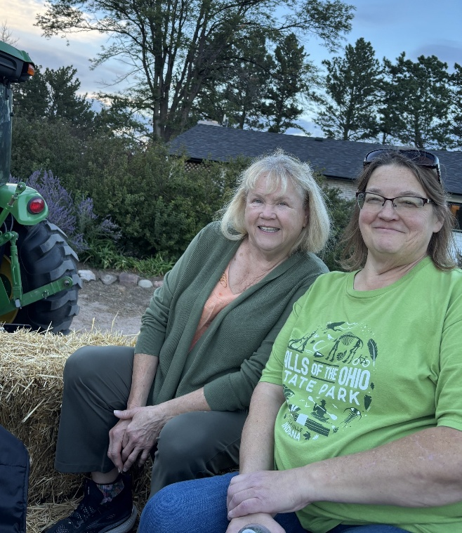
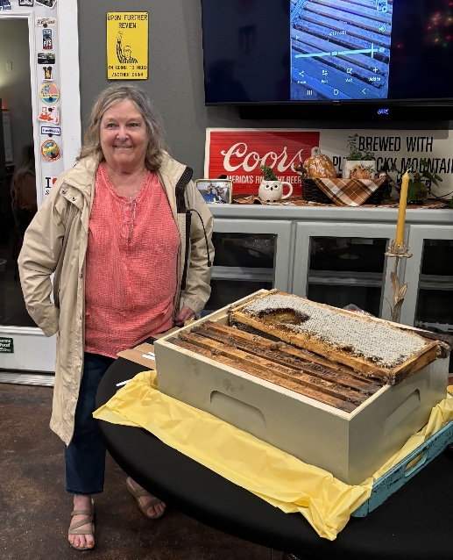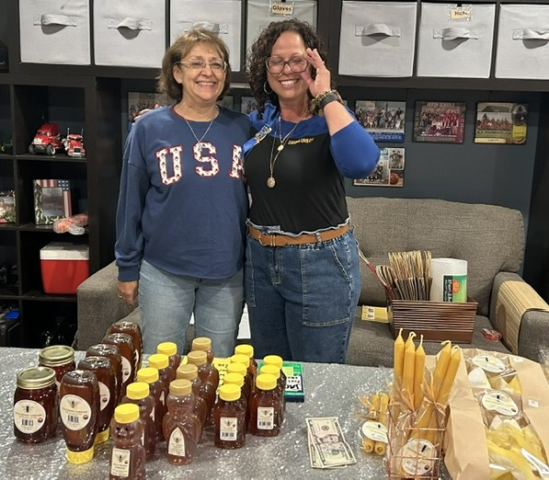
Alice at the Honeycomb demo and tasting Deb Spear with Jessica Filla, our bee expert
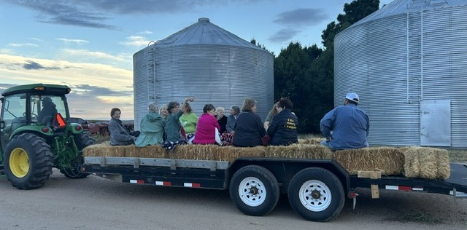
Hay Rides
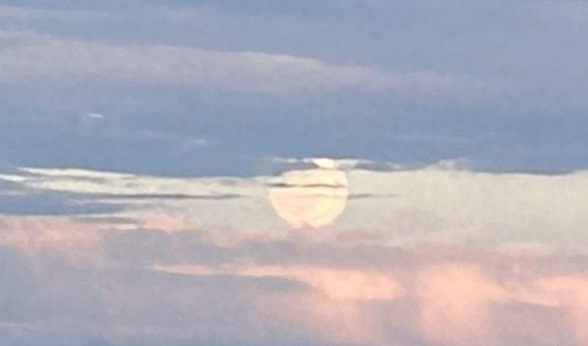 Beautiful weather with a full moon!
Taking a Good Picture 
Taking pictures with your cell phone is common practice these days. We share our pictures through texting, on emails, or through social media and these pictures are seen by many people! Have you ever looked at a picture on Facebook and thought to yourself, “Ooh, that is a very unflattering picture.” Yep, me too. Even worse, my sister posted that picture, and it is a picture of me!
I always loved taking pictures with my 35mm camera. Then, after finishing the roll of film, turning it in to be developed, then excitedly sitting down to check out my masterpieces, I was always dismayed at bad the pictures came out. Out of focus, subject too far away, too dark or overexposed, or even better, one of my kids decided to take a few pictures of their feet (or the cats’ tail or right eye)
The beauty of taking pictures nowadays is that you have the opportunity to look at the pictures and decide if we need to retake the picture or maybe take a minute to edit it. That is my favorite thing about digital pictures. I bought a Canon digital camera as soon as I heard about them. I was able to review them before getting them developed. And now, with the phone, I can just save the pictures on my phone or send them to friends and family.
When taking pictures, while candid shots are fun, you still need to use a bit of control. Ask the group to stop and smile for the camera. Invite others to step into the frame with a single person.
BUT before you hit send, take a minute to look at the photo. Is everyone in focus and fully in the picture? Take several pictures of the same setting and then choose the best one. DELETE the rejects! Crop the picture to bring the subject closer and to eliminate unneeded stuff in the background.
Whether taking stills or videos, pay attention to the content. Any time a person is being recorded, whether on a camera, phone, or even on Zoom, center the lens and make the best picture possible. But I am definitely not an expert. But I continue trying to take the best pictures I can.
-Karen Addison

Save the Date

Cherry Blossom Tea
Please Join
Chi Kappa and Pi Sigma
Chapters of
Epsilon Sigma Alpha International
Date
February 6, 2027

*** New Venue ***

Dreams & Dragonflies
5194 Co Rd 50, Johnstown, CO 80534
More information to follow soon


Chapter News  Sigma Rho #5014

A Wonderful Start for ESA Sigma Rho!

Our first ESA Sigma Rho meeting was a great success! We were excited to have three special guests join us, and we hope they will become part of our sisterhood.

We already have some exciting activities planned, including our Book Fair and a Permanent Jewelry Fun Night. We’re all looking forward to the friendships, fun, and wonderful things we can create together this year. There is so much excitement ahead for ESA Sigma Rho!

Social Chair, Dixie Daly

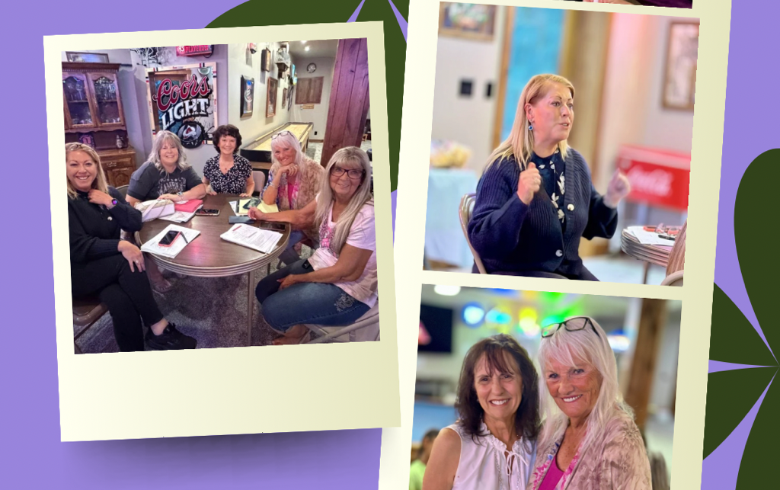
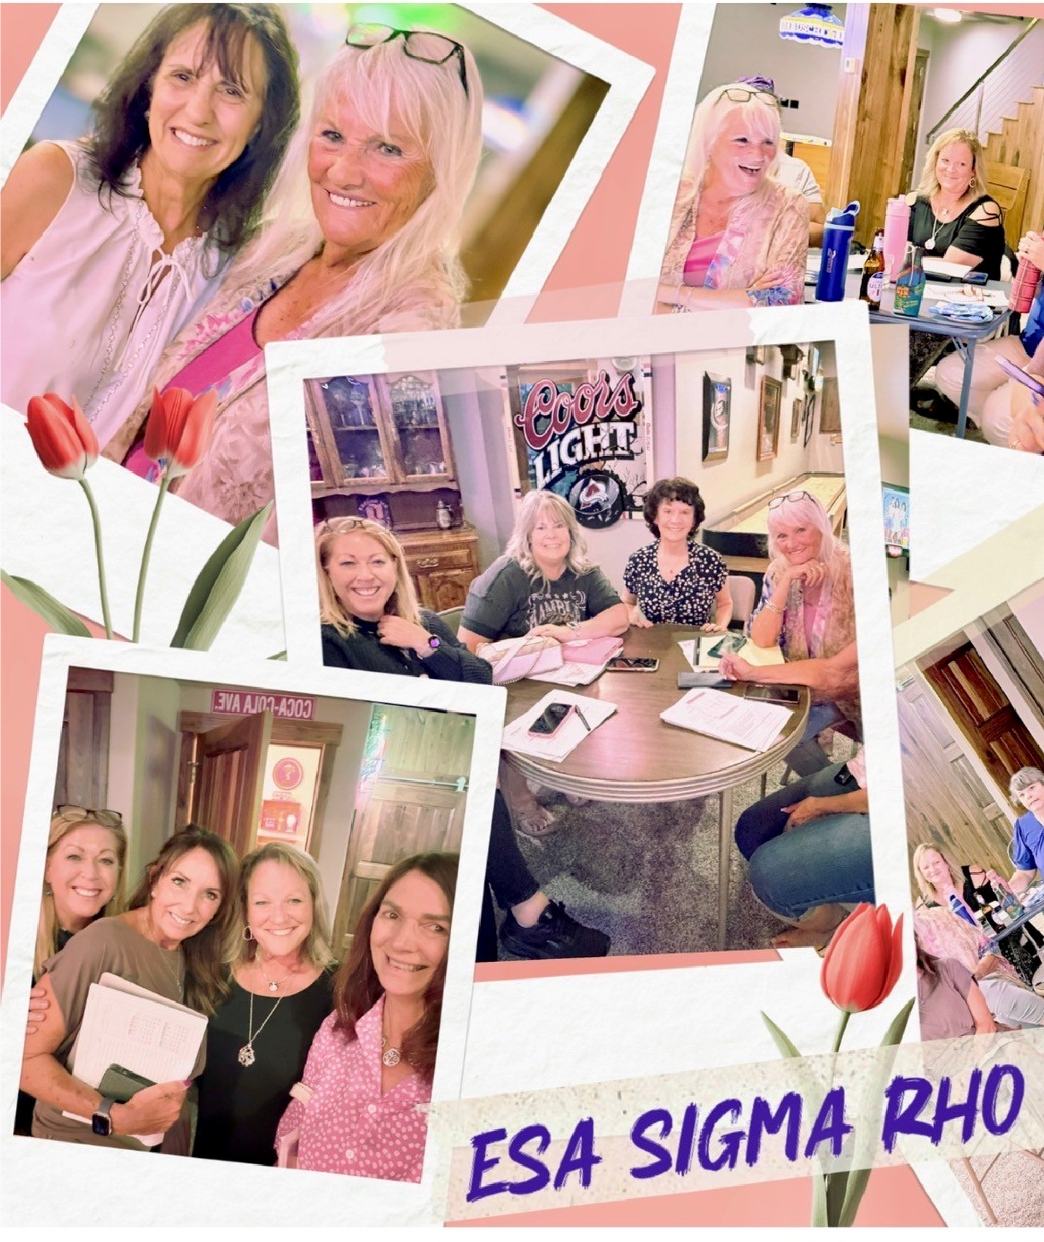

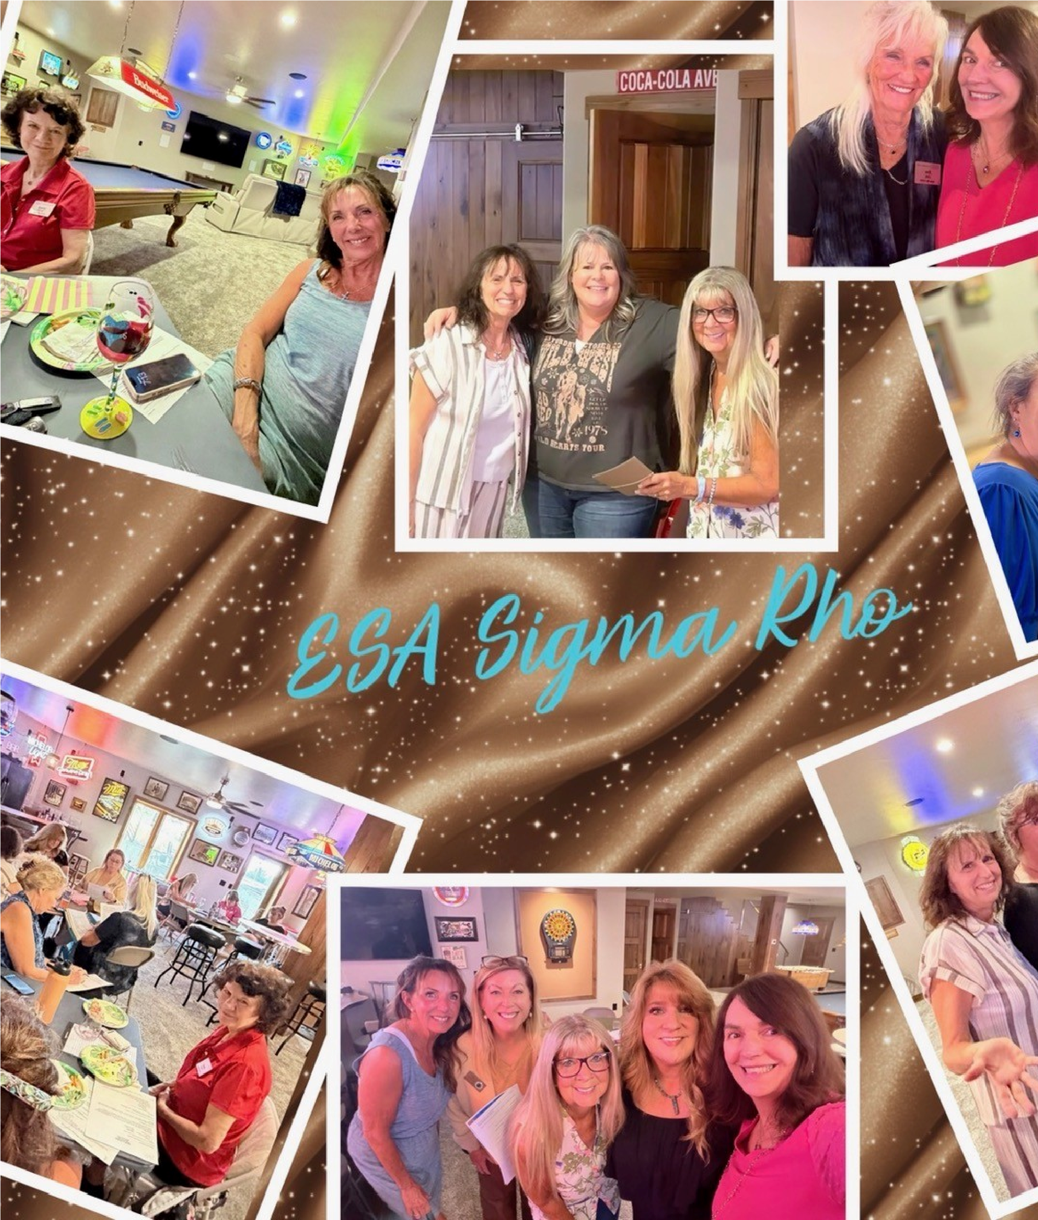
Chapter News  Gamma Chi #3668

Our chapter kept busy through the summer though we did slow down a little. Members were on vacation in various places and some of us just hung out in Loveland.
In June we helped Culver’s celebrate their 19 years in business. Dillon, the owner, planned to donate to our chapter 19 percent of their profits that day. In September, at our first meeting, some of their staff and Dillon joined us and presented a check to our chapter for $2,206.90. We are very appreciative of their generosity.

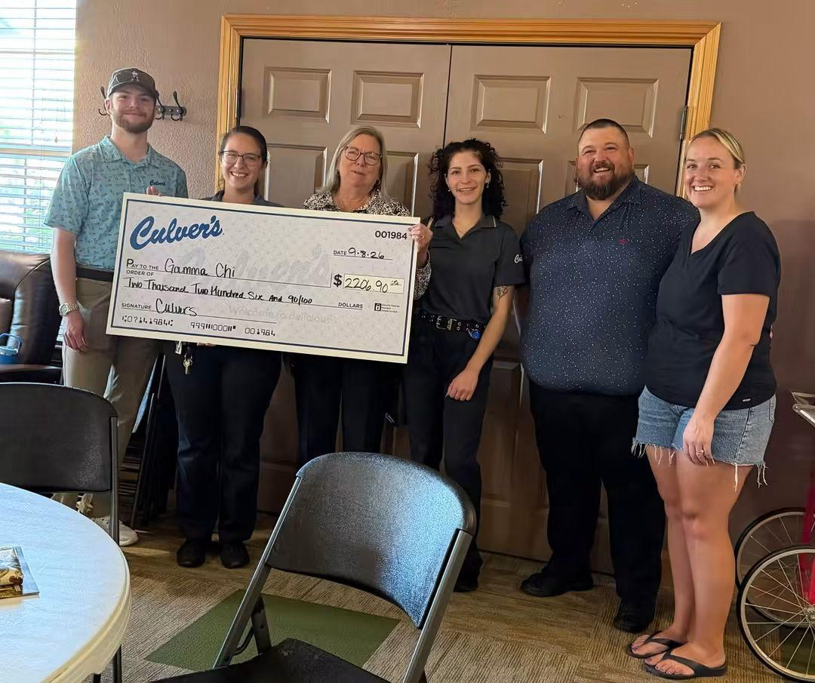
That same day we were interviewed by writer Mindy Daigle for Veteran’s Life Magazine. Her husband, James Daigle took our photos for this article. Phyllis had been working with them for quite a while. We were interviewed because of the many activities our chapter does to support veterans. The article appeared in the August/September magazine. ESA was mentioned in the article along with the various projects we do.
At the end of August, 10 Gamma Chi sisters spent a fun evening at AKA Kitchen, in Loveland.

In September we helped set up and serve lunch for the artists and volunteers that take part in Pastel’s on Fifth. This is an annual event to support Alternatives to Violence.
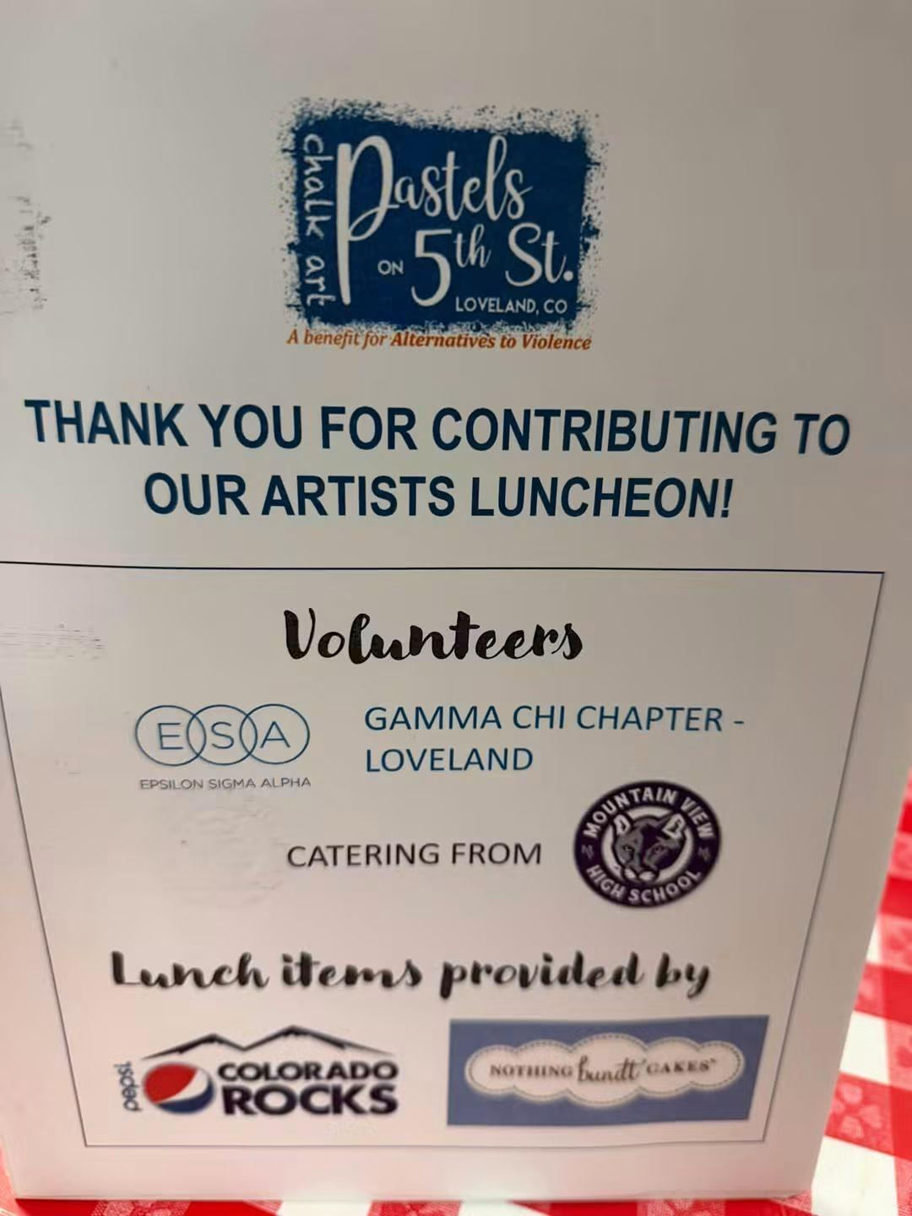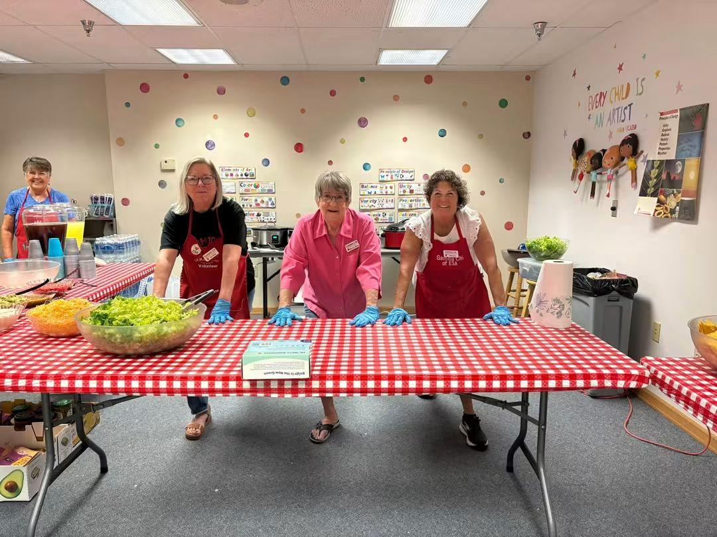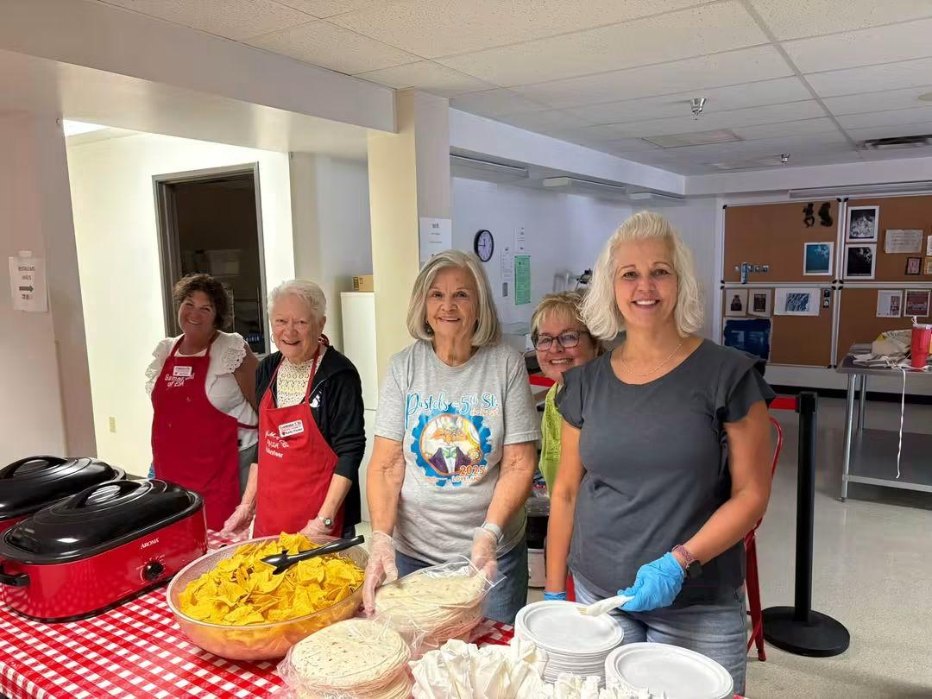
The past two months we have volunteered at our weekly activities. Community Kitchen, handing out bread and produce at the Loveland Veterans Clinic, Loveland Visitors Center, and elementary schools.
We are getting ready to host our annual Mahjongg Tournament in a few weeks. Bonnie and I had a great time in Akron for Fall Board.
Happy Halloween to all our sisters.
Pam McGee
Chapter News Zeta Nu #5608
Our Craft Show booth did very well this year. The proceeds were dedicated to our Ways and Means fund which provides Ronald McDonald meals as well as other chapter expenses. We had a good variety of crafted items and they were well received!
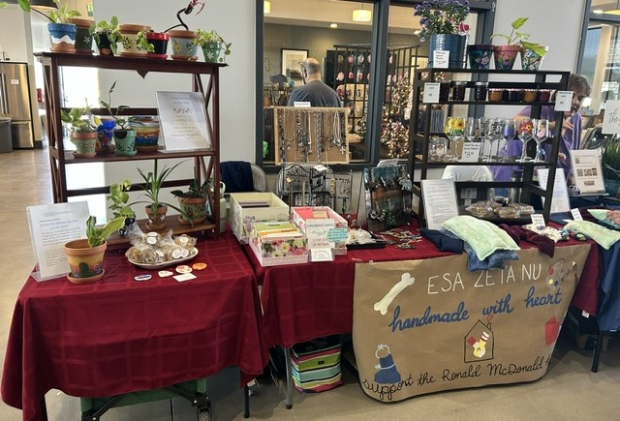
Our annual Hope for Heroes Bunco night will be held on Oct 16, so we are getting ready for that. We are honored to have The Honor Bell will be there to do a demonstration.
We are planning a night out at the escape room later this month.

Fun Pages

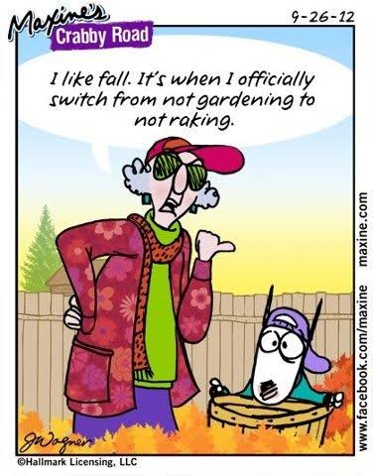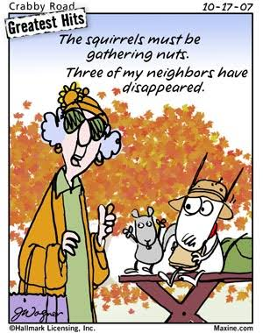


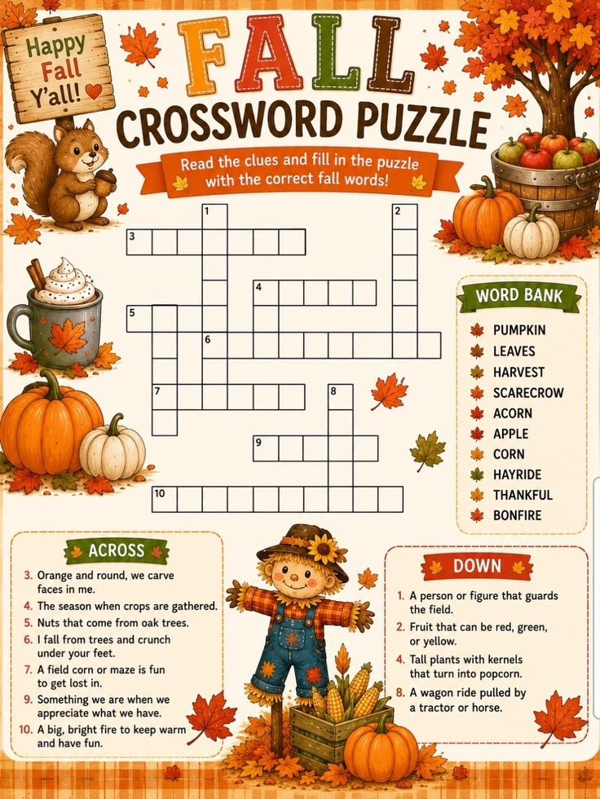

Oh, Deer!
St. Johns County Sheriff's Office received a call about an unusual home break-in -- one that involved a large buck making its way into the bathroom. According to a Sept. 4 report from WSVN, after moving furniture and offering a few words of encouragement, the deputies were able to guide the buck out of the house ... only for it to fall into the pool outside the home's doorway. With further guidance, the buck got out of the pool and took off running. However, it came back one more time for a quick plunge before making its way back into neighboring trees. The sheriff's office social media post said, "The buck fled before deputies could issue a warning for trespassing." [WSVN, 9/4/26]
Did you know??
The Name Swap: October was the eighth month in the original 10-month Roman calendar, which began in March. When January and February were added later, October shifted to the 10th spot, but its name was never changed
The Hunter’s Moon: October’s full moon is traditionally called the Hunter’s Moon, named because its bright light helped early hunters track animals and prepare food stores before winter.

National Pizza Month: October is officially recognized in the United States as National Pizza Month.

The Wine Month: Before it was called October, the Saxons referred to this time of year as Wyn Monath, which translates directly to "wine month" because it marked the season for harvesting grapes and pressing wine.

Beyond black cats and bats, the owl is the official animal mascot of October. Historically tied to the ancient Celtic festival of Samhain, October is often called "hooting season" because owls become highly vocal as they establish winter territories.

Cosmic Showers: October features two spectacular annual meteor showers: the Draconids (usually peaking around October 8–9) and the Orionids (which peak later in the month).

