
ESA Colorado  Golden Lamp |  | June 2026| Volume 80 | Issue 11
Nancy Cameron

Colorado State President
2026-2027

Editor’s Corner  They say that as you get older, time goes by faster! I hate to admit it, but that seems to be so true! Or maybe it’s the way we think. It is the beginning of June. Schools are out for the summer, tourists are filling the roadways, and we are busy planting our gardens and filling our pots with flowers! Now, we should be taking it a day at a time, enjoying the warm weather and sleepy rainy afternoons. But instead, we are worrying about the scorching hot days that haven’t even gotten here. So, I recommend that we all slow down and have some fun! Call your friends, plan a picnic, go to a show and catch a summer concert! Have fun!  I’d like to welcome our new 2026-2027 State Council!  We have lots of new faces on the board and I am looking forward to a fun and fresh year! Check out page 4! |  | WHAT’S INSIDE
PAGE 2-5
President’s Message

PAGES 6-9
Officer’s Pages

PAGES 10-15
Chapter News

PAGE 16
RMR Registration

PAGES 17-18
Fun Pages


President’s Message
By Nancy Cameron

I LOVE ESA!

I LOVE EACH AND EVERY ONE OF YOU!

If not for ESA, I would never have known you and enjoyed the friendships we have made - had opportunities to learn and go places I would never have experienced. Thank you for being a part of it.

I have chosen WINGS as my theme as they represent to me the desire and ability to rise above everyday things to reach new goals. It is my way to express what has been one of the greatest blessings in my many ESA years.
To try new things knowing I had the encouragement and support of many “members”!

I could disappoint and fail without the world coming to an end OR I could succeed and FLY!

WINGS to encourage all of you to have the confidence that we are here to help and support you. Each time you reach a bit higher as each part you contribute gives you stronger wings to lift your confidence higher.

The Butterfly Effect is the notion that as small a stir those delicate WINGS make; it can have major effects down the line. They do move the air around them. We do not know what that movement may affect to start or add to the world around them.



You’ve already earned your wings, in E.S.A. Now, JUST FLY!

It is apparent that we will need to examine the direction our State Council will take this coming year. What our future might be. The lack of new leaders willing to step forward is a big problem!

-2-

YOU have earned your WINGS in Chapter, Council and community - but are reluctant to commit to FLYING on the State Level of ESA or above.

We will be meeting before activities start this coming September to discuss and brainstorm solutions - probably by ZOOM - isn’t it amazing we can meet that way? Be thinking about what is important about Colorado State Council to you. Let’s work together to make it better than ever!

Thank you all for everything you are willing to do for others. Can you believe that through ESA, we have helped to raise over $30 Million for St Jude over the 15 years we’ve been involved with the Dream Home Raffle!

For this year alone - A total of giving 1,167 hours, driving 8,266 miles and raising over $57,000 in money and goods for your various projects! AND $3,427,801.47 with 2 Dream Home Raffles!

You are amazing!

Thank you Deanna and Sigma Rho for this great convention! This beautiful facility is another thing I would never have seen and experienced if not for ESA!

Congratulations, Lori and your Board. It’s been an outstanding year! Congratulations to all the award winners!
And congratulations to all of us non-winners! Our butterfly wings have contributed to the totals.

Thank you Leslie, Susan and Candie for the impressive installation ceremony. It is my blessing to have you in my life

Thank you for the opportunity to lead the Colorado State Council one more time - NOW LET’S spread our WINGS and FLY!!

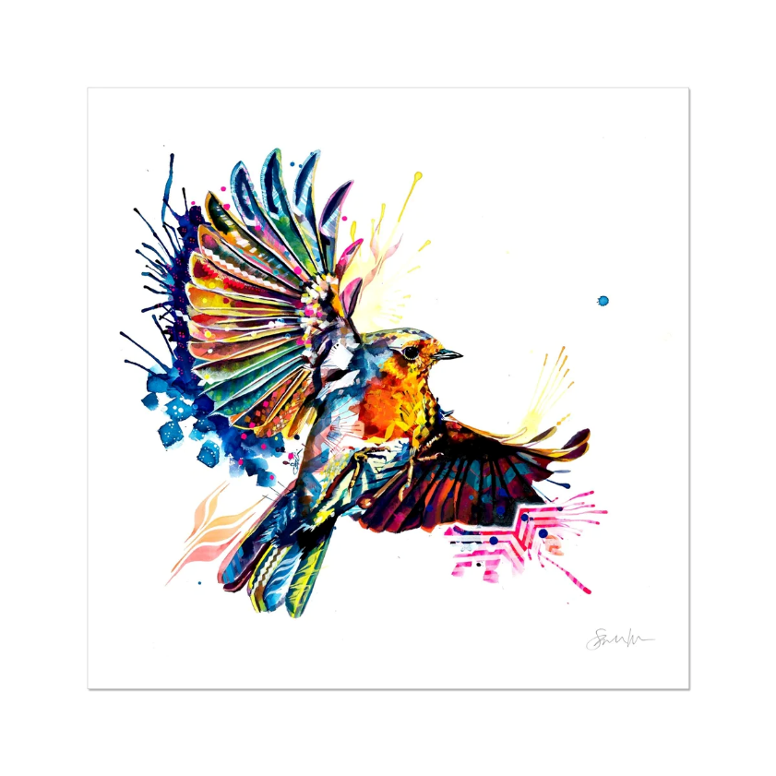

Introducing your new ESA Colorado State Board!

COLORADO STATE COUNCIL
Officers for 2026-2027 Committee Chairs for 2026-2027

PRESIDENT CHAPLAIN
Nancy Cameron Margaret Ames

PRESIDENT ELECT/MEMBERSHIP CHAIR COMMUNICATION COORDINATOR
Emily Westphal Ginger Dodge

TREASURER EASTERSEALS
Deanna Sloat Linda Noell

SECRETARY EDUCATIONAL DIRECTOR
Chris Dostal Kevin Richards

PARLIAMENTARIAN ESA FOR ST JUDE
Leslie Stevens Jenniffer Carlson-Mazza
& Adi Mazza

ESA FOUNDATION COUNSELOR
Sandy Alexander

GOLDEN LAMP EDITOR
Karen Addison

HOPE FOR HEROES
Susan Bloss

PAST PRESIDENT/AWARDS
Lori Anderson Havelick

PHILANTHROPIC
Mary Humphrey

SPECIAL APPOINTMENT
SOCIAL MEDIA
Dixie Daly

WEBMASTER
Candie Patino

-4-

MESSAGE TO ALL COLORADO ESA MEMBERS
By Nancy Cameron
Colorado State President 2026-2027

I’m still trying to recover from a very exciting 80th CSC Convention in Loveland!
Sigma Rho, with Deanna Sloat at the lead, came through with a fun and exciting weekend! There was lots of energy, smiles and hugs for everyone. Food was delicious and the facilities worked great!
If you’ve seen any of the many, many photos on Facebook (Thank You Dixie Daly!) you can tell how we followed
the Red, White & Blue theme on Friday evening. Shirley Conway & Connie Balsley were “Best in Show”! And the beautiful Casa Sagrada facility was perfect for the Denim & Diamonds Evening activities!

THANK YOU SIGMA RHO!!

For me, starting convention with only ONE Nomination submitted - Leslie Stevens for Parliamentarian -
for elected office was STRESSFUL to say the least! After much discussion and encouragement by members and Lamplighters during the business meeting, we were successful receiving nominations from the floor for President Elect, Secretary and Treasurer. WHEW!

Lori conducted the meetings with patience, order and HARMONY! Susan Bloss’ Awards presentation was
great! The Memorial Service was beautiful Thanks, Margaret!
Loved Lori with her past Outstanding Woman Tiara on her blue cowboy hat!

This communication is to introduce you to my theme and goals and the new officers and committee chairs
for the coming ESA year.

My THEME is “YOU’VE ALREADY EARNED YOUR WINGS, IN E.S.A. NOW JUST FLY!”

Everyone has been Secretary, Treasurer, etc. in your Chapter. It’s not much different from that holding
office on the State Council. There are two meetings a year (Fall & Spring) and Convention. See - you’ve
already done it and earned your WINGS!!

MY LOGO is that cute little chicken above - think I’ll name her Birdie - and all kinds of flowers and colors.
Thus, all the different “WINGS” included with the flowers at my installation (Thank you - Leslie, Susan B.,
and Candie!)

PRESIDENT’S CHOSEN CHARITY is - what else? - St. Jude Children’s Research Hospital. It’s been my passion
since 1975! If you make donations other than the St Jude sponsored programs, would you mind directing
to the ESA campaign to raise $5M in 4 years that is now in effect. We’ll have more info for you later on,
but you could find it on the epsilonsigmaalpha.org website.

MEETINGS - Still in the works. I really like to go to all the different places in the state so I’m trying to set
the Fall & Spring meetings in different areas. Convention is in Grand Junction so that takes care of the
west - Akron for fall - so that would take care of east - any volunteers for spring - south or north?
I’ve been chatty - lots of exclamation marks! Can you tell? I’m really EXCITED to see you all throughout
the year!

REMEMBER - Angels have WINGS!

Hugs, Nancy


Message from our Outgoing President
By Lori Anderson-Havelick
Hi All,
I hope you are all having a great summer. We have been pretty busy, hopefully slowing down in a few weeks.

I was honored and humbled to be your ESA Colorado State President. It is quite the learning experience, but very rewarding. Thank you for all the help behind the scenes, so that we could all be together. I couldn’t have done it without all your help!

Thank you to the hostess chapters that helped put on the Fall, Spring and April Convention. Thank you to
the Hostess Chapters - Alpha Omicron, Jennifer Carlson Mazza in Salida, Kappa Iota, Nancy Cameron & Leslie
Stevens in Englewood and Sigma Rho - Deanna Sloat in Loveland. A great time was had by all at all three meetings.

As we look ahead, let’s hold onto this feeling - the rhythm we find together, the way our voices are blended,
imperfect on their own, but powerful in harmony. I enjoyed everyone getting together and hearing everyone visiting. At the Fall Fest meeting, the Spring Fling and now the State Convention. That is what ESA is all about. We have fun while getting business done.

Like music, friendship isn't about hitting every note perfectly, it’s about listening, adjusting, and creating something meaningful. My family are all very much impacted by music. My Mom and Dad were both musicians. My Dad was a Band Director and Mom was a Choral Director. So, music has been my life. I used to sing in the choir under the direction of my mom, in high school for Community Concerts. I used to sing in church choirs in Boulder, in the Boulder Chorale with the Boulder Philharmonic Orchestra, and in Longmont, Colo at the Rocky Mountain Christian Church.

I was very busy. Along with being in ESA. I sang in harmony - 2nd Soprano or Alto. When my illness came, God didn’t take away my music. It has taught me to listen to enjoy a concert, a karaoke night or a simple conversation, and being with friends and ESA friends.

This weekend isn’t just about the melodies or the lyrics - it’s about connection. It is about the laughter between the verse, the encouragement, and the quiet understanding that we’re better together than we ever are alone.

On a final note, as we leave here, don’t think of this as an ending. Wherever you go next, let’s carry this harmony with us. Let’s keep showing up for one another, lifting each other up, and finding the music in life’s quieter moments. Keep the music alive. Keep the friendship close. And never underestimate the power of a little harmony. Thank you for being a part of this wonderful chorus.

Thank you all so very much,
Lori Anderson Havelick
Colo State Council President 2025 - 2026
“ESA Friends In Perfect Harmony.” -6-



St. Jude Report

A big thank you to all our generous ESA sisters in Colorado. You donated a total of $636.00. $200 of that was given to Nancy for IC and the other $436 was collected from the Spring Fling and State Convention.

I know the reporting system is new but remember to complete one of the forms when you do a fund raiser for St. Jude but keep that information for our state's St. Jude and Philanthropic reports in April. They are two separate things. The form is easy to complete but try and complete them monthly. Also have one person designated to complete the forms, it will make it easier to keep the information straight.

I have enjoyed being your St. Jude Coordinator and you’re in good hands next year with Jenniffer.

Have a great summer. Thank you so much for everything you do.

Pam McGee





Hope for Heroes
April 23, 2026
Hope for Heroes 2025-2026 Report
Submitted by Deanna C Sloat, Hope for Heroes Chair
As the 2025-2026 Hope for Heroes chairperson, I have chosen High Plains Honor Flight for this year's Colorado State project. High Plains Honor Flight is a nonprofit whose mission is to take all the local veterans on an all-expense paid trip to see the memorials erected in their honor in Washington, DC. You can donate to the High Plains Honor Flight through their website www.highplainshonorflight.org or you may look for a local Honor Flight in your area.
As part of our continuing mission to honor and support veterans through hope for heroes, we are participating in a craft at or this year's state convention folding pocket flags to be given to veterans that are on the Honor Flight.
I personally have been volunteering for the Honor Flight since my father went on it in 2017, he is a Vietnam veteran, and it was the most moving experience that he had since coming home from the war. Locally High Plains Honor Flight provides 2 flights a year round trip expenses hotel accommodations travel to and from the monuments and all of their meals as you can see that is a great expense and it's the least we can do to honor these veterans finally I have provided basket drawings were onboard spring fling and today at convention with red, white and blue themes throughout and those ticket sales will all be going to High Plains on our flight. Please remember to thank a veteran by purchasing their meal or a Welcome Home and a handshake. It is important to thank them for our freedom because freedom is never free.
Submitted by Deanna C Sloat
2025-2026 Hope for Heroes chairperson
-8-

Colorado Web Team

esacolorado.org
Proclamation
WHEREAS the Colorado State Council of Epsilon Sigma Alpha granted a forward-thinking group to research the feasibility of a website for its members.
WHEREAS data was collected as to the effectiveness of such a website to save treasury funds while providing a multitude of essential information as well as required current documents. ￼
WHEREAS, upon the presentation of the group’s findings, the Colorado membership of Epsilon Sigma Alpha voted to implement such a website.
WHEREAS, in September 2001, said website “went live” and has continually served as a digital focal point for its members for information as well as history for the past 25 years.
THEREFORE, the Web Team thanks all those who have contributed to this successful endeavor. Without YOU, there would not be a Colorado State Council website. THANK YOU!
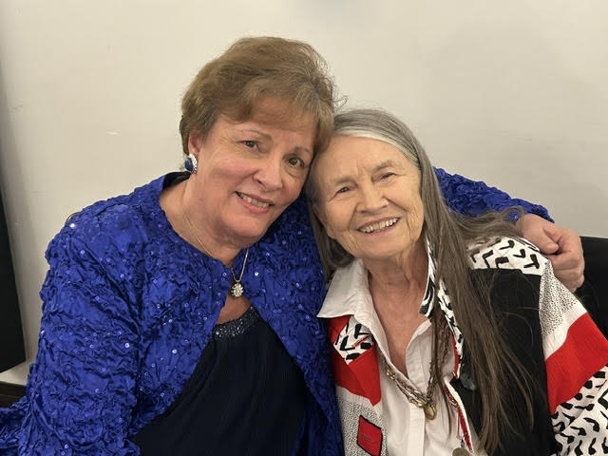

BAGS for BUCKS
AKRON ESA CHAPTERS St Jude Fundraising Tradition
April 11, 2026
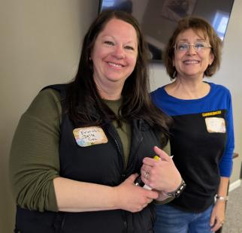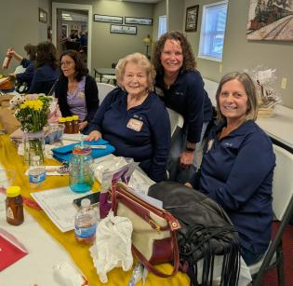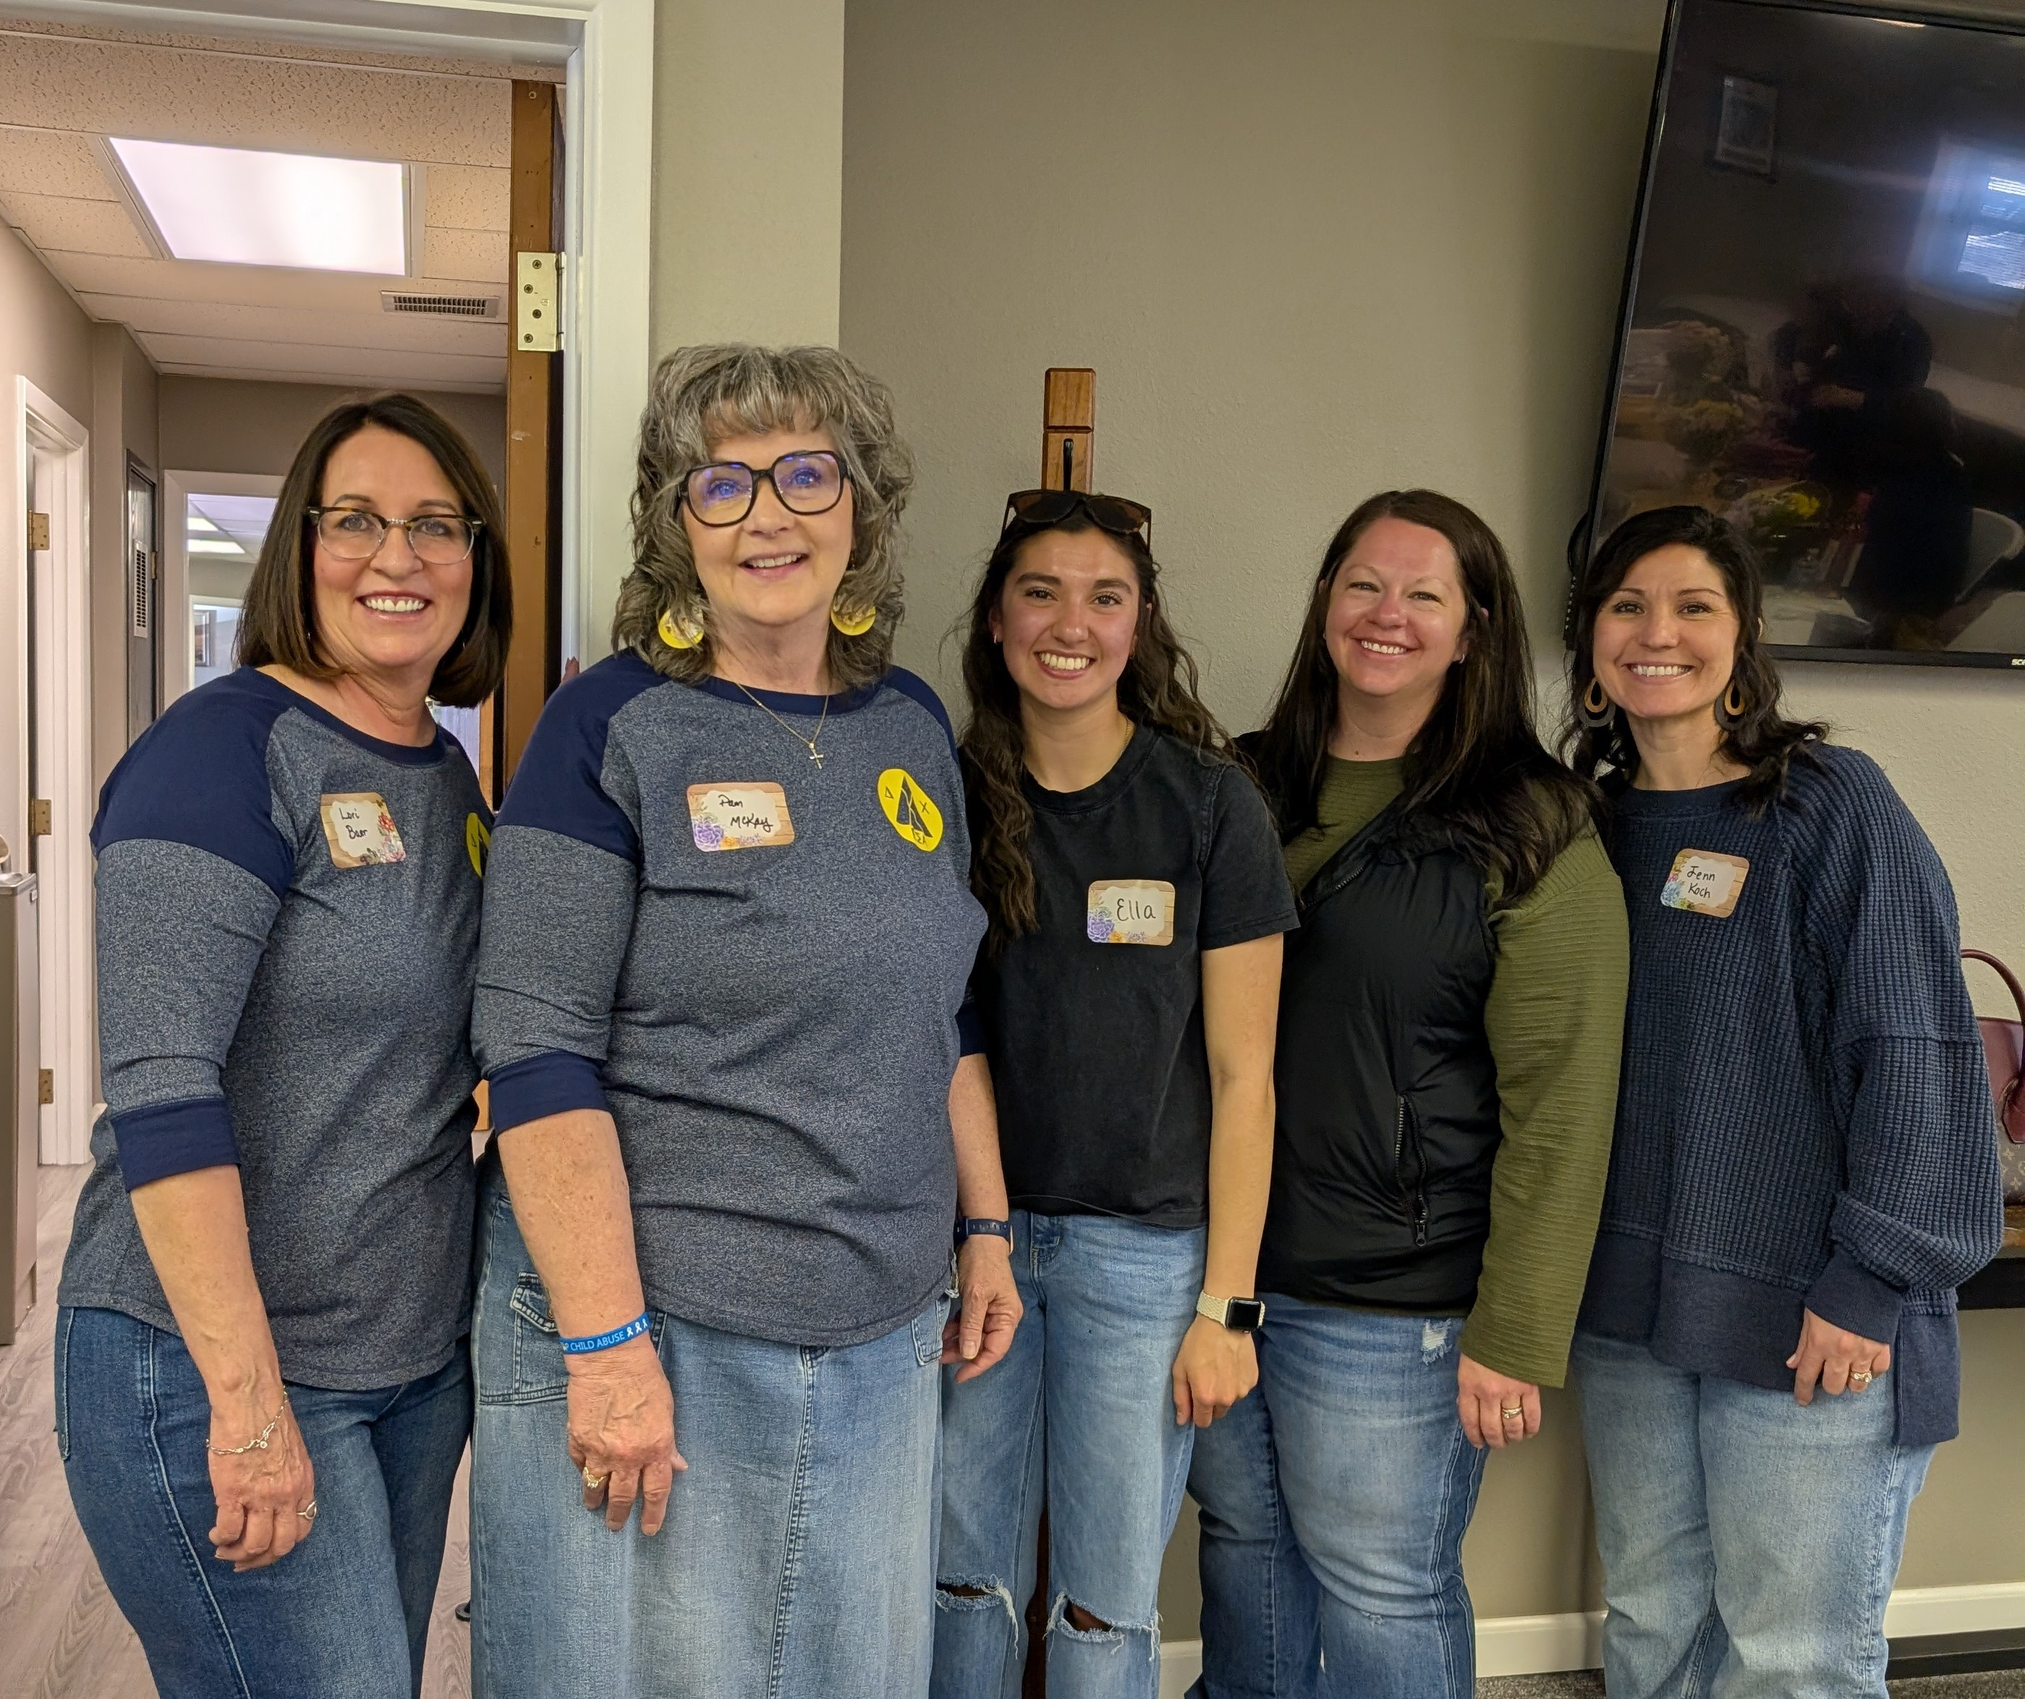
Erin Hill, Delta Chi & Alpha Nu Members Delta Chi Members Debbie Spears, Gamma Omega

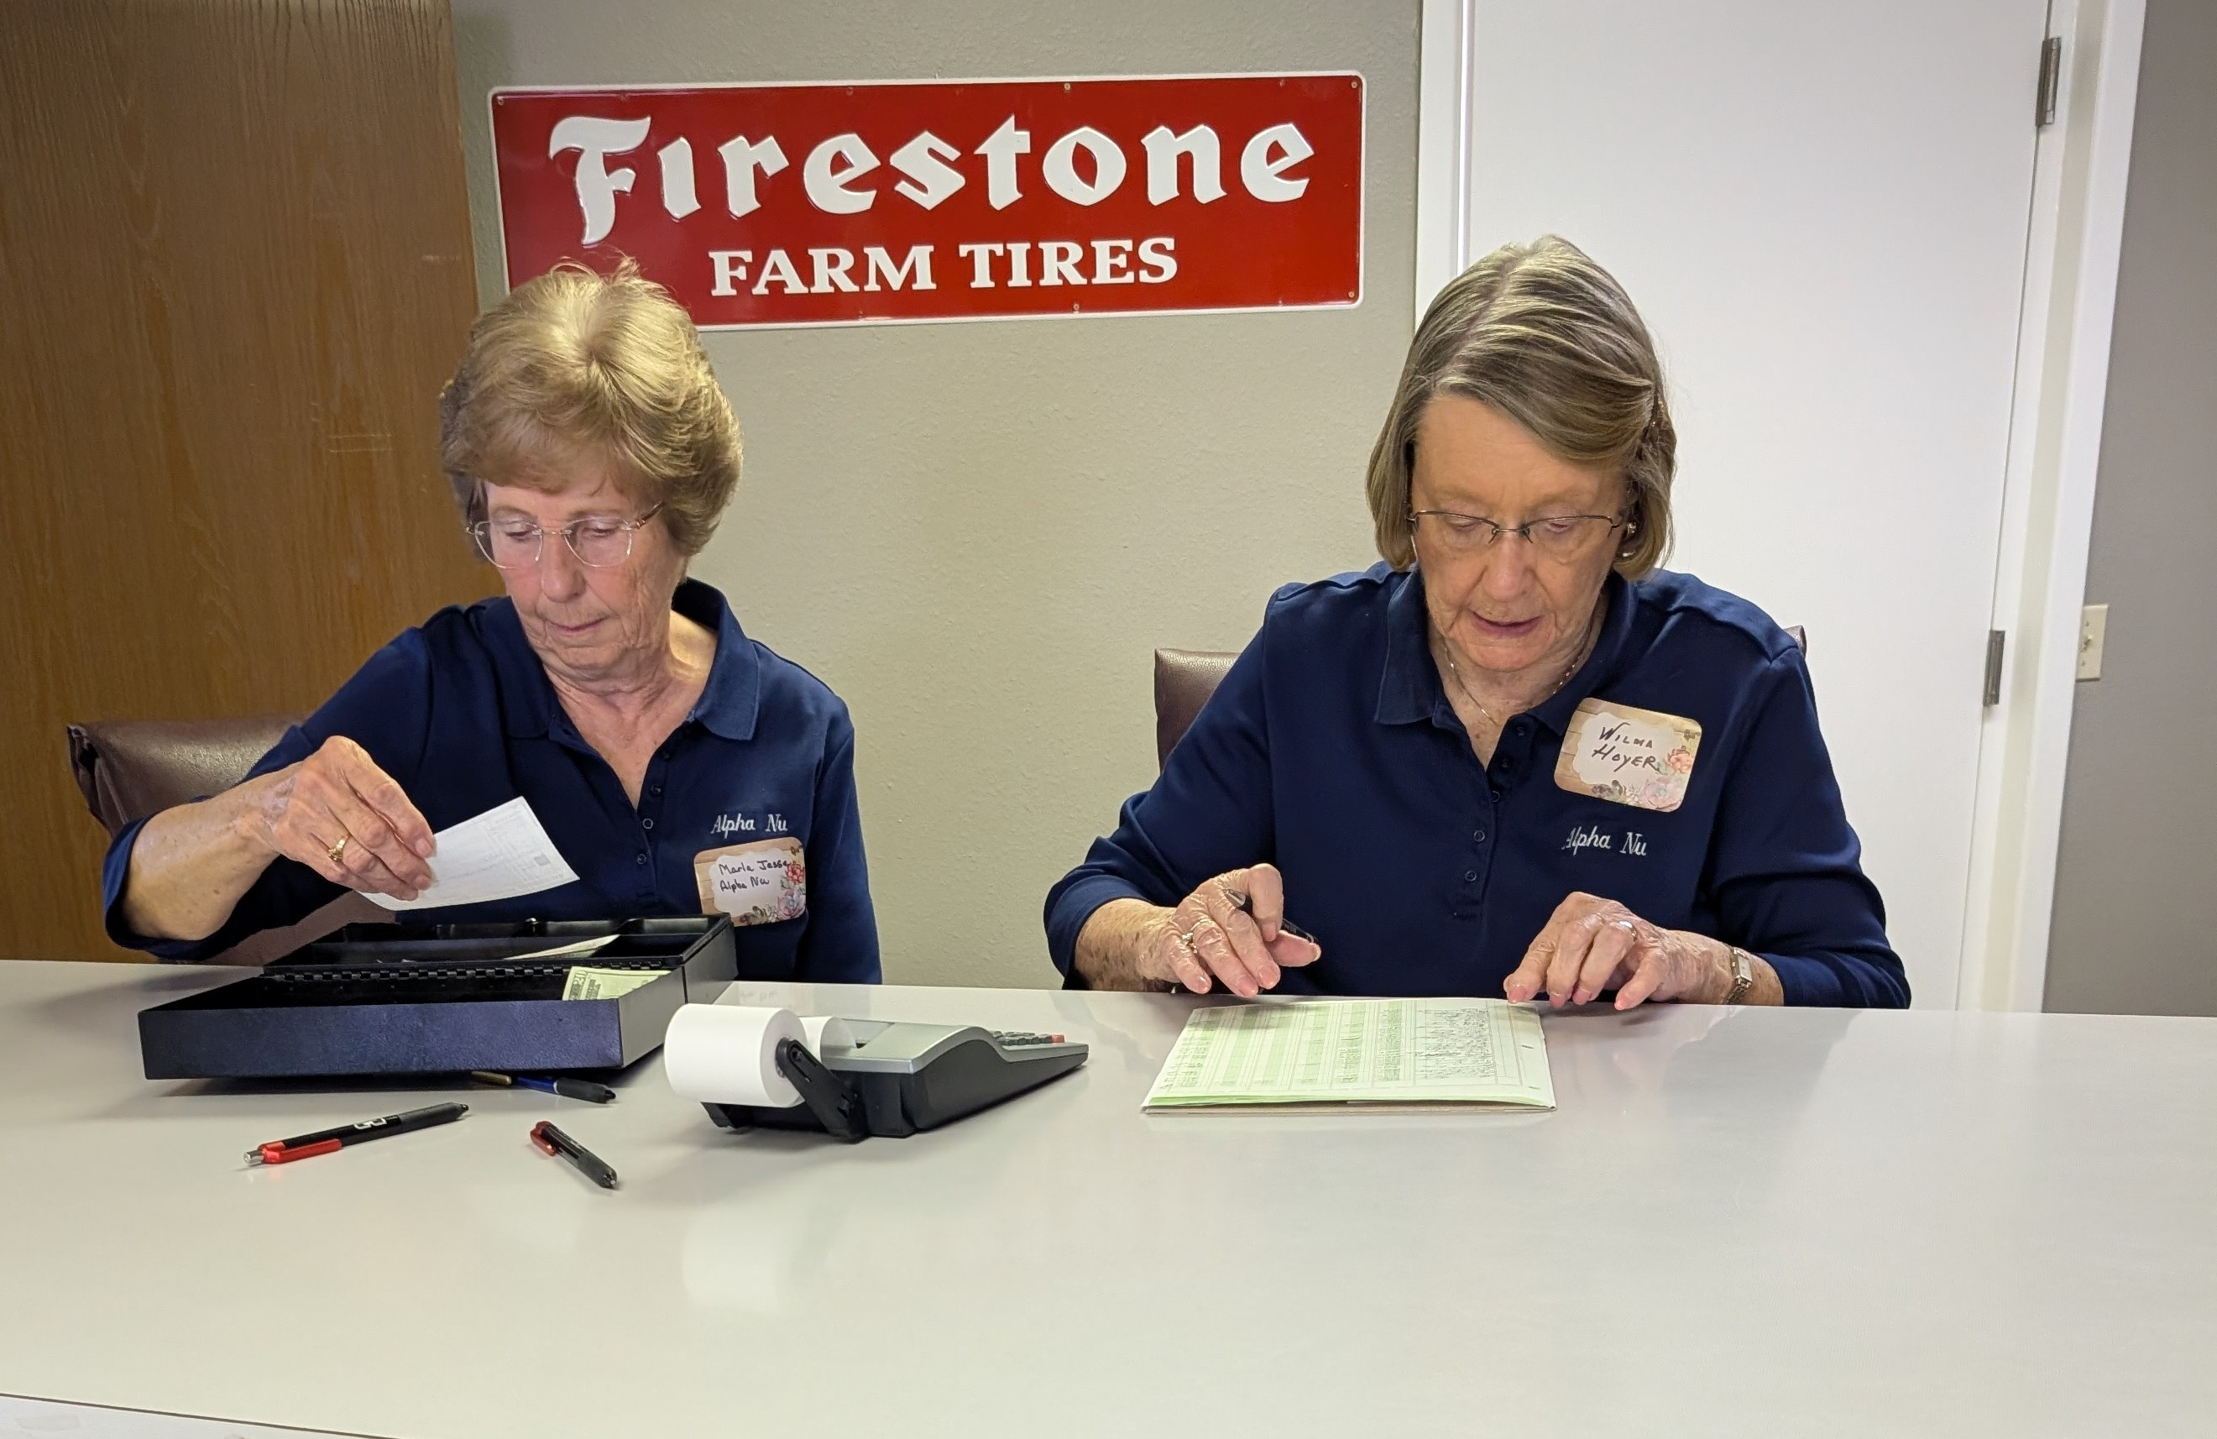
Marla Jesse & Wilma Hoyer Adding Up Amazing Total $$$
Rita’s Purse is Full! How do you get a bouquet in a purse?
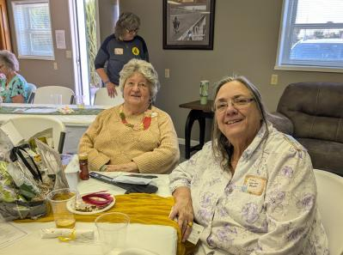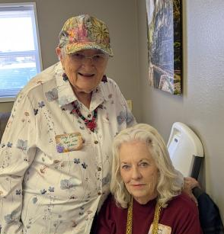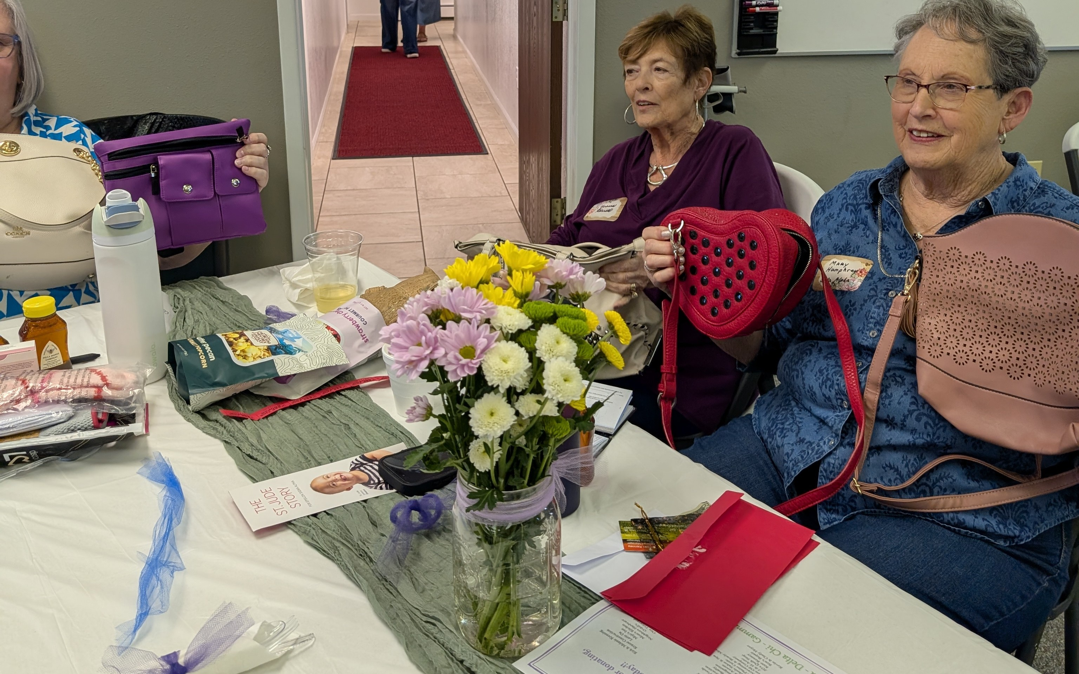
Visitors - Rita Martin & Nancy Cameron & Yvonne Farrell & Vickie Chavers Bruso Nancy Carray Mary Humphrey
-10-
Chapter News  Gamma Chi #3668

Gamma Chi
Early in April we held our second Blood Drive for the year. Lisa reported that we gave 20 total units of blood at our last drive. There were 12 whole units, 3 power red units and 2 red units. In all, 44 lifesaving blood products were donated.
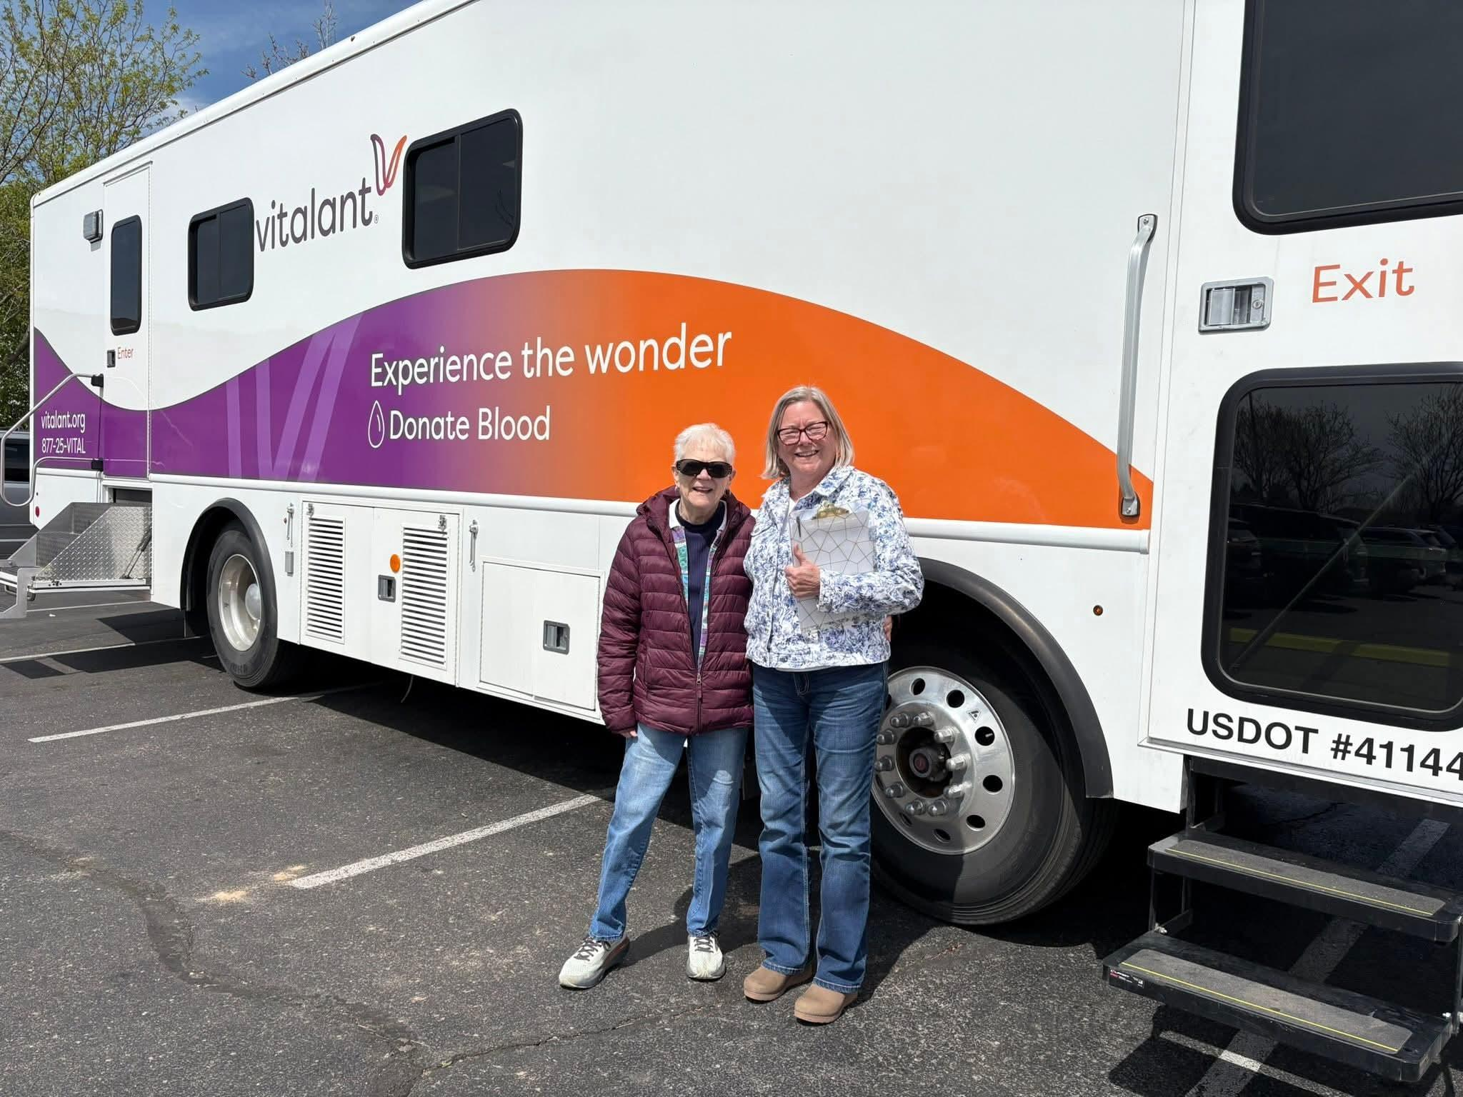
On April 22nd, we had a craft night with Irene from Unshaken Candle Co. She came to our social and helped us arrange her beautiful flower candles in coffee cups. We could use one of her cups or bring our own. We had a fun time and we were all happy with the finished product.
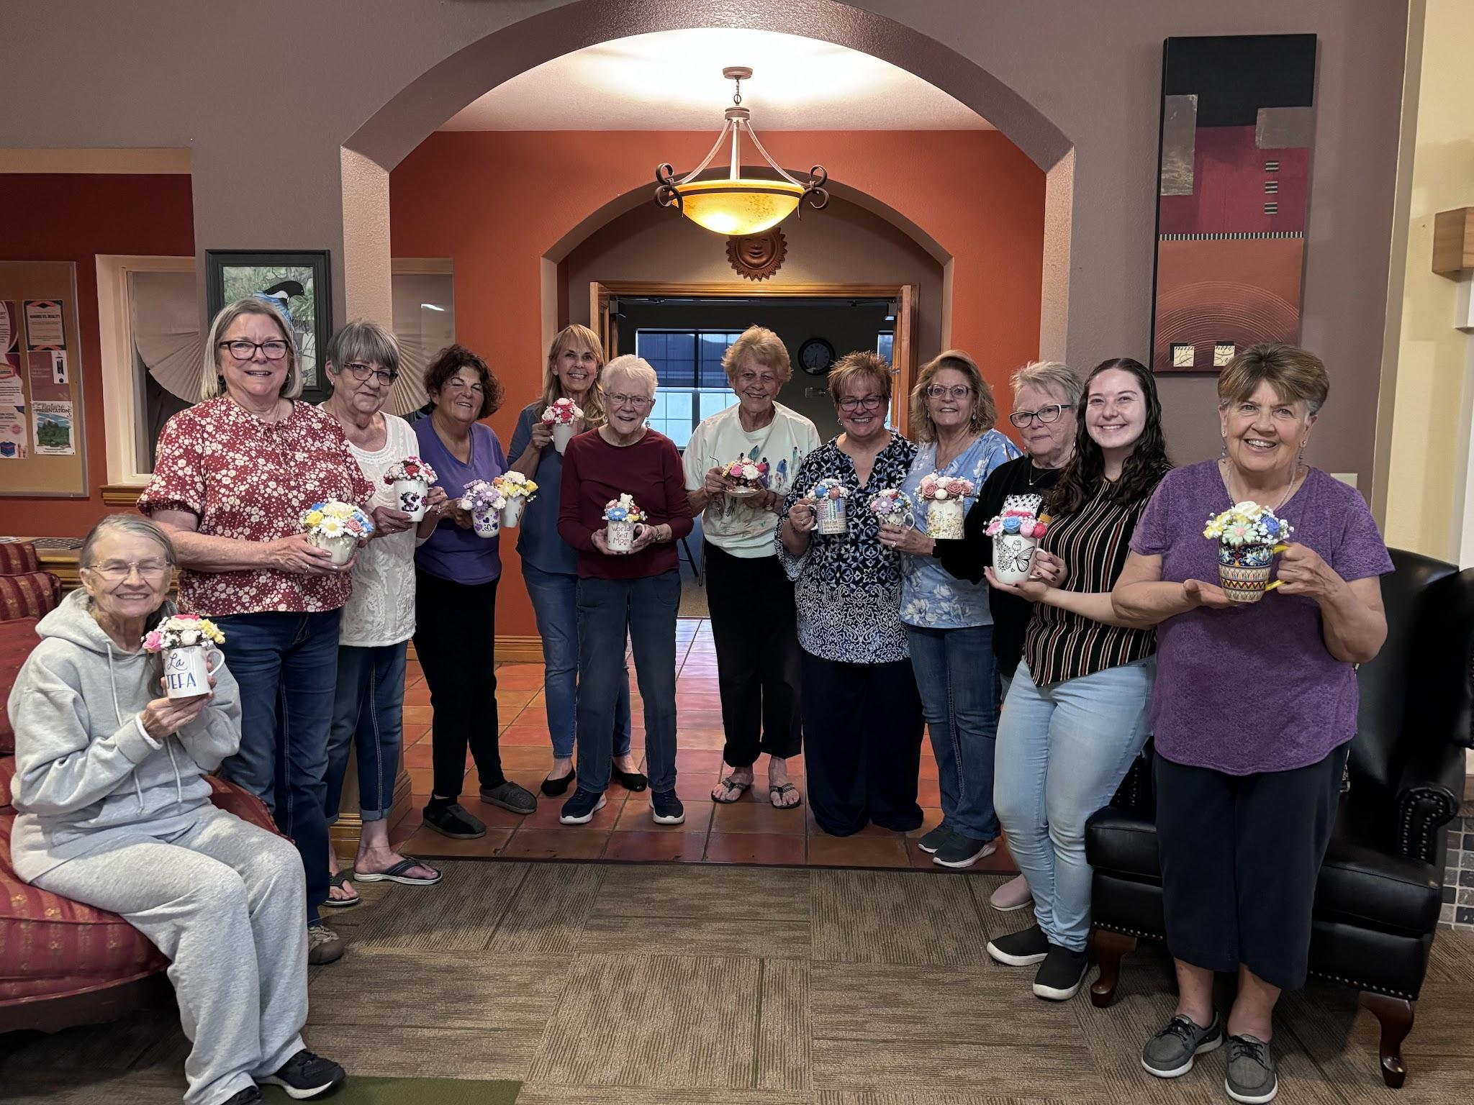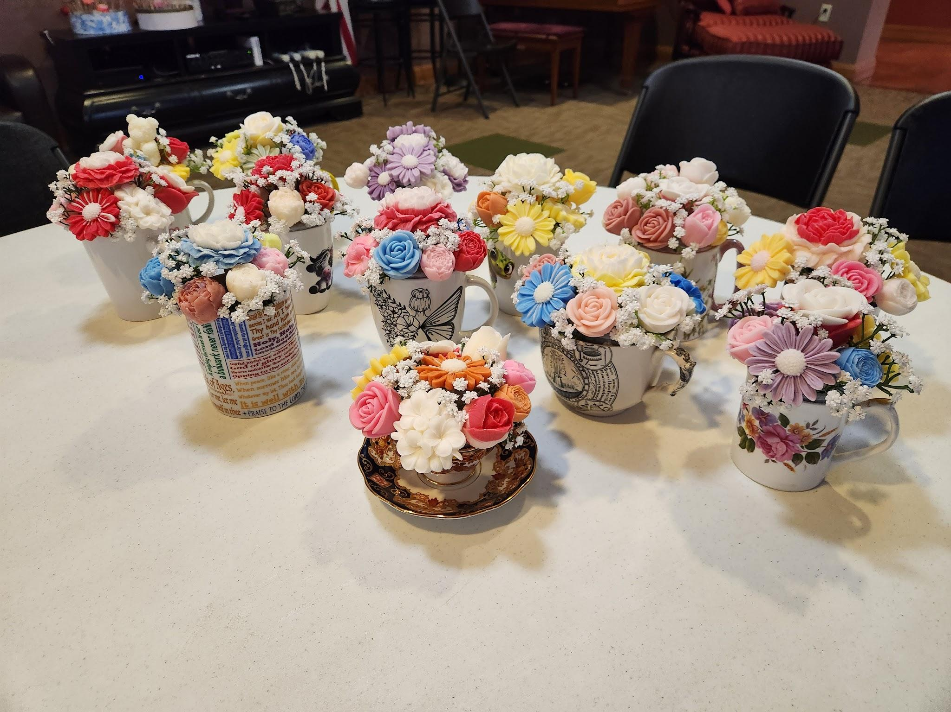

-11-
That same day six members attended the ATV Purple Ribbon Breakfast at Embassy Suites. Alternatives to Violence raised $107,000.00 that morning.
After that fun craft evening we had, nine Gamma Chi members attended the State Convention that weekend. It was very special as Pat Bernhardt and her daughter Jamie also joined us. We had a great time. It’s always good to see and visit with everyone from around the state.

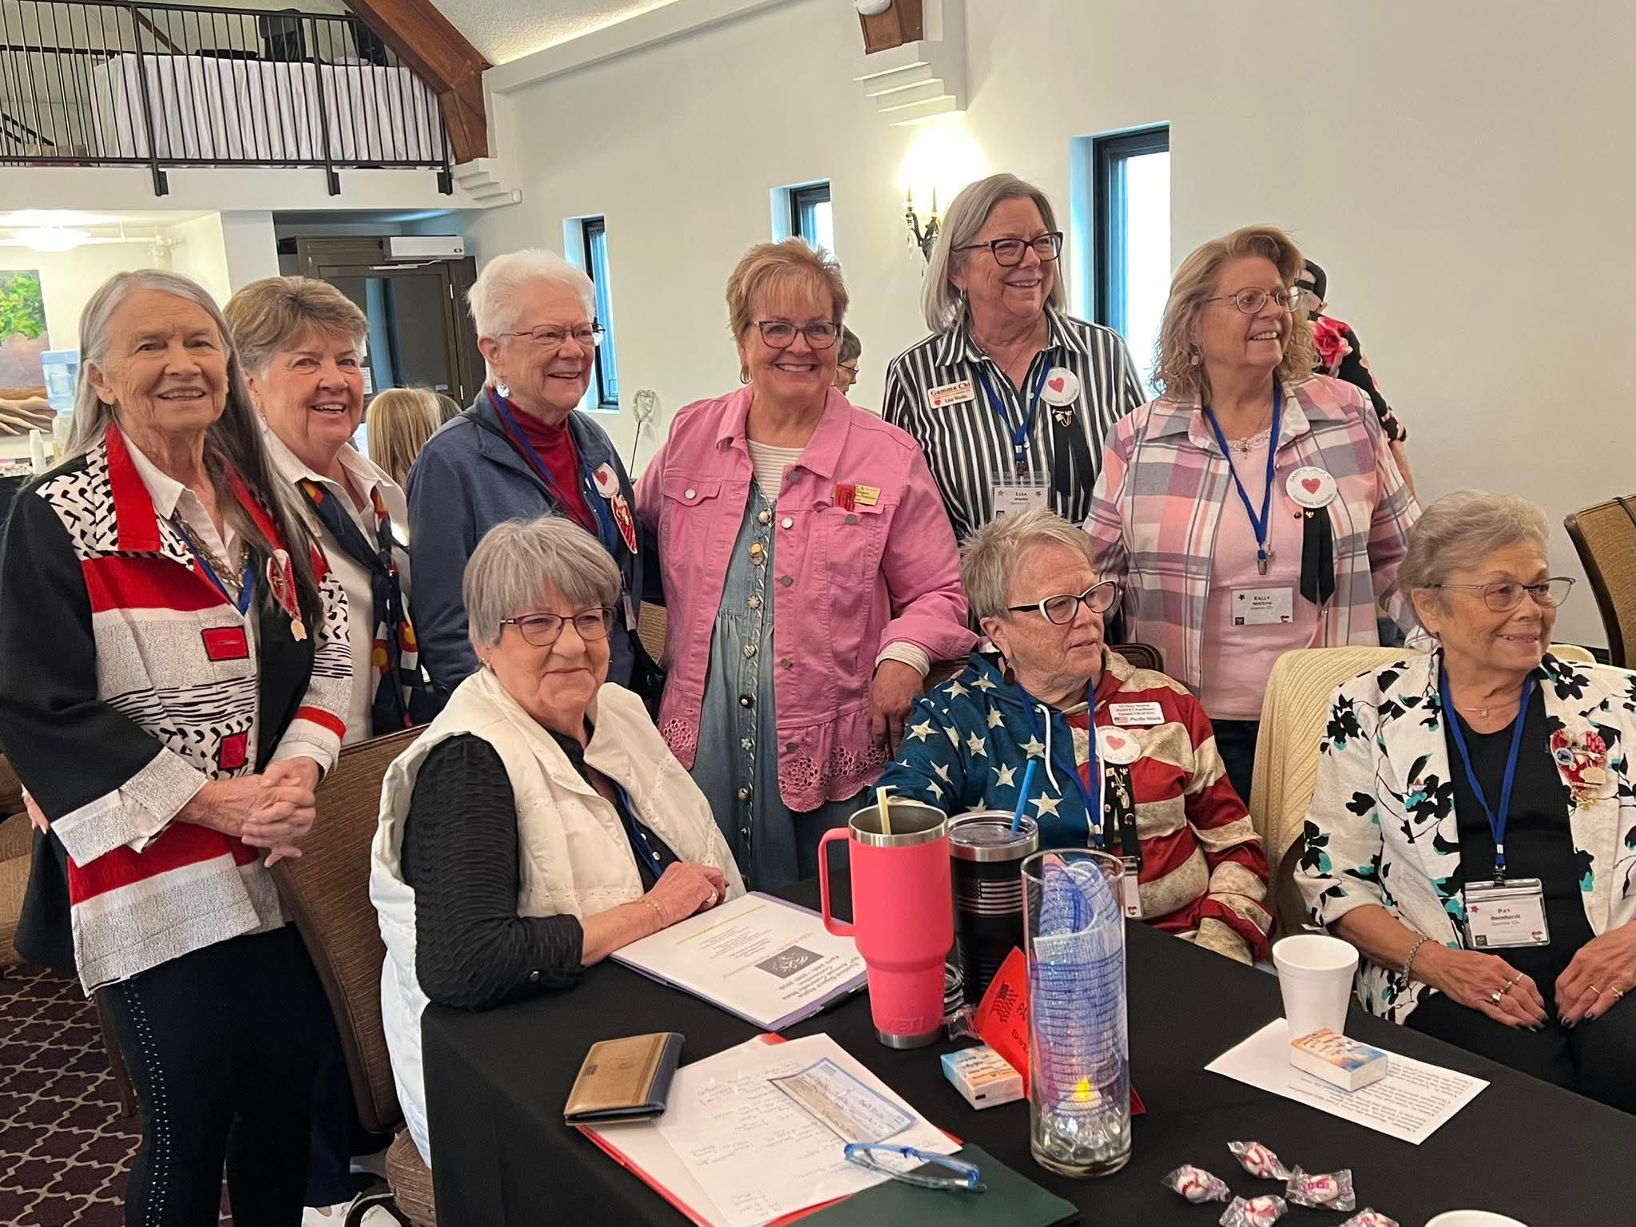
As always the past two months were filled with Community Kitchen, Food Bank, Friends of the Library, Veteran activities, and volunteering at schools. Gamma Chi was represented at the ribbon cutting for the new Veterans Memorial Park in Loveland.
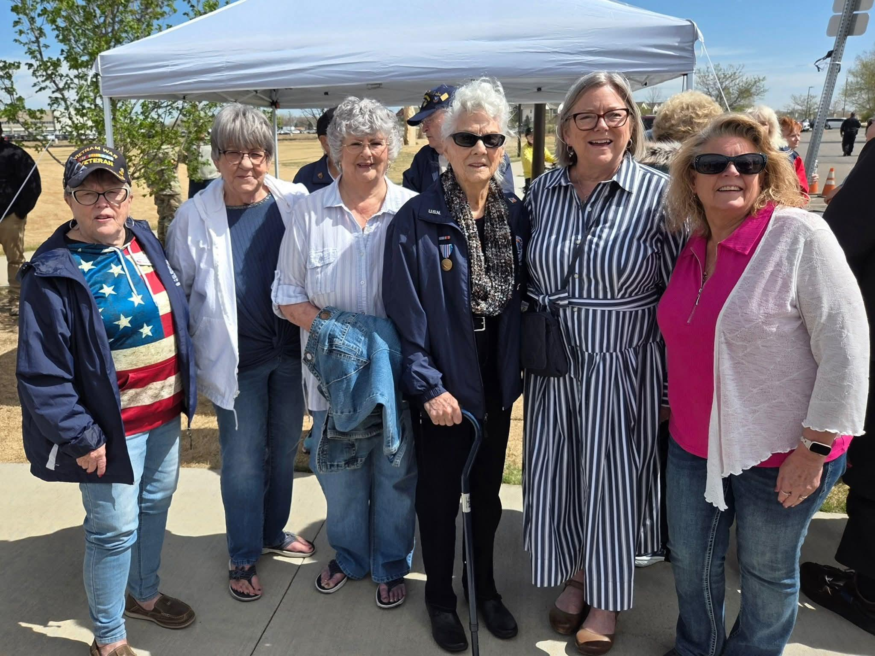
We ended our year with our annual dinner at the Golden Corral. As Awards Chairman for our chapter, I shared the awards received at convention. Our 3 new pledges were presented with their Jewel Pins after taking part in the Ceremony of the Jewels. Before dinner we had a brief May meeting and discussed some of our summer projects.

During the meeting it was shared that the 1st annual Culver’s & Gamma Chi Cares Scholarship would be given. Yuki Chen graduating from Mt. View High School was awarded the $1,000 scholarship. She’ll be attending the University of Pennsylvania.

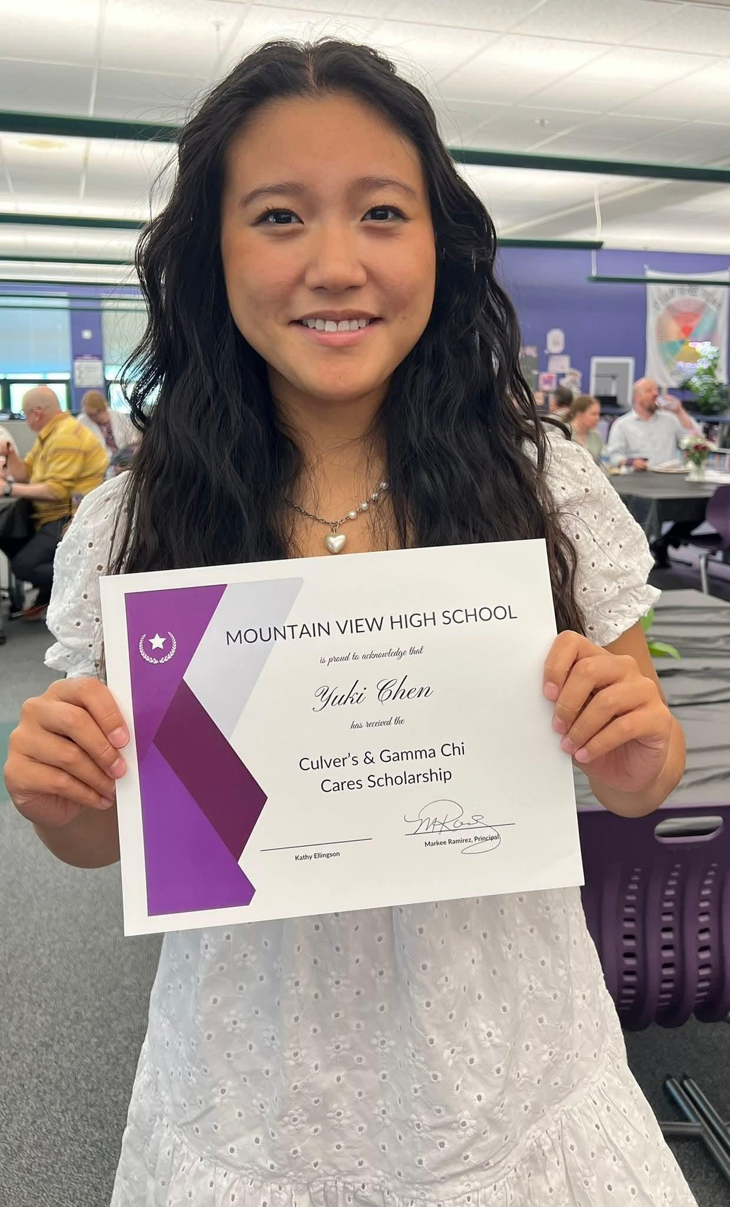
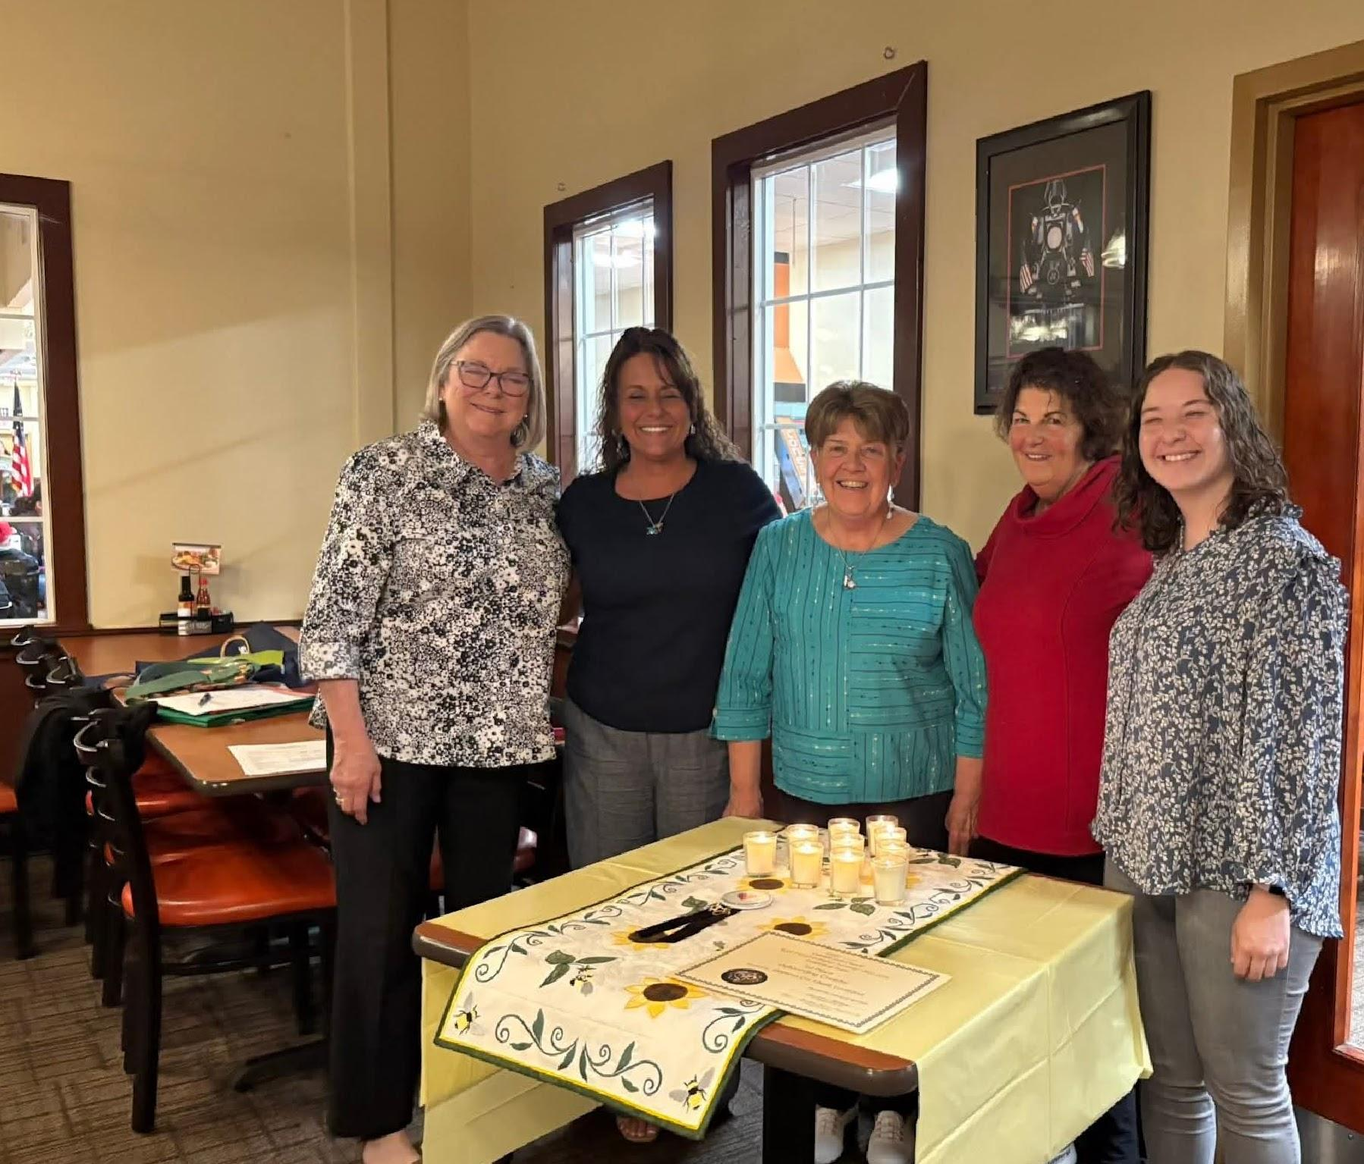

Have a wonderful summer.
Pam McGee

-13-

Beta Zeta #3149 Omega Chi #4842
By Carol Dunn
Beta Zeta and Omega Chi Chapters met for our Founders’ Day gathering at the Steeple Events Center in Cañon City on May 13. Beta Zeta presented a recap of our meetings for the year, following President Mary’s theme of “Connections”. VP Sue constructed a paper chain for each meeting with comments from each member about the educational program or social event. It was fun to recall the fun and interesting year.
The group enjoyed a delicious dinner and mingling with our friends. Carol and Vickie presented Beta Zeta’s awards: to Gena for 35 years of membership, to six members for Perfect Attendance, and to Mary Chamberlain as “Woman of the Year”.
Installation of officers for the 2026-2027 year for both groups was conducted. The ceremony always means so much as members are reminded to “work diligently, to be ever alert that nothing breaks this chain of blue and gold.”
Now on to summer activities—hoping you all have outdoor fun with friends and family!
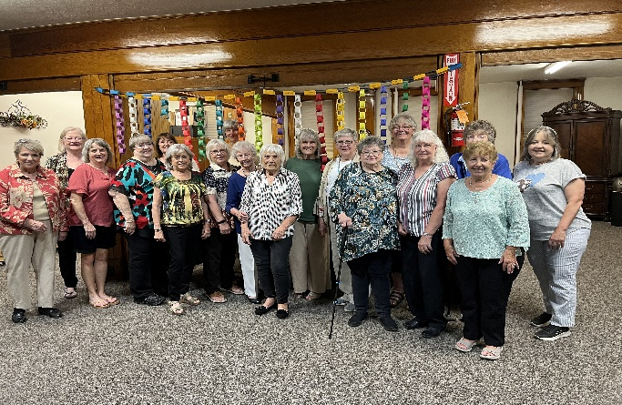
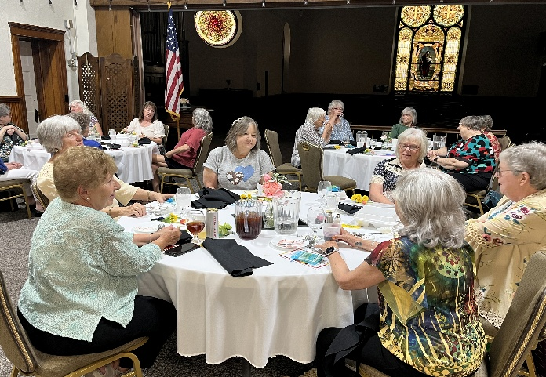
Chapter News Zeta Nu #5608

Zeta Nu hosted a Mosaics class last Friday as a fundraiser for The Place. We made garden rocks which is a very popular class! It is always well attended and since many are repeat attendees, we only have a few newbies that need instructions.
The Place is a local outreach center for our homeless youth. At The Place, young adults aged 15-24 can get help with shelter, education, job training, food and clothing.
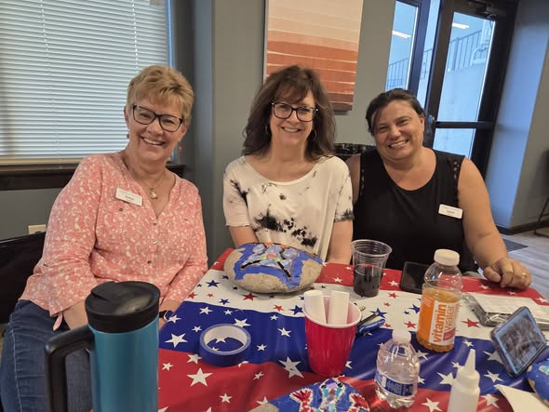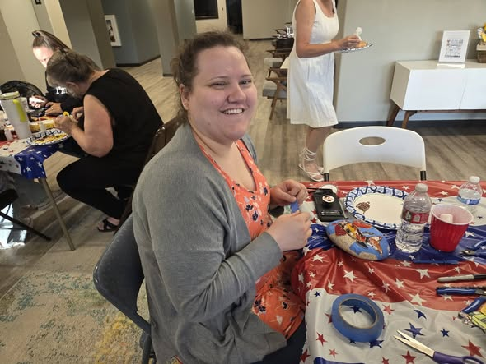
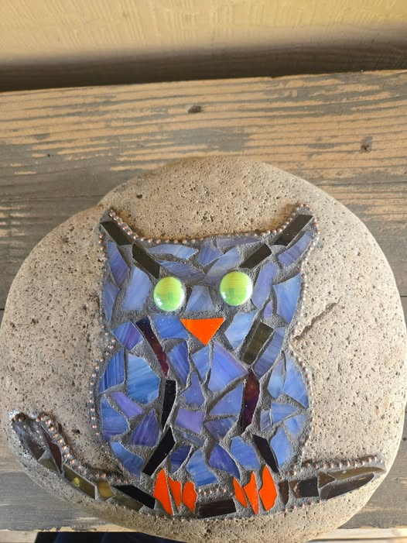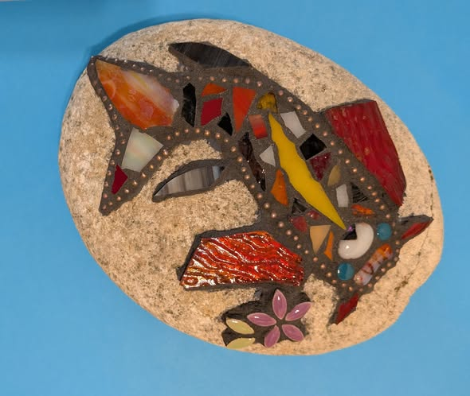
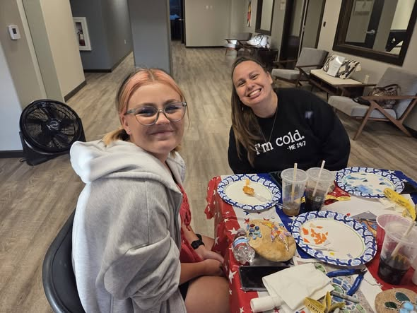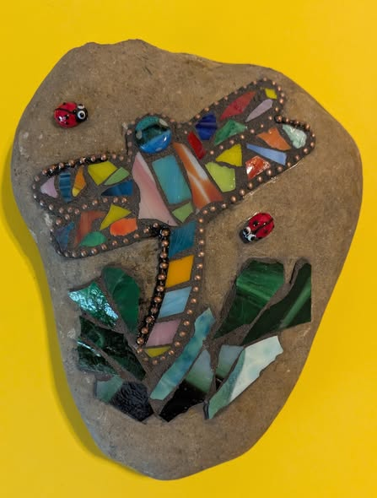

-15-

The New Mexico State Council of Epsilon Sigma Alpha International invites you to attend….
2026 Rocky Mountain Regional Roundup
August 28-30, 2026
NRA WHITTINGTON CENTER
Raton, New Mexico
DIRECTIONS
Located just off Interstate Highway 25, north out of Albuquerque and south out of Raton. At New Mexico Exit 446 turn west onto State Highway 64. The NRA Whittington Center is 4 miles down the road on the right side. Everyone entering the facilities must sign in at the gate.
The building we will be using has a central lobby with three separate wings. Each wing contains five bedrooms, each with two single beds, a kitchenette and two separate bathrooms with showers. There are no bunk beds, and all rooms are on the same floor. Bedding provided. Bring your own towels and toiletries
We have housing for 30 people. Husbands or Guests may stay in the building as long as we do not exceed 30 total. They should register the same as a member. If we exceed 30 we will check into other options.
Send Registration to: Bobbie Massey For information contact Bobbie PO Box 316 575-640-2370 (cell) Las Animas, NM 88020 bjmassey@vtc.net
RESGISTRATION FORM
Registration Deadline: August 7, 2026
Registration: $125.00 per person, $130.00 late. Includes 5 meals and 2 nights lodging.
Name: State:
Address:
Phone Number: Email:
Special Dietary Needs:

Just for a Laugh

At The Zoo

A man was delivering penguins to the zoo when his van broke down on the highway. A man stopped to see if he could be of assistance.
“Oh, I’m in some real trouble here”, said the first man. “I’ve got to take these penguins to the zoo today, and now I’m not sure I’ll get there in time.” The second man volunteered to put the penguins in the back of his car and take them to the zoo.
The first man gratefully accepted his offer and promised to get to the zoo as soon as possible.
A little later, the man was on the road again and went immediately to the zoo. When he got there, he did not see the helpful man or any of the penguins.
In a panic, he drove back into town. Just as he was wondering what to do next, he saw the “volunteer” walking across the street with the penguins waddling along behind him.
The first man ran up to him and said, “What are you doing here? I thought you were going to take the penguins to the zoo!” and the volunteer replied, “I did. We had such a good time, we decided to come into town for ice cream!”

Cracking Under the Pressure

Benjamin Fragale, 23, of Palm Harbor, Florida was arrested for felony criminal mischief on May 24, after vandalizing a local marquee sign known for its puns, The Smoking Gun reported. According to the police report, Fragale used bricks and branches to "smash the sign, damaging the letters, message board and interior lights." The sign belongs to a local chiropractic office and memorable phrases include: "We never crack under pressure," "It's easier to throw out your back than your mother-in-law," "We won't stop until everyone is cracked up," and "Our Easter adjustments are eggsellent." The message that made Fragale crack? "Licensed Crack Dealer." The arrest report indicates that Fragale thought the statement was illegal, but court records do not corroborate the claim. Fragale remains detained while he awaits a court hearing.



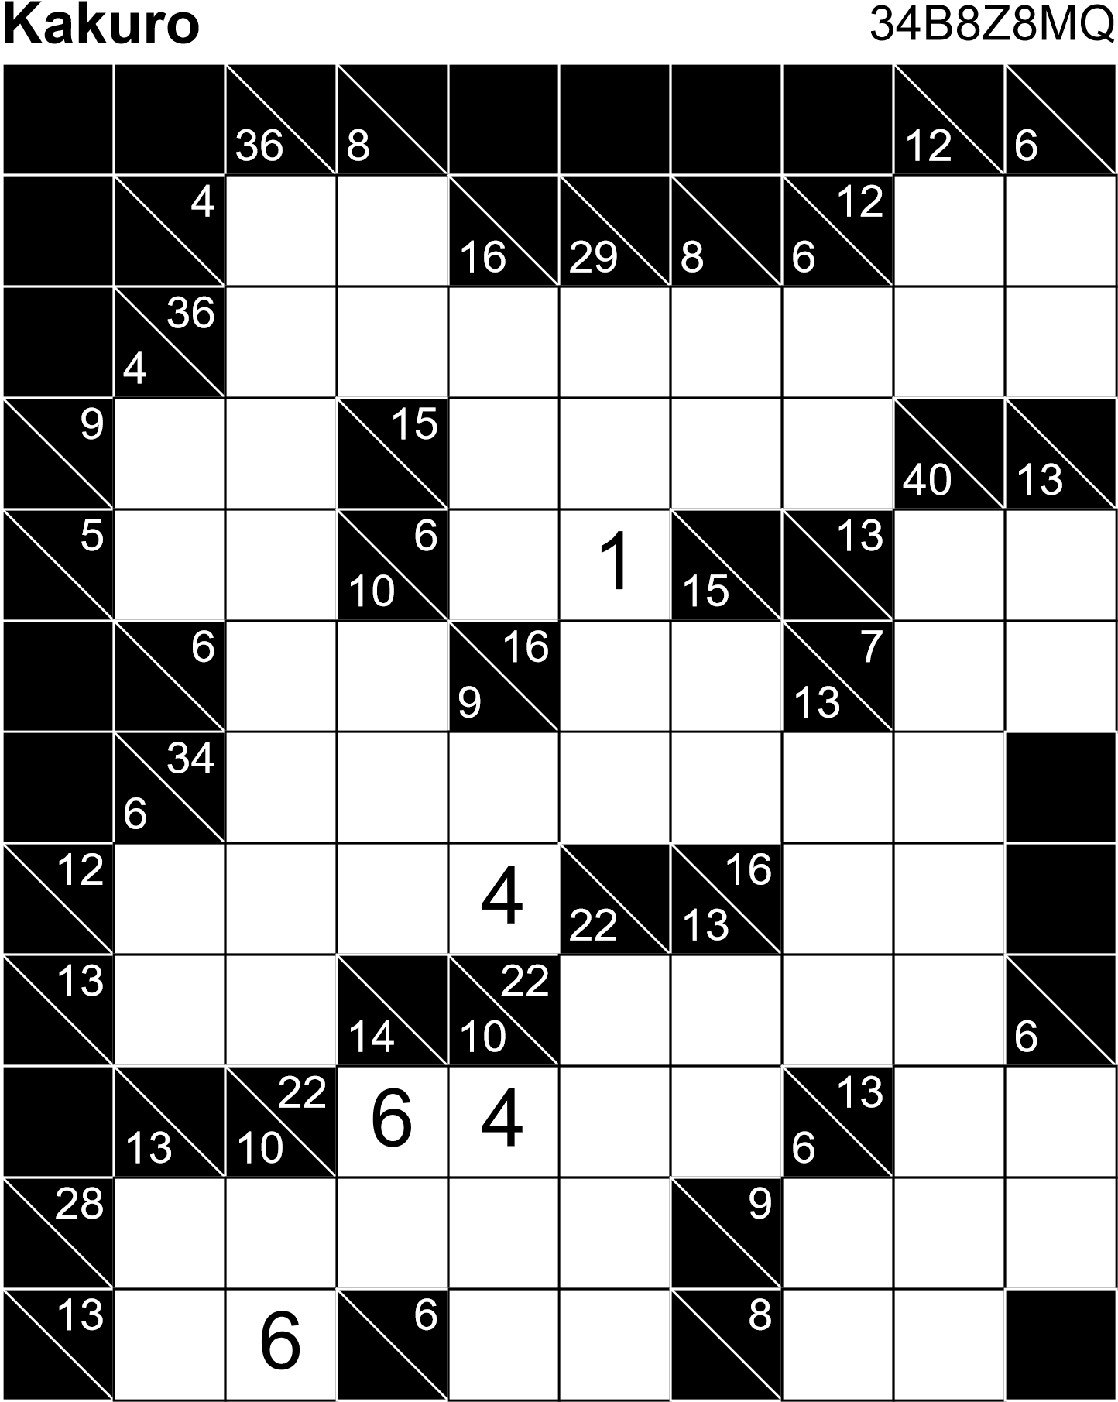



When is the Summer Solstice?
The June solstice occurs on Sunday, June 21, at 4:24 A.M. EDT.
This solstice marks the official beginning of summer in the Northern Hemisphere, occurring when Earth arrives at the point in its orbit where the North Pole is at its maximum tilt (about 23.5 degrees) toward the Sun, resulting in the longest day and shortest night of the calendar year. (By longest “day,” we mean the longest period of sunlight hours.) On the day of the June solstice, the Northern Hemisphere receives sunlight at the most direct angle of the year.

