
ESA Colorado  Golden Lamp |  | February 2026| Volume 80 | Issue 9
ESA Friends
In
Perfect Harmony

Lori Havelick-Anderson

Colorado State President 2025-2026

Editor’s Corner  By Karen Addison  I always look forward to Winter Solstice every year. It lifts my mood knowing that the days will begin getting longer. I take my son to work at 6 am, so I get to see the sun rise earlier each morning as we move toward Spring. I do love the sun!  I am looking forward to seeing everyone at the Spring Fling in Lakewood! I wanted to share that when I called in late January to reserve a room, the Hampton Hotel did not have any more rooms available. I was able to rent a room with two queens at Fairfield Inn & Suites for a better price than offered at Hampton. There are a lot of good hotels in the area.  If it’s been a while since you have attended a convention, plan on attending one! We have made a few changes, and I find that we have a lot more fun. I hope to see you soon! |  | WHAT’S INSIDE
PAGE 2-3
President’s Message

PAGES 4-11
Officer’s Pages

PAGES 12-15
Convention info

PAGES 16-24
Chapter News

PAGES 25-27
Fun Pages

President’s Message

Hi All,

I hope everyone had fun over the Holidays. It has been a fast and furious month of January for me. I have been working on the Registration Forms for the Spring Fling Meeting and for the April Convention Meeting with the two Host Chapters - Kappa Iota and Sigma Rho lining things out. They are going to be wonderful meetings.

Just an FYI. I was notified by an email from Mackiegan that some of the staff at the ESA MC (Headquarters) may be joining us for the events in March and in April. They told me that they would like to come and attend. I will know more in the future of who will be coming. Would like to have good attendance at both meetings if you are able.
Spring Fling March 13th and 14th - Flyers are out on our Website. Please register soon. The Spring Fling meeting is all set with Kappa Iota hosting. We are hoping that people will attend since the meeting is in Lakewood, Colo. For the first time, Zoom will be offered for this meeting. Price for
Zoom attendance is on the registration form and needs to be sent in by the deadline. The zoom price was designated in our ESA Colo general budget from the zoom meeting committee. Each person attending by zoom will need to be registered. If there is a group attending, everyone should register individually.

We are looking forward to attending the Friday activities and the Saturday meeting. Friday afternoon, we will be making care packages for our Veterans. Most items for Operation Gratitude can be bought at the Family Dollar Store. Including the puzzle books. Feel free to pick and choose but we do need to fill all 10 boxes. (See the list on the following page)

ESA State Convention will be early this year because of scheduling issues. It will be April 24th and 25th in Loveland The flyer and registration are on the Website. Please Register for this Convention soon. Sigma Rho will be putting on a fabulous Convention. Sigma Rho has booked the church for a reasonable price. All activities on Friday will be at the Hotel. The memorial service will be on Saturday at the church as well as the meeting. The church is called Casa Sagrada in Loveland. Inside of the Church it is made into a venue where they hold weddings, retreats and celebrations. There is a front door to the left that is handicapped accessible. The church will be two blocks from the Hotel. People say that this event venue offers a beautiful and versatile space with stunning, stained glass, original woodwork, and a warm, inviting, and peaceful atmosphere. The landscape outside is beautiful.

Have a great February and a great Valentine’s Day!

Thank you,
Lori Anderson Havelick
2025-2026 CSC President

Operation Gratitude Project
President Lori’s Special Veteran’s Project

Instead of serving food at the Veterans Hospital, I have decided to send Care Packages for Operation
Gratitude. So, for our activity at the ESA Spring Fling Friday afternoon activity, I am asking everyone to bring various items to fill the boxes.

Please have all items to the Church by 4:00 PM. Here is a list of suggested items needed to fill boxes:

Personal Care items –lip balm, sunscreen, lotion, shampoo, body wash, deodorant, dental hygiene items
OTC Medicines - Advil/Tylenol packets, cough drops, Tums, vitamins
Small sewing kits, nail clippers, combs
Individual snack items - Salty/sweet snacks, protein snacks, beef jerky, Slim Jims, trail mix, nuts, peanuts, dried fruits, hard candies, sugar free gum, tea bags, instant coffee packets
Magazines, crosswords, sudoku, puzzle books

Funds raised at the Friday evening Bunco game will be donated to cover shipping costs of these packages.

Thank you in advance for your contributions,

Lori Anderson-Havelick
CSC State President 2025 – 2026

-3-
President Elect

THE COLO STATE COUNCIL NEEDS YOUR HELP!!
February 15 is upon us and we need a slate of officers!

Finding future leaders is not the responsibility of one person or even a committee alone. It is in our Council’s best interest if we ALL take the charge to look for those who will follow us.
Will you join me in this search this coming month?
Please seek out ONE person who would benefit from the sisterhood of council participation. You know how great it is just to know members from other chapters thru the years. They may be reluctant to step up but ask them to ”just try it one time” and encourage to them to attend with you. Doesn’t necessarily need to be from your chapter - anyone!!
Of course, encourage any who are now serving on the Council to continue with your support!
I will keep you advised on what positions have been filled as we go along.

Thank you, dear ones, for your help and support in the past and in the future!!
I love you all so very much!

Committed:
Parliamentarian - Leslie Stevens
Educational Chair - Debbie Spear
ESA for St Jude – Susan Bloss

Hugs,
Nancy
President Elect

-4-
PARLIAMENTARIAN

CSC Bylaw Proposed Changes

1st Change
Under Membership:
Article III section 3 Reads:
Members who participate as individual members are considered Members-at-large (MAL). They shall have all the privileges of membership except that of holding office and voting.

Needs to read:
Members who participate as individual members are considered Members-at-large (MAL). A Member-at-large remains active by paying their individual member dues even though they are not affiliated with a specific Chapter. They are eligible to attend state meetings and may attend Chapter meetings upon the invitation of a Chapter. They shall have all the privileges of membership except that of holding office and voting.
Reason for change: To clarify the description of Member-at-large (MAL).
2nd Change
ARTICLE VIII - DUTIES OF ELECTED OFFICERS
Section 4, Treasurer/Disaster Fund Chair
H. Preform duties of Disaster Fund Chair
1. Inform the membership of the purpose of the Disaster Fund.
2. Encourage donations to the Disaster Fund.
Reason: Need to add as there were no duties listed.

Rita Martin
Parliamentarian
Lamplighter President

-5-

Past President/Awards
Hi everyone. It’s been an odd winter—not too much snow or cold. Hope we get some
moisture to help with our snowpack or Spring Showers to bring us flowers. First request: If you and/or your chapter would be interested in helping with a Convention, please reach out to me. We might as a State work to “pair” chapters who could work together on a Convention. I have a lead for 2027—but it’s not too early to
start for 2028. Wouldn’t it be grand to have Convention lined up for TWO years in a row?
A*W*A*R*D*S
That time of year is coming up and Colorado State Council would like to recognize everyone for their achievements. As we have moved Convention up to April, there is a VERY SHORT turnaround time for getting the awards put together. Please be timely with your submissions, and even early if you can. (This includes years of service for
individuals and chapters.) Also, be aware of the following:
Below is from the December 2025 Manifest Newsletter sent to the State Presidents and others.
Patty Gale, the Recognition Chair, formerly IC Awards Chair said:
“This year at our IC Convention we will be holding our first annual Recognition Luncheon; a change from our Awards Luncheon. It will be similar but with a slightly different approach. At the luncheon we will be honoring your philanthropic accomplishments as well as recognizing events, programs and members.
In the near future, we’ll be sharing nomination forms with you that will include a variety of areas where you can submit nominations for people, events and activities that you are most proud of. The categories will include a fundraising event, an educational program, a fellow member who demonstrates what ESA is all about, and more.”
With the new recognition, there are new forms on the IC website with varying due dates and some have no due date. The old IC forms used for reporting are obsolete, except for Philanthropic.
Easterseals (Due May 15)
2025-2026 Individual Recognition Form
2025-2026 Fundraiser/Event Recognition Form

Educationals: New form (Due June 1)
Hope for Heroes: 2025-2026 State of Hope Recognition Form
2025-2026 Legacy of Hope Recognition Form
2025-2026 Regional Council Recognition Form-coming soon

Membership
Emerging Flame Award* (Due May 1)
Membership Innovation Award*
Membership Magnet Award*
You Had to Be There Award*
*Links will take you to a google form to fill out (you may need to right click on the link and select open in new tab)
News Bulletin Recognition (Due April 30)
2025-2026 News Bulletin Recognition
Philanthropic (Due June 15)
2025-2026 Philanthropic Report Form (same as before, State
Philanthropic Chair completes and sends to IC Philanthropic)
Event Recognition Form
Volunteer of the Year Submission
Social Media (Due March 30)
2025-2026 Social Media Excellence*Link will take you to a google form to fill out to nominate someone.

I did not directly receive this information but am forwarding it to everyone as an FYI (sent from Mary Humphrey; thank you to Mary). As the Awards Chair for CSC, I will try to get further information and have a report for
everyone at Spring Fling on how we will be affected by this change. I think that’s all for now---
Hope to see everyone in March at our Spring Fling.
Susan Bloss, Past President/Awards

Philanthropic

Reminder: Chapter Philanthropic Reports are due by April 1; they may be emailed or mailed.

The current form is on our Colorado website under Yearbook; be sure to complete both pages of the form. The IRS mileage rate is $.70, as listed on the current IC Philanthropic Report form on the ESAMC website.

From Patty Gale, Recognition Chair, formerly Awards Chair: “This year at our IC Convention we will be holding our first annual Recognition Luncheon; a change from our Awards Luncheon. It will be similar, but with a slightly different approach. At the luncheon we will be honoring your philanthropic accomplishments as well as recognizing events, programs and members. You can submit nominations for people, events and activities that you are most proud of. The categories will include a fundraising event, an educational program, a fellow member who demonstrates what ESA is all about, and more.”

IC has developed new recognition forms for all ESA activities: Easterseals, Hope for Heroes,
Membership, News Bulletin, Philanthropic, and Social Media. The new forms are on the ESAMC website under International Council. Under Philanthropic there are two (2) new forms: Event Recognition (no ALSAC events) and Volunteer of the Year Submission. Request each chapter review both forms and submit to the IC Chair.

Another change that’s coming is a new Service Reporting System for hours, mileage, goods
donated, and monetary donations for all ESA members. The system will allow members to log all services through the Member Portal on the ESAMC website. Lori and I have virtual training February 2 that we’ll share at Spring Board.

Mary Humphrey
Philanthropic Chair

-7-

Colorado Web Team

esacolorado.org


February, the month of hearts, flowers, and thoughts of LOVE, LOVE, LOVE!

Speaking of LOVE, we love all the items we have received for posting to our Colorado ESA website. Thank you, thank you, thank YOU! Our website continues to be a source of information as well as the latest/greatest instructions and forms.
In addition, we would LOVE to receive MORE. More items for our Projects page would be fabulous! We know you are doing great fund raisers for our many great projects and would like to share them with all our members. Don’t be shy. We can’t wait to see them.
REMINDER: The Colorado State Council has its own ZOOM account. In addition, councils and chapters are using this account – FREE. The advantage of this account is its unlimited time use as compared to the 40 minutes on the free account. To reserve a date/time just contact Candie Patino.
See you at Spring Board!
The Colorado ESA Web Team,
Bonnie & Candie

ESA for St Jude

I keep waiting to hear from chapters how their various fundraisers have been going for St. Jude. I am sure they have all been successful.

On February 3rd I attended a Zoom meeting about a new Service Reporting System for St. Jude, Easterseals, Hope 4 Heroes, and Philanthropic. This system will allow chapters to log on all hours, mileage, goods donated, and monies donated. At our March meeting there will be a presentation by our Philanthropic chair Mary. She will share this new information.

Adi is the spokesperson for From My Birthday to Yours campaign for 2025-2026. Remember that ESA has pledged to raise $5 million in 4 years. Of course Adi continues to raise money with her various cookie sales. I encourage members or chapters to make donations through this program also.

I just attended the Valentine Tea by the Sea today for St. Jude. Chi Kappa and Pi Sigma did a great job. The food was delicious and had lots of great baskets.

See you in March.
Pam
St. Jude Coordinator

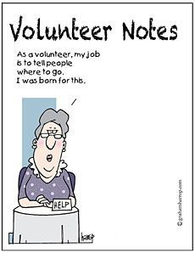

Education Report

See below the email I received this week. It outlines the new procedure for submitting Educational Reports to the IC Education Chair. As far as I can tell, no changes have been made to the traditional way we submit our notebooks to the State Education Chair. I would like to see our state reports move to virtual reporting as well. But for now, we will still be submitting our reports in notebooks.

And so, it is time to submit your Educational Reports to me. I must receive them by April 1. I will be at the Spring Board meeting, so I can accept them at that time. If you will not be at the meeting, contact me so we can make arrangements to get the notebook to me. You can contact me through the ESA Colorado website. All chapters should have the yearbook, with my contact information. Attached is the Educational Form to be included with each individual report. It is available on the Colorado website. Please contact me with any questions.
I am looking forward to seeing your submissions!

Karen Addison
Education Chair

Remember, the email below is for IC submissions only.

Hello State Presidents and Educational Chairs,
I am excited to share that Education Report Forms are now available as Google Forms on the IC webpage. All reports and supporting documents will now be entered and uploaded to Google Forms. This will eliminate the cost of shipping binder(s) to the IC Educational Director and requiring that individual to maintain possession of the binders that would be returned to Chapters and/or States at IC Convention.

To find links on the IC Webpage, log in under the Member Center and click on the International Council Logo. Scroll down to Education and you will see two links: Educational Reports (chapter) and Maie Wells Education (state)
2025-2026 Education Report (Chapter) Instructions: Click on the link. Because the requirement is to have at least six different reports, please note that there are questions #1 - #6 in each section. Insert your answer(s) for each question. When you reach questions about Method of Presentation, you will be able to upload handouts, pictures, and pdfs. After you have answered all questions, you will need to click on the button “Submit” and the form with its attachments will be emailed to the IC Educational Chair.
2025-2026 Maie Wells Education Recognition (State)
Instructions: Insert your answer(s) for each question. When you reach questions about communication and articles, you will be able to upload handouts, pictures, and pdfs. After you have answered all questions, you will click on the button “Submit” and the form with its attachments will be emailed to the IC Educational Chair.
Please remember that entries must be submitted by June 1 or no later than one (1) week immediately following your State Convention if it is held later than the June 1 deadline.
I know that this is new territory for many of you so, if you have any questions, please feel free to reach out to me.
Best,

Susan Garner
IC Educational Director 2025-2026

-10-


COLORADO STATE COUNCIL
CHAPTER EDUCATIONAL REPORT FORM
Chapter Name and Number: _____________________________ State: _______________
City: _______________________________ Meeting/Presentation Date: _______________
Yearly Theme: _____________________________________________________________
Topic of this Program: _______________________________________________________
METHOD OF PRESENTATION: (Check all that apply)
☐ Member's Oral Report (name)
☐ Guest Speaker (who/title)
☐ Visual Aid Program (kind and type)
☐ Field Trip (where)
☐ Reference Listing (book or magazine)
☐ Other (explain - internet, pamphlets, etc.)
SUMMARY: (Briefly summarize the program and attach a more complete narrative or outline stating all major points emphasized so the program can be fully understood.)

COMMENTS BY THE EDUCATIONAL CHAIR: (Value to chapter/community, general comments about the presentation and chapter discussion)

NOTE:
- Prepare for each Educational.
- Place in front of the Educational.

CHAPTER EDUCATIONAL CHAIR: _____________________________________________
DATE: _______________________

SEND TO: Educational Director
ESA Colorado State Council



COME JOIN US!!!!
For the Colorado State Council

SPRING FLING !!!!
MARCH 13TH - 14th
Green Mountain United Methodist Church
12755 W. Cedar Lakewood, CO

$55.00 by March 6th - $60.00 after March 6th

There will be lots of FOOD, lots of ACTIVITIES and LOTS OF FUN!!!!

We’re trying something NEW this year and offering a ZOOM invitation for $25.00 per invitation ( get your Chapters together for ONE, GREAT BIG ZOOM MEETING!!) There is a Registration Form, JUST for the Zoom Meeting. This will be ONLY FOR THE SATURDAY BUSINESS MEETING. NOT Friday’s activities.

President, Lori, has chosen Operation Gratitude as our Philanthropic activity on Friday night. Attached is the List of Items she would like to include in these packages. We will be putting the care packages together at 4:00 PM, so please have these items at the Church by that time.

Also Friday evening, after dinner, we will be having “BUNCO With A Twist AND a Cherry on Top!!” (Flyer attached). Proceeds will go to covering the shipping charges on the Operation Gratitude care packages. Lori is hoping to send out 10 packages, (@ $25 ea) so get your rolling fingers stretched out and come help us with this worthy cause!!!

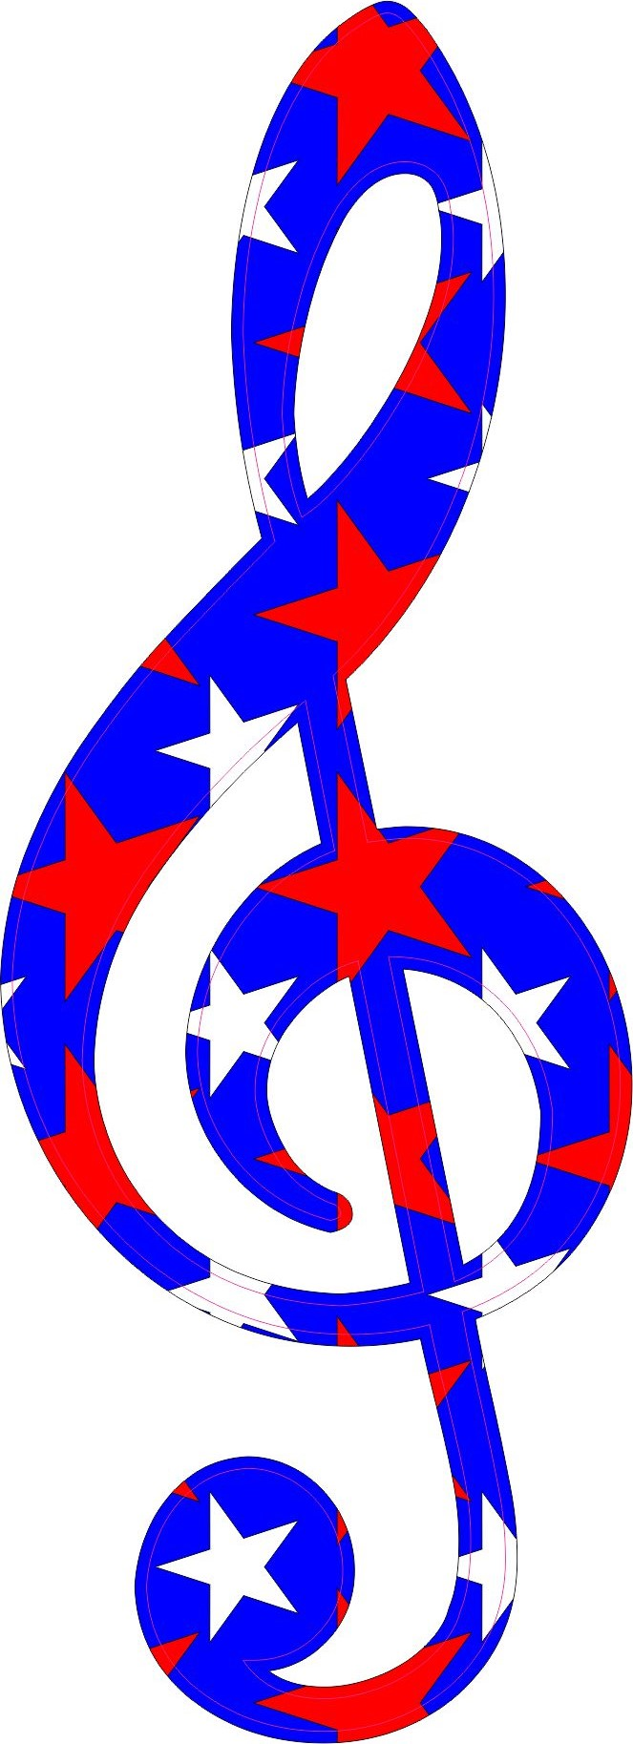
COME ONE, COME ALL AND LET’S MAKE SOME MUSIC!!!!

SPRING FLING REGISTRATION FORMS

March 13th - 14th 2026
Green Mountain United Methodist
12755 W. Cedar Lakewood, CO

$55.00 by March 6th - $60.00 after March 6th

Please make checks out to : Kappa Iota
Mail checks and Registration Form(s) to:
Nancy Cameron 16690 W. 11th Ave.
Golden, CO 80401 303-279-7365

FRIDAY, MARCH 13TH

LAMPLIGHTER’S MEETING: 3 - 4 PM

ALL OTHER ACTIVITIES BEGIN AT 4:00 PM

DINNER @ 6:00 PM

This meeting, we will be providing access to the SATURDAY MEETING ONLY, via ZOOM for a cost of $25.00 PER INVITE! Please include this fee with the Registration Form below for the ZOOM meeting.

ZOOM MEETING REGISTRATION - $25.00 (Sat. ONLY)
Name: ___________________________________________
Chapter: _____________________________#___________
EMAIL: __________________________________________
Phone No: _______________________________________________
_ _ _ _ _ _ _ _ _ _ _ _ _ _ _ _ _ _ _ _ _ _ _ _ _ _ _ _ _ _ _ _ _ _ _ _ _ _

IN PERSON ATTENDANCE REGISTRATION FORM
Name: ___________________________________________
Chapter:________________________#________________
EMAIL: ____________________ Phone No:______________

Please list any allergies or Dietary Requirements: __________________
_______________________________________________________

I will be attending the DINNER OUT on SATURDAY EVENING TBA




And A Cherry On Top!!
With A Twist

KAPPA IOTA PRESENTS

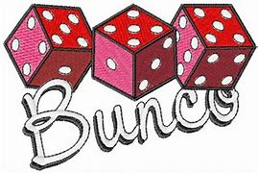

FRIDAY, March 13TH - 7:00 PM
(Green Mountain United Methodist)
$20.00 Entry Fee at the DOOR
TOP PRIZE 20% of PROFITS - CASH
(Most BUNCOS) Prizes for Most Wins & Losses
Profits to pay for postage for Operation Gratitude Postage/H4H


Expect the unexpected


Colorado State Convention

REGISTRATION FORM
2026 Colorado State Convention
Loveland, Colorado
“Friends in Perfect Harmony”

Friday, April 24: Towne Place Suites, 256 E. 2nd Street, Loveland
(parking in parking garage free – use link ESAColorado to reserve room until 3/27/26 for $124.00 +tax per night or call 970-203-1166)
12:30 pm – President’s Executive Luncheon – by invitation only
2:00 pm – Registration Opens
3:00 pm – Lamplighter’s Meeting
4:00 pm – IC Representative’s Party
5:00 pm – Happy Hour: Red, White and Blue Event,
Hope for Heroes presentation by High Plains Honor Flight
6:00 pm – Introductions, Awards, Dinner provided by Sigma Rho

Saturday, April 25: Casa Sagrada, 404 East 3rd Street, Loveland
8:30 am – Registration
9:00 am – Memorial Service
10:00 am – General Assembly
12:00 pm – Lunch
1:00-4:00 pm – Awards
6:00 pm – Installation/Dinner “Denim and Diamonds”

Payment Information: Please make checks payable to Sigma Rho
Mail to: Deanna C. Sloat, 601 West County Road 16, Loveland, CO 80537
Cost: $125.00 by 3/27/26 then $135.00

Name: ___________________________Chapter Name/Number_______________
Phone #: _________________________ Email:______________________________
Food Allergies?________________________________________________________
Check All that apply: ____First Time Attendee ____ Chapter President
____State Officer ____ Lamplighter

Chapter News  Sigma Rho #5014

Chapter News

Sigma Rho #5014
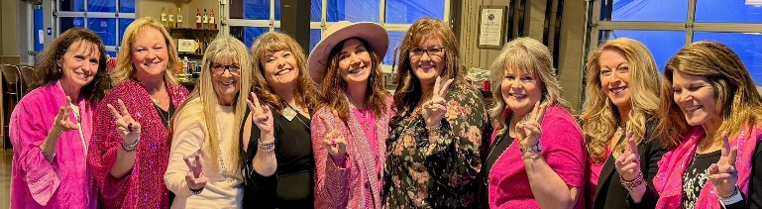

BLINGO was a huge success! Sigma Rho hosted an amazing and FUN evening at our Blingo party (where bling meets bingo)! The prizes were gorgeous Touchstone Jewelry pieces, and what girl doesn’t love a little sparkle?!
We are beyond excited to share the final total… with a generous matching donation from High Country Beverage, we raised over $11,000 for St. Jude’s!
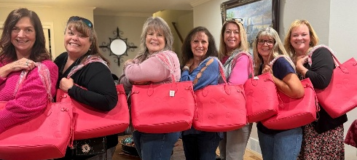
Our auction baskets were beautiful pink bags stuffed with lots of fun goodies.
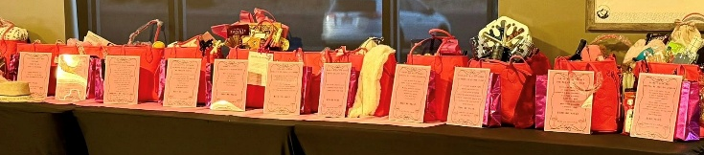

A huge shoutout to Craig, Brian, and Todd, our “Blingo Security.” They helped us out so much, and we’re pretty sure they had a little fun too!

-16-
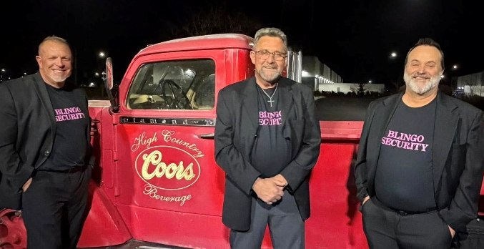
Everyone left with full hearts, big smiles, and knowing they supported an incredible cause. Thank you to everyone who joined us—what a night to remember!

(Photos courtesy of Dixie Daly)

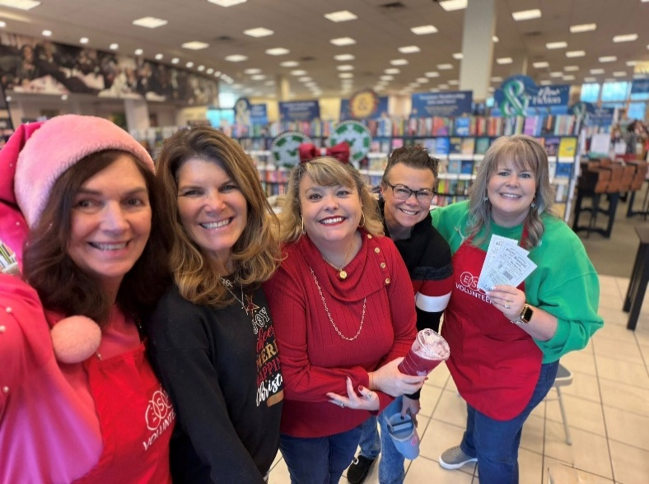
Also, Sigma Rho volunteered at Barnes & Noble for our annual gift-wrapping fundraiser, in support of St. Jude’s. 100% of the cash donations go directly to St. Jude, along with a portion of book sales for the day.
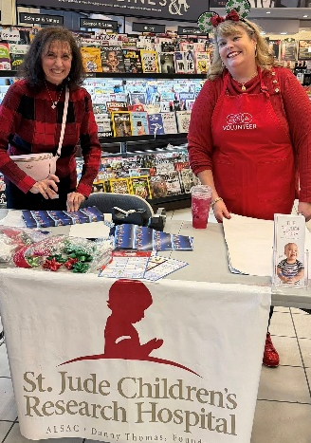
We are so grateful to Barnes & Noble for their continued partnership and generosity. Thank you to everyone who volunteered and supported this cause.
(Photos courtesy of Dixie Daly)

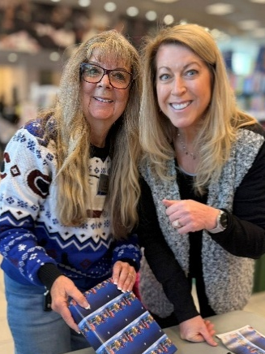
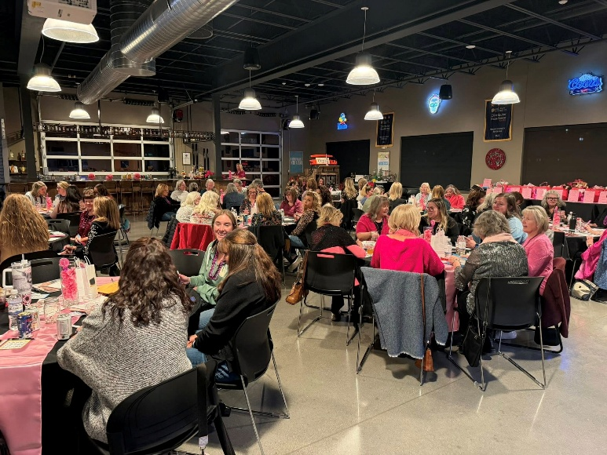

Chapter News Gamma Chi #3668

Gamma Chi News

It is definitely February in Loveland. There are numerous Valentine activities around the Sweetheart City, besides the festivities on the 14th. Hundreds of Valentines hanging on the light posts. One of our pictures shows a Valentine posted with our member Judi and her husband Brad names and years married.

Every December Gamma Chi is involved with many activities for our Veterans. It starts with the handing out of coffee mugs filled with goodies, lap robes, and hats at the Veterans Clinic. Then the next week we fill 180 red stockings for the PAMVET weekly breakfast at the Golden Corral. The second Saturday is a wonderful celebration of Christmas as there is a Santa, and we hand out the stockings, and other surprises. Members also mail Christmas cards to Veterans that are alone. During the early part of the month we finished delivering candy.

We started our annual Amaryllis contest in December instead of after Thanksgiving. Finally in January Tammy Muzzio had her flower open first.

During January’s meeting we installed a new member Ashlin Lorenzo. She works full time so she helps whenever she can. We are delighted she joined Gamma Chi. During the month we continued our volunteering at the Veteran’s Clinic handing out bread, prepping food for the evening meals at the Community Kitchen, helping a couple of nights serving dinners, and volunteering at the Food Bank.. We ended the month with a social at Loveland Tap and Tavern in downtown. Eleven attended and had a great time. They make great Blood Marys.

Happy Valentine’s Day our wonderful Colorado sisters.

Pam McGee

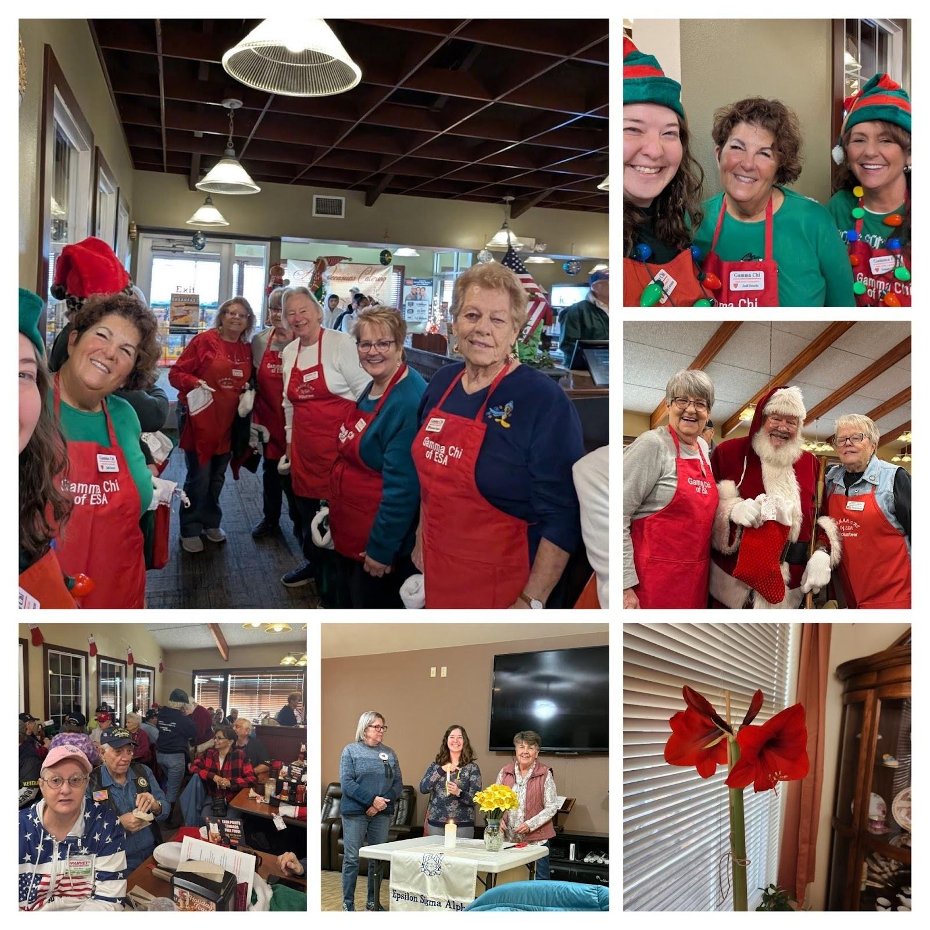

Chapter News  Beta Zeta #3149

Beta Zeta Chapter #3149
Canon City
Carol Dunn, Sue McMillin, Publicity Committee

Beta Zeta gals are always excited this time of year when the Philanthropic Committee distributes the funds we made from our Fall Auction. Incidentally, the auction garnered over $800 for our wonderful St. Jude Children’s Hospital, as well as enough to fund diverse recipients in our community.
Donations will be made to Fremont and Sangre de Cristo Hospice Programs, Senior Services Solutions, which provides medical transportation, and to Meals on Wheels for Cañon City seniors. It is so much fun to donate to the Cañon Literacy Center and Dolly Parton Imagination Library for the kiddos who love to read.
We help CASA (Court Appointed Special Advocates) support families in our area, and the Department of Human Services makes Christmas for teens a special time. The Green Thumb Project and Orchard of Hope help people with mental health and cancer diagnoses.
Our scholarships for high school students, whether they are going into higher education or specialized training programs, have been rewarding over the years. We just received a report from Samantha who received the funding in 2024. She has a plan for a career in social work ending with a doctorate. What a go-getter!
So gratifying to see all our hard work benefiting our community in so many ways.

-20-
Chapter News Zeta Nu #5608
Zeta Nu is off and running in the new year! We have our first fundraiser for 2026. We have it set up for March 12th at Brush Crazy. This is one of our favorite fundraisers and one of our best attended. Brush Crazy is an Art Center, where you can go to do several different craft projects such as paint, ceramics, mosaics, signs, paint glass, etc. The center generously donates 50% of their proceeds to our designated organizations. This year we have chosen St Jude as our project.

Here’s pictures from last years’ fundraiser
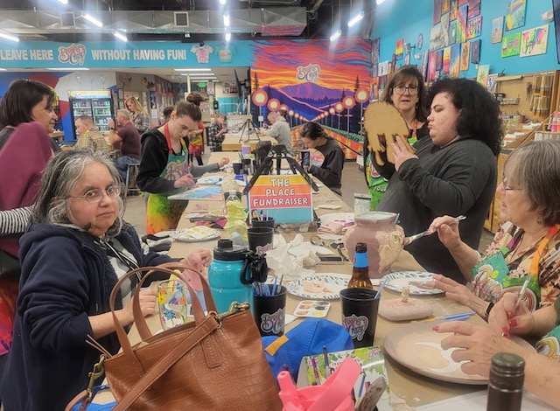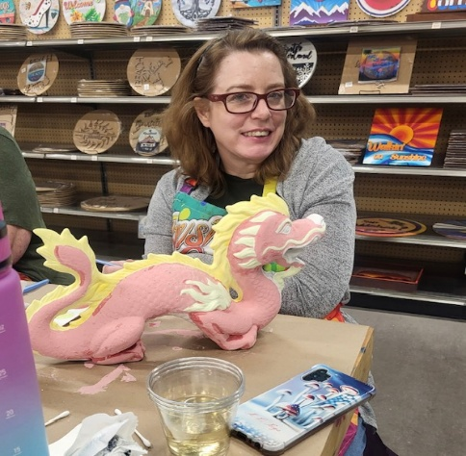

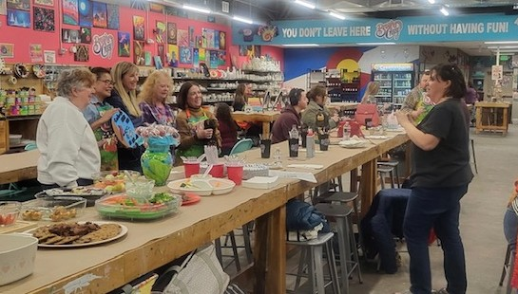

Honor Bell Destinations
Honor Bell Fondation & Zeta Nu Members
This month our meeting was again different but one of the most memorable we’ve ever had. You see, in October, 2025, we conducted our annual fundraiser specifically designated for our Hope for Heroes campaign. This year, significantly influenced not only by outgoing President Susan Bloss’ endorsement of the Honor Bell program but also deeply moved when the Honor Bell presented at the memorial service for the husband of Margaret, a beloved member of our sister chapter in Colorado Springs, we chose our new Pikes Peak Honor Bell Foundation as our recipient.
Not only was the Foundation grateful for our support, they honored US with a meeting presentation (that actually took up our entire February meeting) to not only thank us but to explain their program & honor those of us (& our beloved friends & family members) who have served our country.
So, how does this fit in to our amazing destinations? First, let’s consider the history of the members of the foundation & those honored. All veterans present introduced themselves & their arenas of service. Let’s talk about:
- Southeast Asia
- The Middle East
- The Far East
- The European Theater
- Various United States bases
- Various Colorado bases
Then, they graced us with an official Honor Bell ringing ceremony, allowing those members & their guests who had served to ring the bell. All others were encouraged to honor their loved ones during this event by saying their names & their arenas of service. Those amazing destinations included:
- Iwo Jima
- The Philippines
- Southeast Asia
- Thule, Greenland
- The European Theater
- The Far East
- Various United States bases
- Various Colorado bases
Tears flowed, salutes were offered, neighbors emerged from their homes on this snowy evening to watch. Then, we had a moving presentation about where the Honor Bell travels. While during the week they concentrate on Fort Logan National Cemetery, Pikes Peak National Cemetery, & the Air Force Academy Cemetery, on weekends they travel wherever requested and/or needed to honor any veteran of any service. In fact, their most recent ceremony was in Alamosa, Colorado, a beautiful, picturesque town in the San Luis Valley, Colorado.
The most amazing fact – as of now, there are only two Honor Bells to cover the requests in Colorado. As there are approximately 100 tolls a month at Fort Logan National Cemetery covered by the first Honor Bell, and now approximately 70 Honor Bells tolls a month at Pikes Peak National Cemetery & the Air Force Academy Cemetery (both unspeakable in their beauty & destinations unto themselves), the hope is to expand the program to encompass even more tolling’s to honor more heroes who served, & often perished, in more amazing but hallowed destinations, as well in their beautiful final destinations & hometowns.
Fun fact – our bell contained 12 artifacts donated by veteran families in the region smelted into the bell, including items from the USS Arizona (donated from the family of Donald Stratton) and artifacts from a military K9 unit (handler & K9) who died in the line of duty in the Middle East.
So, what say you? Certainly, if not for the history-changing conflicts, each of these conflict areas would be amazing destinations. Now, should we visit, to not only see how far the destinations have rejuvenated & what their future holds but to honor those who died to preserve their freedom? Should we visit those remote hometowns that reflect the values & charm that instilled their values in our honored heroes? Should we visit those final resting places, either collectively or in solemn gratitude & solitary remembrance, for our neighbors who willingly paid the ultimate price for us? Should we all invite Honor Bell as our Hope for Heroes campaign?
In closing, I guess my personal favorite amazing destination might be Cheryl’s house, where we held our February meeting. You want to know why? Because there we learned about history, family, unity, & sisterhood.
Bibliography –
Presentation by American heroes
Honor Bell pamphlet
www.honorbell.com (seriously, check it out)

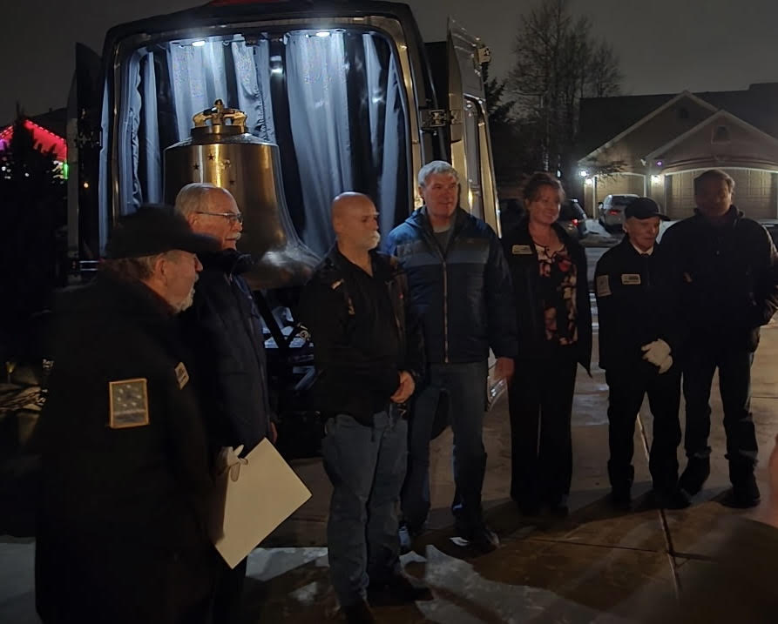

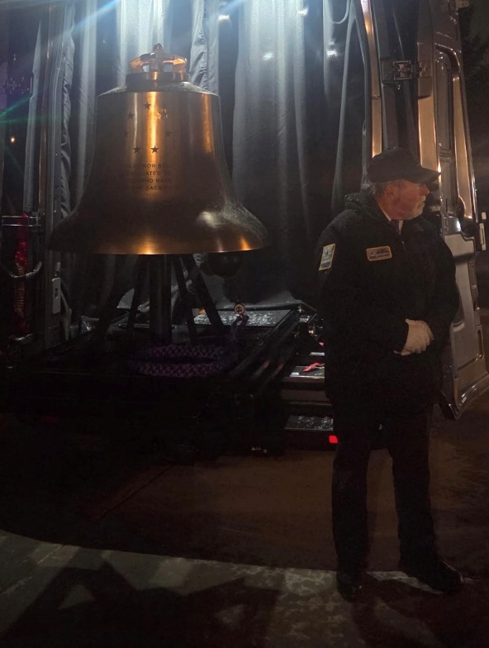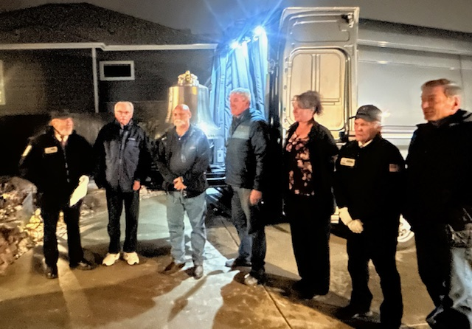

When the Honor Bell Foundation offered to come to our meeting, we invited those who had attended our Bunco Fundraiser to see the bell, as well as any Veterans who would like to see it. It was a very moving evening. By far, our best meeting to date!
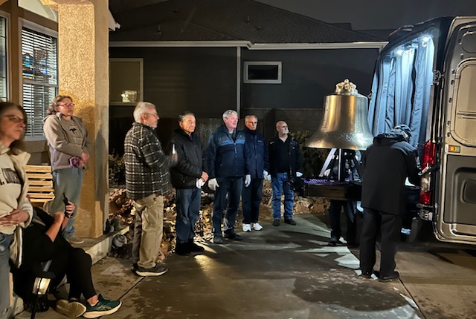

-24-

s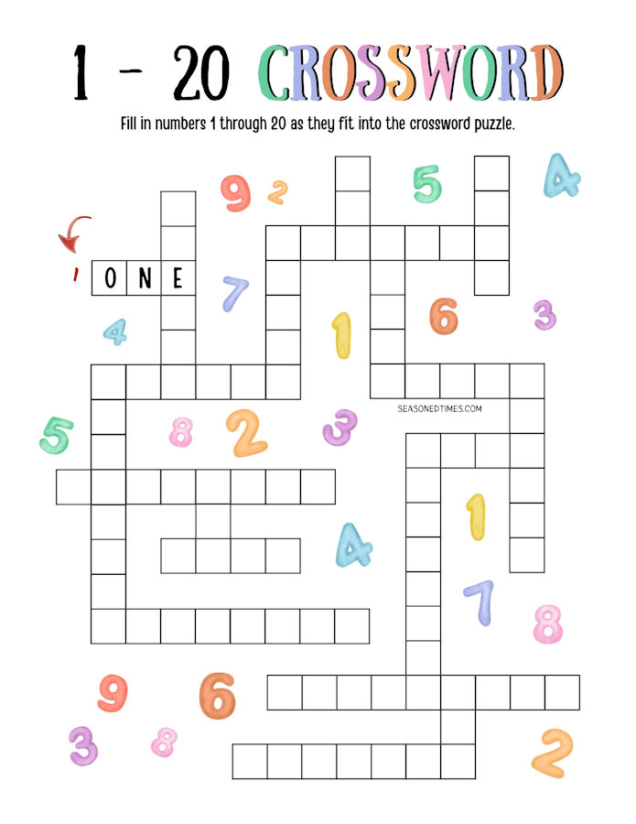

Understanding Gender Differences
A Spanish teacher was explaining to her class that in Spanish, unlike English, nouns are designated as either masculine or feminine.
"House" for instance, is feminine: "la casa."
"Pencil," however, is masculine: "el lapiz."
A student asked, "What gender is 'computer'?"
Instead of giving the answer, the teacher split the class into two groups, male and female, and asked them to decide for themselves whether "computer" should be masculine or feminine.
Each group was asked to give four reasons for its recommendation.
The men's group decided that "computer" should definitely be of the feminine gender ("la computadora"), because:
1. No one but their creator understands their internal logic
2. The native language they use to communicate with other computers is incomprehensible to everyone else
3. Even the smallest mistakes are stored in long term memory for possible later retrieval
4. As soon as you make a commitment to one, you find yourself spending half your paycheck on accessories for it
The women's group, however, concluded that computers should be Masculine ("el computador"), because:
- In order to do anything with them, you have to turn them on
- They have a lot of data but still can't think for themselves
- They are supposed to help you solve problems, but half the time they ARE the problem
- As soon as you commit to one, you realize that if you had waited a little longer, you could have gotten a better model.
The women won.

Very Daring
“The lingerie store where my aunt works was crowded with shoppers selecting Valentine’s Day gifts for their wives. A young businessman came to the register with a lacy black negligee. My aunt noticed that the next customer, an elderly farmer, was holding a long flannel nightgown and kept glancing at the younger man’s sexier choice. When it was his turn, the farmer placed the nightgown on the counter. ‘Would you have anything in black flannel?’ he asked.” — Reader’s Digest


Happy Valentines Day! Happy St Patrick’s Day!

Just one more, I promise…..
An Irishman had been drinking at a pub all night. The bartender finally said that the bar was closing. So, the Irishman stood up to leave and fell flat on his face. He tried to stand one more time, same result. He figured he’d crawl outside and get some fresh air and maybe that will sober him up.
Once outside he stood up and fell flat on his face. So, he decided to crawl the 4 blocks to his home. When he arrived at the door he stood up and again fell flat on his face. He crawled through the door and into his bedroom. When he reached his bed, he tried one more time to stand up. This time he managed to pull himself upright, but he quickly fell right into bed and is sound asleep as soon as his head hit the pillow. He was awakened the next morning to his wife standing over him, shouting, "So, you've been out drinking again!!"
"What makes you say that?" he asked, putting on an innocent look.
"The pub called. You left your wheelchair there again."

