ESA Colorado April 2026 | Volume 80 | Issue 10
Golden Lamp

Lori Havelick Anderson 
Colorado State President 2025-2026
ESA Friends
In
Perfect Harmony

Editor’s Corner
By Karen Addison

Happy Spring! I celebrated Easter yesterday with family. I always What’s Inside
look forward to our ‘family days’- those special times when we can
be together. I’m proud to have raised my children to be dedicated, President’s Message
independent adults who are also compassionate and guided by strong Page 2
values. It is always a joy to spend time with them.
President Elect
It is time to clean out my flower beds and vegetable garden to get Page 4
ready for the coming season. I got a new garden table at Costco for
my deck, so I’m excited to see what I can grow there. I also have a Officer Reports
landscape project that I hope to finally accomplish. Pages 5-11

Every chapter in ESA works on various projects throughout the year. Chapter Reports
As well as our international and state endeavors, many chapters sup- Pages 12-17
port local organizations. In coming issues, I’d love to highlight some
of these projects. I always love to hear about where they are Just for Fun
dedicating their time. Page 20
Message from the President
Hi All,

We had a very successful Spring Fling meeting in March and the weather turned out
great, yet again. It was held on March 12th and 13th Fri evening and Sat at Lakewood
United Methodist Church in Lakewood, Colo. Thank goodness, because we had quite a lot of
snow the weekend before and the roads were not very good. We had an attendance of 32 with
one member on Zoom for a total of 33. I wish that we could have had a bigger crowd since it
was in Denver. But I understand that things get in the way. If you missed it, it was Great Fun!!
Thank you so much to Kappa Iota - Nancy and Leslie for hosting. Food was catered for Fri
evening and Sat lunch and it was delicious. The fun started on Friday at 3:00 pm with the Lamplighter meeting at 4:00pm. Our afternoon activity involved filling 12 boxes for Operation Gratitude. Our Colo ESA’ers showed up with tons of items that were requested
for the project. Everyone came together for this project. I was overwhelmed. It was so
great to see everyone filling up the boxes with huge smiles on their faces.
After dinner, we played Bunco to raise the funds for the postage for the veteran boxes. Postage for the boxes is now at $31.50 for that specific box. We raised enough to cover all the boxes!! Thank you Zeta Tau from Colo Springs for your donation of $25.00. Yay!! Yay!!
You will be able to see from Nancy’s article how much we raised. Everyone had a great time, lots of conversation, fun and laughter. I don’t know about everyone else, but I enjoyed listening to all the conversations and visiting. It reminded me of my childhood at home when we had people over to play cards, board games, Canasta and even poker. We had a great time visiting with friends. It reminds me of the saying, “Our laughter is the best harmony.”
ESA for St Jude, Hope For Heroes and Easterseals Chairs had great baskets for the basket giveaway drawings.
Mary Humphrey, our Philanthropic Chair, gave a report on the new ESA Service
Reporting System. Please look on the ESA Website for more info.
After lunch, Karen Addison our Educational Director/Golden Lamp Editor gave a short
workshop on Cybersecurity and AI Technology. A great question and answer session was followed by the report.
After the meeting on Saturday night, several members went out to the El Jimador restaurant
close to the Church and the Hotel. Great Food! It was a good ending to a great event.

We hope to see many of you at the April Convention. Sigma Rho, our host, is planning an awesome State Convention in Loveland! We are excited to see all of you there. This will be a fun weekend!!
A reminder to look at the ESA Website and Calendar to see what is coming up, including the IC Convention.

Thank you,
Lori Anderson Havelick
Colo State Council President
-2-
Spring Board Friday Night Bunco

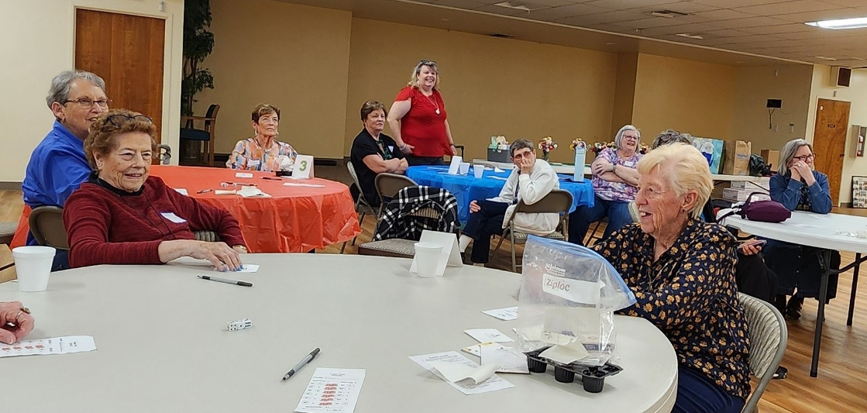

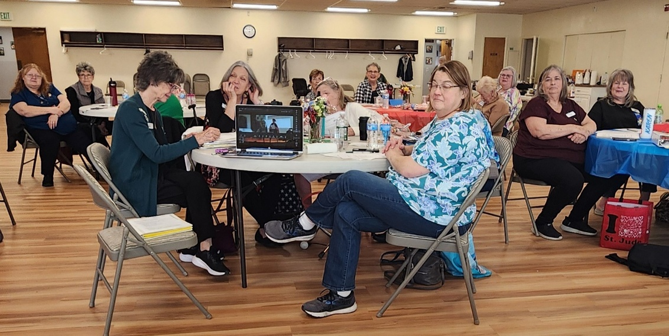

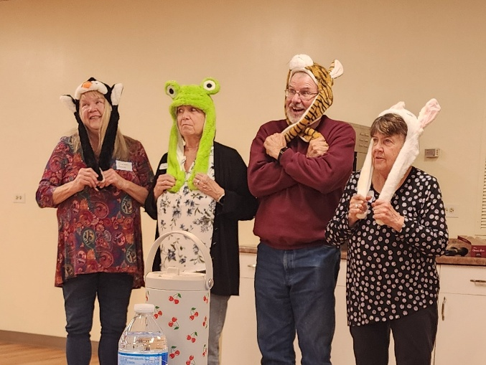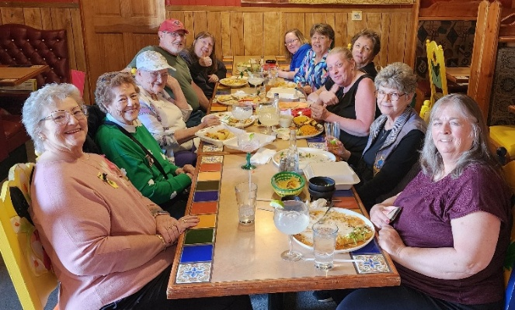

ESA COLORADO STATE COUNCIL
2026-2027 CANDIDATES FOR OFFICE

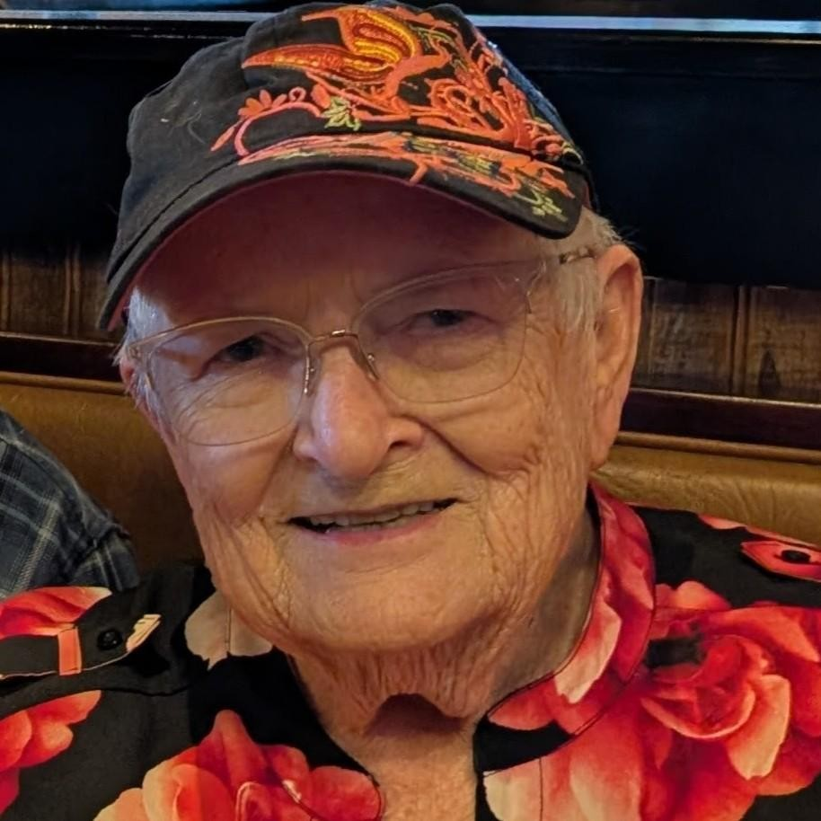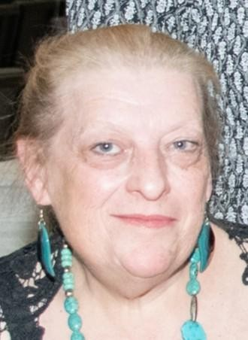

PRESIDENT PARLIAMENTARIAN
Nancy Cameron Leslie Stevens
Kappa Iota #5442 Kappa Iota#5442



PRESIDENT ELECT RECORDING SECRETARY

TREASURER

NOMINATIONS TAKEN UNTIL SATURDAY

APRIL 25,2026

CONTACT NANCY CAMERON
303.263.4673
ncnoremac@aol.com

Philanthropic Chair

Thank you everyone that submitted your Chapter State Philanthropic Report. It’s amazing and rewarding to see the “good works” everyone does in their local community. Hats off to you for your tireless service.

Reminder for next year: When reporting your fund-raising projects under Chapter Projects, only report the hours, donated monies that actually went to support the fund raiser, donated goods, and miles. Report the proceeds under donated monies for the organization(s) the fund raiser supported. Otherwise, it appears that the proceeds were donated back to the fundraiser. Also, if you report the proceeds under the fundraiser and again under a project your chapter supports, the donated monies are doubled.

If you have any questions, please contact me.
Mary Humphrey, Philanthropic Chair
esamarykh@gmail.com



-5-
ESA Foundation
Please remind your chapters that once again Colorado State Council will provide an item to be auctioned off at the International Council Convention held in Norfolk, Virginia. Please bring any gift cards you would like to donate to this auction to the Colorado State Convention in April. Please give your cards to Nancy Cameron. Rita Martin has donated a “cute” purse for the gift cards.
In January, the Board elected this year’s officers: Rosalie Griffith, Chairman; Tammy Akines, Vice Chair; Jennifer Sparkman, Secretary; and Gordon Leong, Treasurer.
The Annual Board Meeting in February marked the official transition of several leadership roles. They extend their sincere appreciation to outgoing Director Kim Mandrell, who has completed her second three-year term. ESAF also celebrates continuity and growth as Kathy Loyd returns to the Board, and Brenda Schaffer joins as a new Director.
DID YOU KNOW?
ESA Foundation Grants Program
Professional Development & Vocational Support
Career Enhancement Grants: These grants support individuals seeking to strengthen their professional skills through additional education or training.
Eligible Uses:
- Registration fees for workshops, seminars, or training programs
- Required study materials.
Not Covered: Travel expenses or Hotel accommodations
Review Cycle: Applications reviewed quarterly
Funding: Maximum request is $2,000. However, smaller requests are fully eligible.
Vocational Training Grants: These grants assist individuals pursuing new career pathways or enhancing skills in their current field.
Eligible Uses:
- Trade certifications and apprenticeships
- Training programs supporting veterans re-entering the workforce.
- Fine arts programs that benefit returning military personnel
Not Covered: For college tuition, college textbooks, college debt repayment
Review Cycle: Applications reviewed every six months.
Funding: Maximum request is $2,000
Application Information: Apply online at: https://www.epsilonsigmaalpha.org/scholarships-and-grants/grants
For questions or additional details, contact: rosalie.griffith2@aol.com
ESA Foundation Grants Program Professional Development & Vocational Support Career
Enhancement Grants: These grants support individuals seeking to strengthen their professional skills through additional education or training.
Eligible Uses: Registration fees for workshops, seminars, or training programs
- Required study materials.
Not Covered:
- Travel expenses
- Hotel accommodations Review Cycle
- Applications reviewed quarterly Funding.
- Maximum request: $2,000
- Smaller requests are fully eligible.
Vocational Training Grants: These grants assist individuals pursuing new career pathways or enhancing skills in their current field.
Eligible Uses:
- Trade certifications and apprenticeships
- Training programs supporting veterans re-entering the workforce.
- Fine arts programs that benefit returning military personnel Not covered
- Not available for college tuition
- Not available for college textbooks
- Not available for college debt repayment Review Cycle
- Applications reviewed every six months Funding.
- Maximum request: $2,000
Application Information Apply online at: https://www.epsilonsigmaalpha.org/scholarships-and-grants/grants For questions or additional details, contact: rosalie.griffith2@aol.com
~ Sandy Alexander
Past President/Awards
Well, another ESA Year is drawing to a close and soon we will begin the 2026-2027 Year.
It’s been a VERY REWARDING few years on the Colorado State Council Board and I’ve learned a lot, shared laughs and made new friends along the way.
All the Colorado Awards/Recognition Forms/Reports were due on April 1 so hopefully everyone got their information in to the right place on time. I am accepting years of service recognition for members, chapters and councils until April 10th. April Convention in Loveland “A RED, WHITE AND BLUE PARTY” is coming right up April 24 & 25TH in Loveland, CO when we will be able to recognize many deserving members who have done amazing work in the past year.
As we look forward to 26-27, I would like each of you to look within and see if you truly want ESA to continue in Colorado. We are at a crossroads as to how Colorado ESA proceeds. As of April 1 we are lacking candidates for the majority of our elected offices. IF YOU CARE ABOUT COLORADO ESA AND WANT TO SHAPE THE WAY WE PROCEED, YOU AND YOUR VOICE NEED TO BE HEARD. Contact anyone on the current Colorado Board with any comments on how YOU see Colorado ESA in the future.
If ESA Colorado is active next year, we do have a Colorado Convention 2027 in the planning stages in Grand Junction. You might think of hoping on the train in Denver and heading to Grand Junction.
Happy Spring to you all --and keep on HOOTIN’ in Harmony!
Susan Bloss
Past President/Awards Chair 2025-2026

St. Jude Report

At each Fall and Spring meeting money is raised to send our incoming President, which will be Nancy, to the St. Jude Challenge at IC. At the Spring Fling I was able to present Nancy with $200 cash to enter this Annual Challenge.

I will combine the money I have left from the Spring Fling with what I collect from the basket I will have at the State Convention. That amount will be sent to headquarters for St. Jude Children’s Research Hospital.

A big thank you to those chapters that sent me their St. Jude report for state awards. I did check with Mary, our Philanthropic Chairman, as I know some chapters did projects for St. Jude, but never sent me a report.

Remember to support “From My Birthday to Yours” with chapter birthdays, family members birthday’s or your own birthday.

See you in a few weeks.
Pam McGee



It’s National Walking Day, and registration for the St. Jude Walk - Denver is officially open!
Lead the way again for St. Jude kids — Join us on Sept. 19th, 2026!
-9-
Educational Director
Safeguard Your Online Information
What is the most important tool for protecting your online information? Your passwords. Yes, passwords, plural, because you should not be using the same password for all of your online accounts. Once a hacker gets your password, they immediately access all known accounts, from Facebook, to your financial accounts and even your medical accounts. Before you have a chance to react, they will have access to all of your information.

When creating passwords, just remember, longer is best. It isn’t necessary to use a bunch of weird symbols and letters. It’s too hard to remember those. Using a string of random words is best. Just make sure it is at least 12 characters long. For example, “Lane$poppyhouse12” is random, hard to decipher, and easy to remember. But don’t rely on your memory for various passwords. A password manager is invaluable for keeping everything straight.

It is also important to use MFA- Multi Factor Authentication. MFA is an authentication method that requires the user to provide two or more verification factors to gain access to accounts, websites, etc. A texted pin number, facial verification and fingerprints are examples of verification. Your password is a lock, but MFA is the deadbolt.

These practical steps are important to safeguard sensitive information.
- Use strong, unique passwords. Never reuse passwords. Aim for 12+ characters. Use a password manager.
- Turn on MFA. Even if a hacker gets your password, they still need the second factor to get in. This one step blocks most automated attacks.
- Think before you click. STOP. Pause. If it’s unexpected, take a moment to make sure it is safe. Slowing down is your superpower.
- Keep Software updated. Delaying updates leaves vulnerable software. Enable automatic updates so your software is as safe as possible.
- Protect your devices. Use antivirus/malware protection. Avoid public
Wi-Fi. Never input personal information on public Wi-Fi.
- Monitor your accounts. Check bank statements. Check on your autopay accounts occasionally. Review credit reports. Watch for unexpected password reset emails.
Here’s an interesting chart that shows how quickly your password can be cracked.

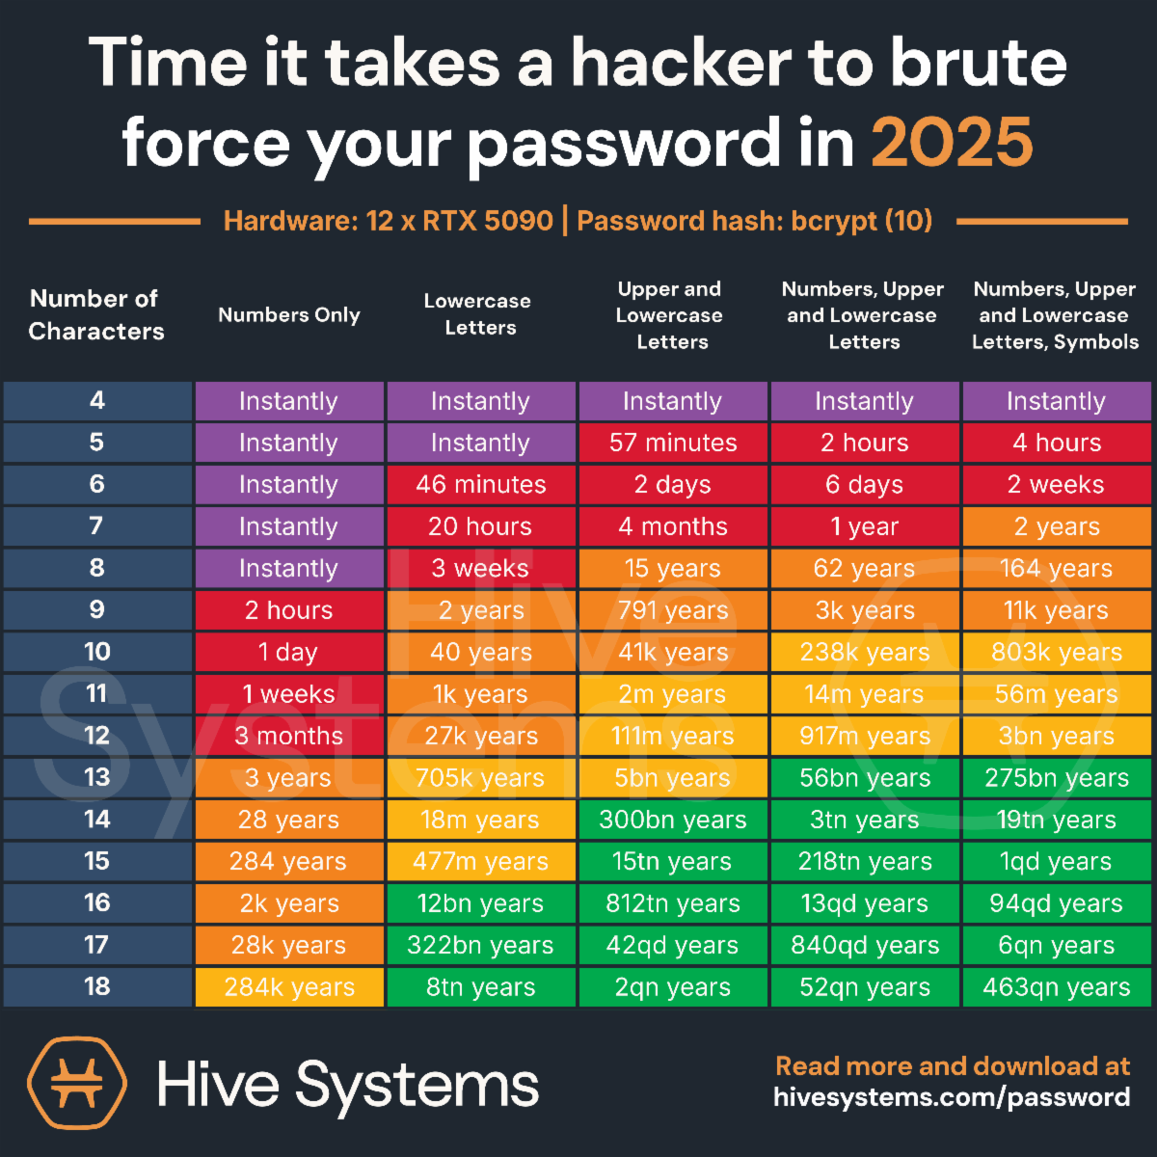

So, remember, the best passwords are long. Aim for 12+ characters. Use random words, symbols and numbers. Do not use your dog’s name or your address. Use a password manager.

Karen Addison
Educational Director

-11-
Chapter News Gamma Chi #3668
By the time you read this Easter is over and we are getting ready for the State Convention.
At our February meeting our educational program was from Steve Olander who owns a farm in Loveland. It’s been in his family for 100 years. He still raises cattle and the meat he sells is excellent. He spoke about how farming has changed from a conventional farm to learning to grow cover crops and use safe insecticides. Another part of the farm sells Root Shoots Whiskey, which won a gold award in England last year. His son runs this part of the business. It was a very interesting program.
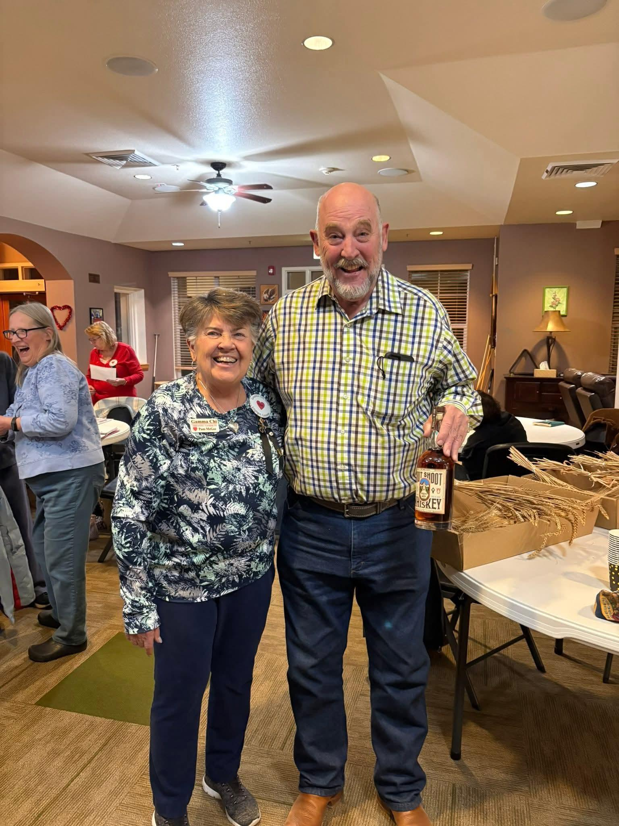
Also, during the month, a couple of us attended the Pi Sigma and Chi Kappa Valentine Tea. They out did themselves with beautiful ocean decorations and food.
. Later in the month our chapter helped greet people at the movie Six Triple 8 that was sponsored by the Loveland Veterans Memorial group. They are getting ready to break ground for the memorial this month. March started with our annual Bunco Party with a St. Patrick’s theme. We ended up with 112 attending, which was the largest attendance so far. It was a fun day, and it
helped our local Community Kitchen. Our program for the month was from Habitat for Humanity. It is always so important to refresh ourselves with the many community programs we have in Loveland. A couple of us volunteered at Project Prom. They have dresses, accessories, men’s shirts, pants, and accessories. Everything is free.

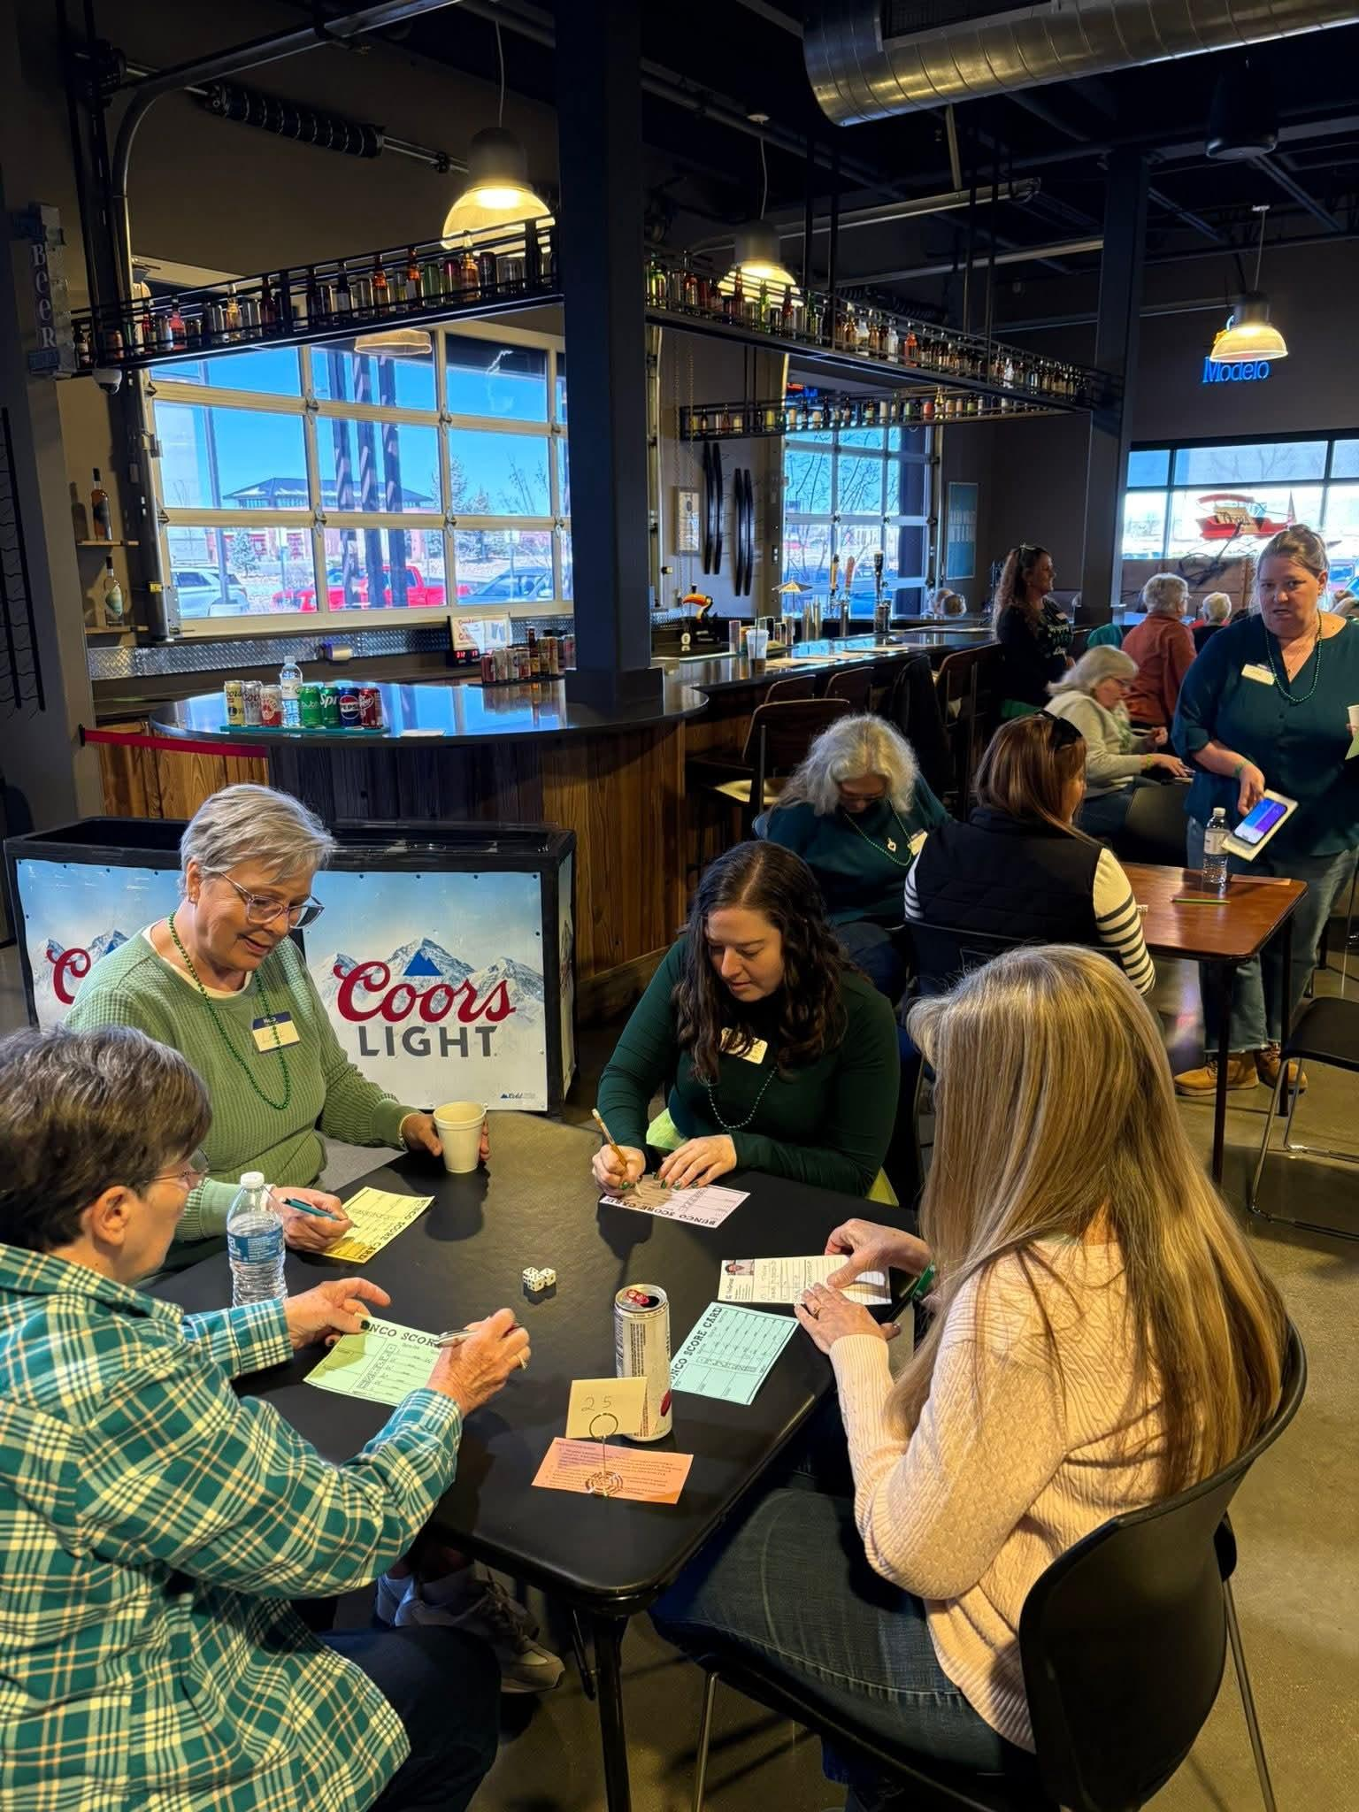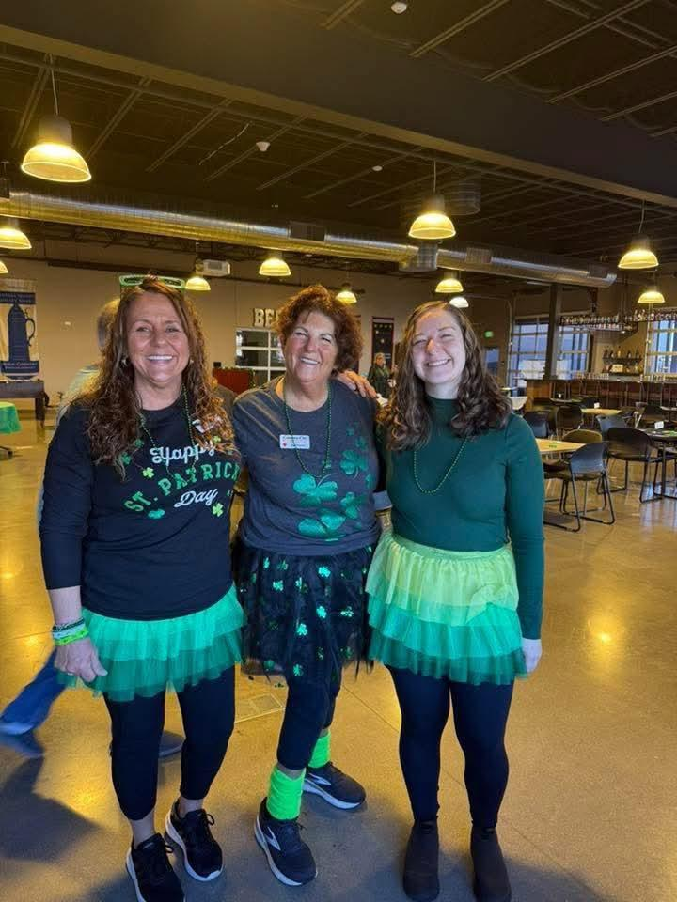
We ended March by celebrating Phyllis’s 80th birthday at Loveland Tap and Tavern. We had a great time and she was surprised.
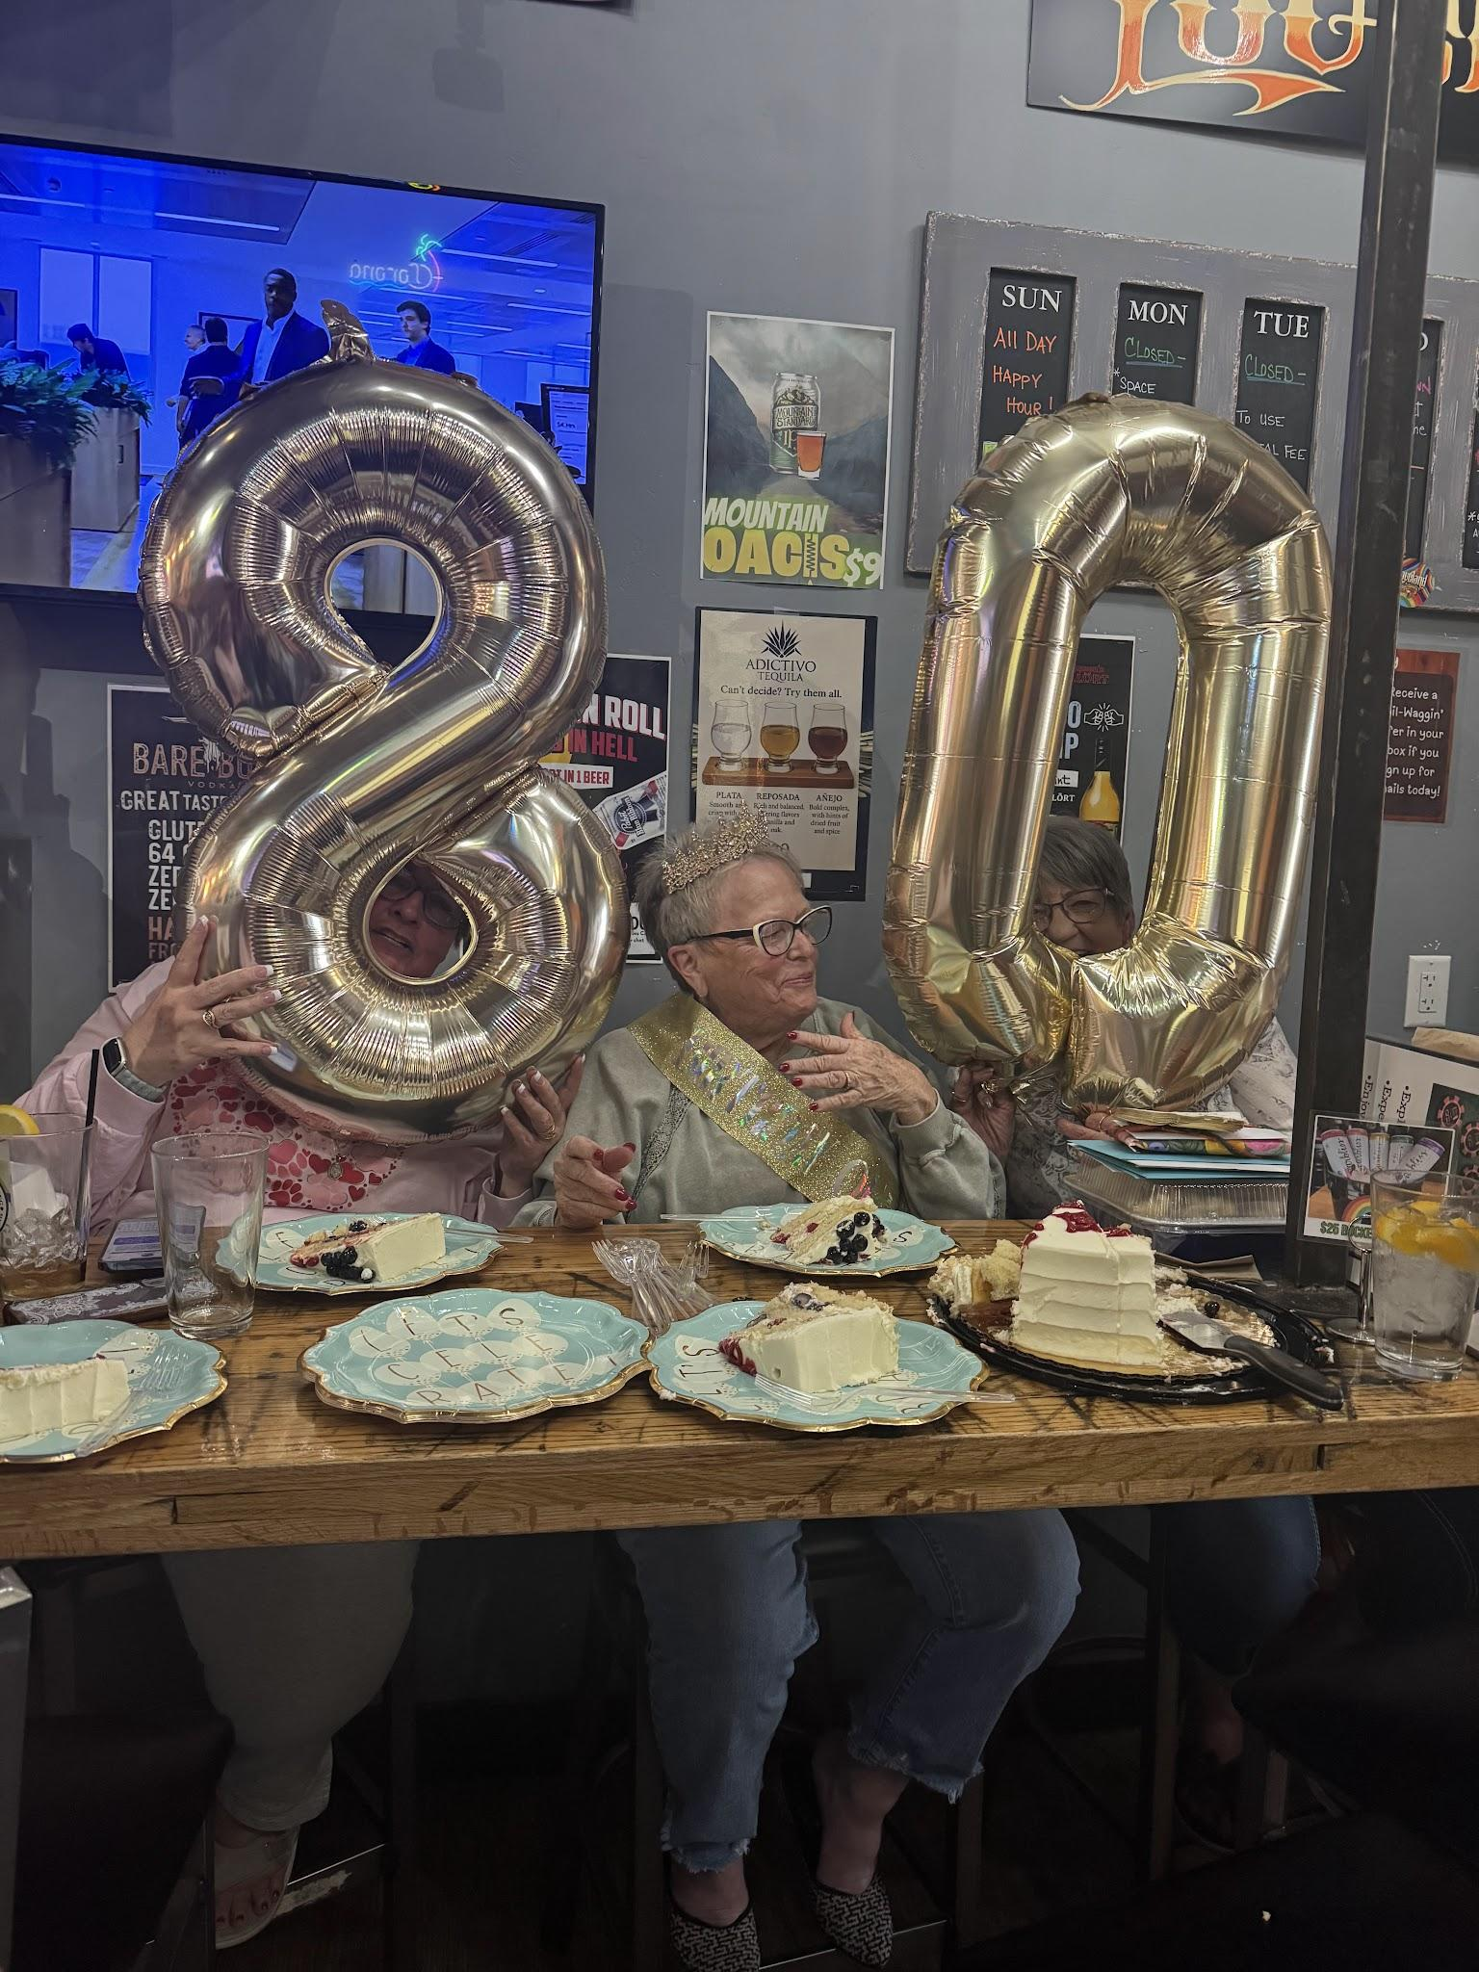 -13-
Chapter News Zeta Nu #5608
We hosted our Brush Crazy Fundraiser last month benefitting St Jude. This is our favorite fundraiser since there is little that we have to do to prepare for it. We provide hearty snacks since some are coming after work. Everyone picks their craft project and Brush Crazy donates half of their proceeds to our cause. We had 30 in attendance this time. Always a fun evening!


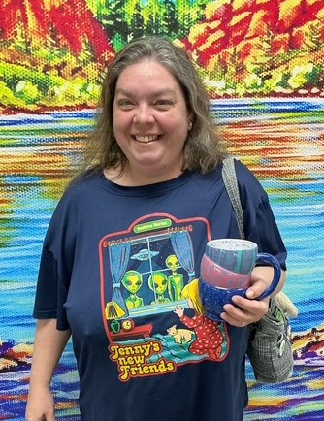
-14-

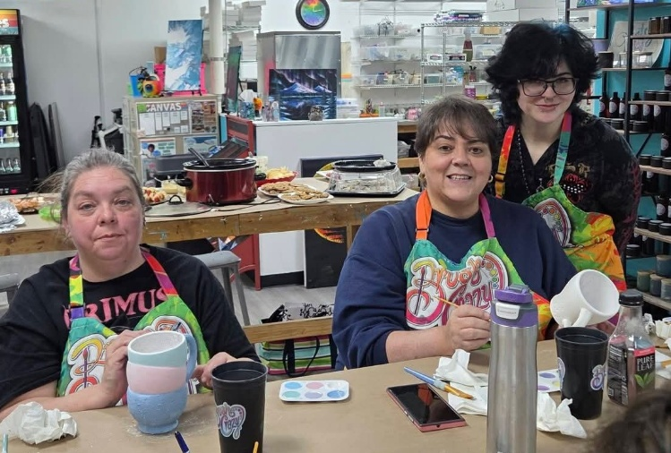
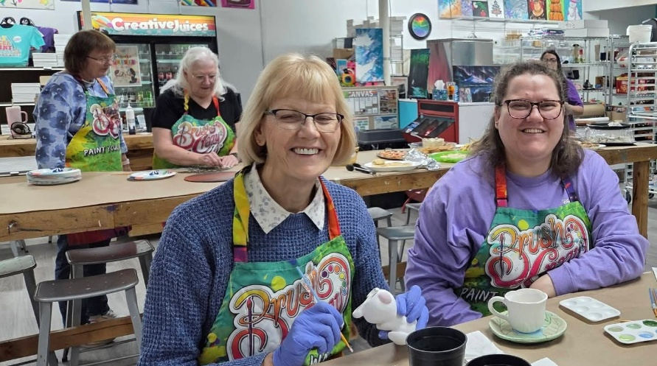


Chapter News Beta Zeta #3149
Beta Zeta has been roaming our town giving away money. We are having fun giving away our philanthropic funds to many organizations including Meals on Wheels, Canon Literacy Center, Orchard of Hope, Sangre de Christo Hospice and even a special appearance with Dolly Parton at her Imagination Library.
Our gals are looking forward to celebrating Founders’ Day on May 13 with the Omega Chi Chapter from Florence. The Steeple Event Center will be the place where we install officers for 2026-27 and recognize special award winners including our “Woman of the Year”.
Having a lovely Spring!
Carol Dunn, Sue McMillin, Publicity Committee
Beta Zeta Chapter #3149. Canon City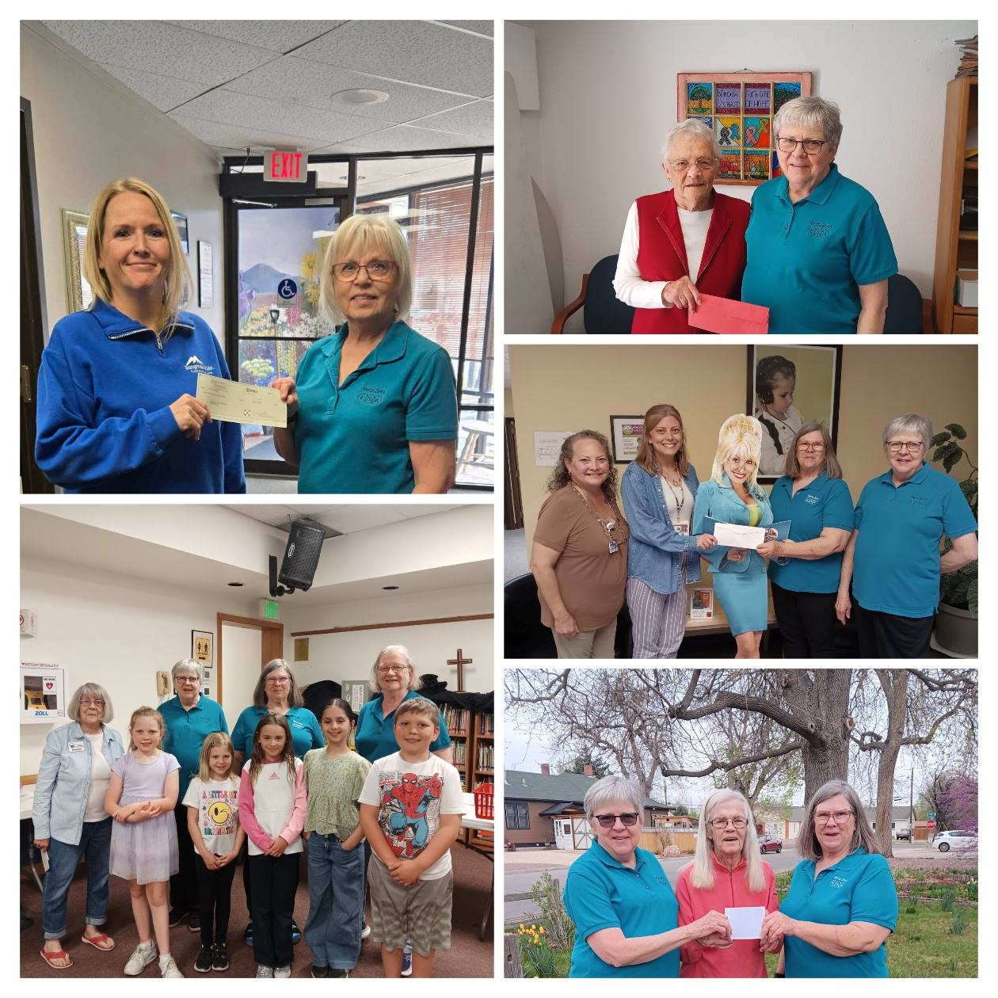

Adi’s Fundraising for St. Jude Children’s Research Hospital.

Adi has started her 5th year of fundraising for St. Jude. She has her biggest goal yet of $75,000 for just this year. She is working on a lot of ideas, and she will continue with her Cookie Stands, Bake Sales, and Pampered Chef Party. She is also working on having a golf tournament this year.
She is always looking for ideas, so if you happen to have a fundraising idea or if you know of a place where she can set up a cookie stand, please let us know. We will take anything we can get, especially with such a high goal this year.
Adi officially has her own website.
https://adiscookiestand.wixsite.com/cookies
Please check it out. It talks all about her fundraising and lists her upcoming events. She has some new places booked this year for cookie stands and we are hoping to go back to some places we went to last year.
She also has a Facebook and Instagram page if you haven’t yet, please follow her. She is really looking forward to fundraising and executing some of her ideas.
We were invited to the St. Jude Gala next weekend at the Denver Art Museum. We are so excited to be a part of it this year.
We want to thank everyone for your continued support with Adi’s fundraising. She couldn’t do it without your help and support.

THANK YOU SO MUCH
Jenniffer Carlson-Mazza
-17-


Colorado State Convention

REGISTRATION FORM
2026 Colorado State Convention
Loveland, Colorado
“Friends in Perfect Harmony”
Friday, April 24: Towne Place Suites, 256 E. 2nd Street, Loveland
(parking in parking garage free – use link ESAColorado to reserve room until 3/27/26 for $124.00 +tax per night or call 970-203-1166)
12:30 pm – President’s Executive Luncheon – by invitation only
2:00 pm – Registration Opens
3:00 pm – Lamplighter’s Meeting
4:00 pm – IC Representative’s Party
5:00 pm – Happy Hour: Red, White and Blue Event,
Hope for Heroes presentation by High Plains Honor Flight
6:00 pm – Introductions, Awards, Dinner provided by Sigma Rho

Saturday, April 25: Casa Sagrada, 404 East 3rd Street, Loveland
8:30 am – Registration
9:00 am – Memorial Service
10:00 am – General Assembly
12:00 pm – Lunch
1:00-4:00 pm – Awards
6:00 pm – Installation/Dinner “Denim and Diamonds”

Payment Information: Please make checks payable to Sigma Rho
Mail to: Deanna C. Sloat, 601 West County Road 16, Loveland, CO 80537
Cost: $125.00 by 3/27/26 then $135.00

Name: __________________________Chapter Name/Number_________________
Phone: _________________________ Email: ______________________________
Food Allergies? ________________________________________________________
Check All that apply: ____First Time Attendee ____ Chapter President
____State Officer ___ Lamplighter

The New Mexico State Council of Epsilon Sigma Alpha International invites you to attend….
2026 Rocky Mountain Regional Roundup

August 28-30, 2026

NRA WHITTINGTON CENTER Raton, New Mexico

DIRECTIONS
Located just off Interstate Highway 25, north out of Albuquerque and south out of Raton. At New Mexico Exit 446 turn west onto State Highway 64. The NRA Whittington Center is 4 miles down the road on the right side. Everyone entering the facilities must sign in at the gate.

The building we will be using has a central lobby with three separate wings. Each wing contains five bedrooms, each with two single beds, a kitchenette and two separate bathrooms with showers. There are no bunk beds, and all rooms are on the same floor. Bedding provided. Bring your own towels and toiletries.

We have housing for 30 people. Husbands or Guests may stay in the building as long as we do not exceed 30 total. They should register the same as a member. If we exceed 30, we will check into other options.

Send Registration to: Bobbie Massey For information contact Bobbie PO Box 316 575-640-2370 (cell)
Animas, NM 88020 bjmassey@vtc.net

__________________________________________________________________________________

REGISTRATION FORM
Registration Deadline: August 7, 2026
Registration: $125.00 per person, $130.00 late.
Includes 5 meals and 2 nights lodging.

Name: State:

Address:

Phone Number: Email:
Special Dietary Needs:

Just for Fun

An elderly man owned a large farm for several years and he had a large pond on the far end of his property. It was perfect for swimming, so he fixed it up as a recreation area with picnic tables, horseshoe courts and even planted some fruit trees.

One evening, the old farmer decided to go down to the pond since he hadn’t been there for a while. He grabbed a big white bucket to bring back some fruit before setting off on the long trek to the remote area.

As he approached the pond, he heard voices shouting and laughing. As he came closer, he saw it was several young women skinny-dipping in his pond.

He made the women aware of his presence, and they all went to the deep end. One of the women shouted, “We’re not coming out until you leave.”

The old man frowned and said, “I didn’t come down here to watch you ladies skinny dip.”
Holding up his bucket, he said, “I’m just here to feed the crocodile.”

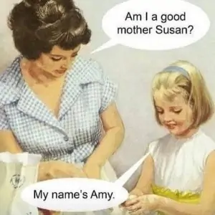

Happy Mother’s Day!


Last August, my daughter and I went to the Denver Botanical Gardens. It was my first visit and we had a wonderful time. To celebrate Spring, I thought I would share some pictures.


