ESA Colorado Golden Lamp |  |  |  |  | October 2025 Volume 79 Issue 8
ESA Friends  In  Perfect Harmony  Lori Anderson Havelick  Colorado State President 2025-2026   |  | 
Editor’s Corner  By Karen Addison, Golden Lamp Editor  I had such a good time at Fall Fest last weekend! Thank you to our hosts, Alpha Omicron in Salida. They are always such wonderful hosts and the food was wonderful, as usual! Thay had to make a quick switch to a different venue, which was a lovely community center even closer to the hotel.  As the trees are beginning to turn lovely colors in my neighborhood, I’m noticing my flowers and lawn are showing signs of going into hibernation for the winter. I’ve put together an article on how to winterize your flower beds. Look for this “educational” later in this issue. |  | PAGES 2-4  President Pages  PAGES 5-12  Council Reports  PAGES 13-14  Adi’s Update  PAGES 16-23  Chapters Reports  PAGES 24-26  Miscellaneous  PAGE 27-28  For a Laugh
The President’s Philanthropic Project  By President Lori Anderson-Havelick  My Philanthropic Project this year is centered around serving the Veterans and active Military.  This includes the Wreaths Across America program. 2025 Theme: Keep Moving Forward. You can make donations at their site to sponsor a wreath and if you are able to participate in the laying of the Wreaths at Veterans Cemeteries. It is $17.00 to sponsor a wreath. The date to lay the wreaths will be Dec 13. WreathsAcrossAmerica.com.  Chapters are also encouraged to contact their local VA Hospital to explore possible programs such as providing ice cream bars, sandwiches, any lunch menu, or Word search, Crossword, and Sudoku puzzles.  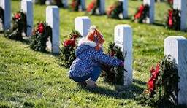 |  |  |  | Cards for the Veterans  By President Lori Anderson-Havelick    Send thank you cards to Operation Gratitude.  Directions are as follows:  Most of you know the address and what to do. Here is a reminder.  Operation Gratitude  19748 Dearborn St  Chatsworth, CA 91311  1. Include an envelope - for each card provide an envelope, check for fit.  2. Don’t insert the card - Do not place the card in the envelope.  3. Slide the card under the envelope flap, ensuring it is visible.  4. No Stamps - Do not include stamps on the envelope.  5. Send cards in a large brown envelope.
Mark your Calendars  Upcoming Events on the Website | Colorado State Chapter Dues deadline December 1  Mail to Susan Winton, Treasurer/Disaster Chairman  St Jude Dream Home Denver Open House September 20-October 21  Giveaway October 23

Message From The President 
Hi All,
I encourage you to read the Minutes of the Fall Fest Meeting. There
was a lot of discussion and information presented.

My goal is to have better communication and teamwork within our membership. There are some new people
on the ESA Colorado Board and there are bound to be questions. Any members with questions should feel free
to contact any board member or Lamplighter. They are always willing and happy to help. Please use Facebook
and other social media to get the name of ESA out there. When you go to events, please bring a friend.
Let’s get more people involved in ESA.

We all had a great time at Fall Fest. A big thank you to Jennifer and to all the members of the Alpha Omicron
Chapter for hosting the Fall Fest. The meals were delicious and activities were fun for Friday afternoon and
evening. We visited while doing the Veterans cards and doing the other activities. We made 70 Thank you cards
for Veterans or Active Military. I will finish 30 more cards to make 100 total cards. Thank you to Karen Addison
for doing the Sangria demo while we ate dessert. Thank you to Leslie and Nancy for hosting Bunco. We had a
fun evening playing Bunco. Candie and Addie were the winners of the Bunco game. On Saturday we held the
meeting and then 14 of us went out to dinner at a great locally owned Mexican restaurant on Saturday evening.

A few updates:
At IC, it was mentioned that there is a new name for ESA Headquarters. Its new name is ESA MC (Membership Corporation). They also had a committee to work on these statements. Susan Bloss, our Past President, was on that Committee. The new ESA Mission and Vision statement is as follows:
Mission Statement -The ESA International Council inspires a culture of authenticity, respect and confidence, building strong community conditions and empowering every member to flourish through purposeful service, bold leadership, meaningful networking and lifelong learning.
Vision Statement - The ESA International Council strives to be a diverse community where every member rises confidently, leads with heart, and learns passionately in a shared commitment to impactful service.
At IC Convention in Cary, NC, IC President Celeste Webb announced she would like for us to do some Random Acts
of Love and Kindness. Post it on Facebook #ESA. I belong to a group on Facebook called Random Acts of Crochet Kindness USA. We crochet small items such as curly worms, spiders, frogs, bookmarks, coasters with a tea bag. I
am fond of doing the crochet coaster and the tea bag. You leave a note, put it in a zip loc bag
and then place it somewhere, where someone can pick it up.
Another good idea is to wear our ESA shirts once a week. Whenever you are doing errands - to the Drs Office,
Grocery stores, out to restaurants, out to coffee etc.
It would be nice to hear about these ideas at the next Spring Meeting. I’ll be asking what you have done for kindness
and if your shirt started any conversations about ESA. We can take some time having everyone reporting on what they did. Keep a log on your results. Also, snd articles to the Golden Lamp. Reports on the Veterans can go in the Golden Lamp too. Send in pictures. Share what you are doing in ESA.
I am in monthly Zoom meetings with the other State Presidents. They have really good information. We get to hear
what other Presidents around the nation are doing. l will have updates on the meetings.

Thank you,
Lori Anderson Havelick
ESA Colorado State Council President

Fall Fest 2025

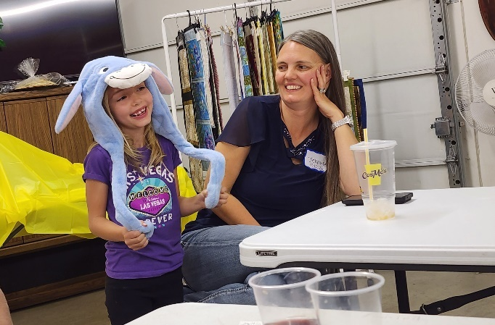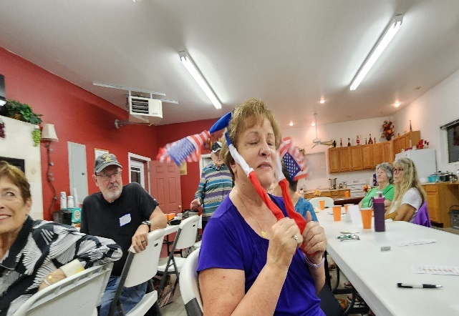

Adi and Candie had the most wins in Bunco, so they won these goofy hats

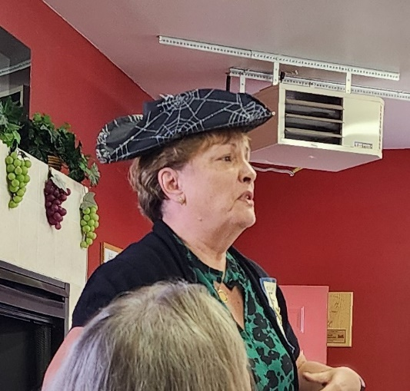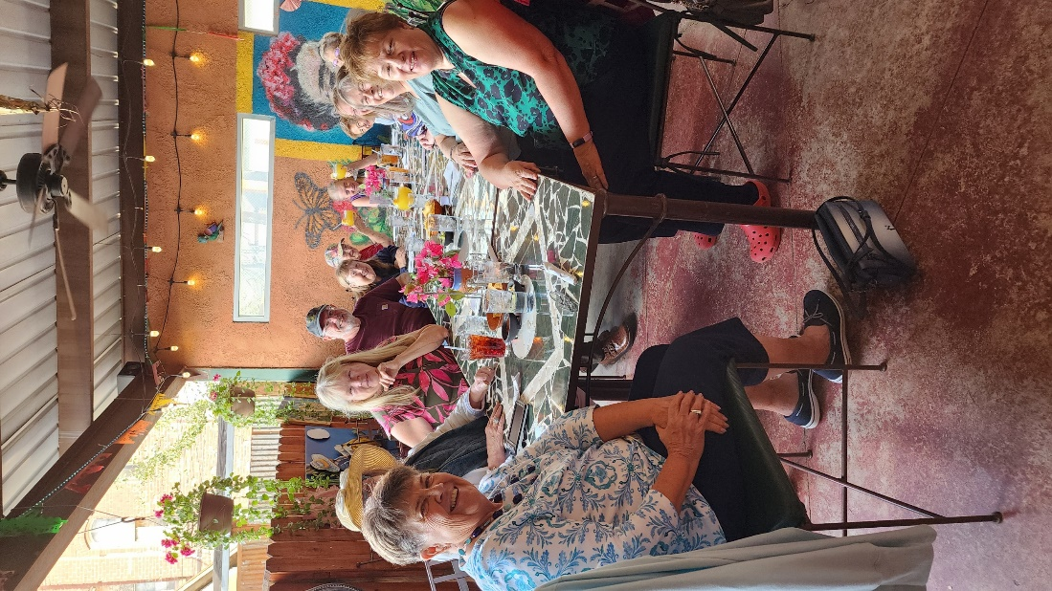

Candie Patino giving her Web Presentation Saturday night dinner

-4-
Nancy Cameron President Elect

Greetings! Congratulations to Lori and her board for a very successful Fall
Fest and Alpha Omicron, Salida, for a beautiful, yummy and fun event. We
missed those who were unable to join us.
Congratulations, too, to Adi Mazza for all her accomplishments for St Jude
Childrens’ Research Hospital! She is SO amazing!
I hope chapters have had a great start to your ESA year.
Looking forward to hearing what you are up to!
I HAVE A GOAL - NEED YOUR HELP!

This is a Do Over for me as President Elect for Colo State Council! I was
President in 1993-94 - over 30 years ago!!!
Things have changed but my love for ESA is still strong!
“In the olden days”, one of the best things about holding office on the CSC
Board was visiting chapters and getting to know new members and renew
acquaintences within their own groups. We’ve gotten away from that - I
would like to visit as many chapters as possible - not for any special event -
just as you are doing your meetings, educationals or projects.

WOULD YOU CONSIDER INVITING ME TO ONE OF YOUR CHAPTER ACTIVITIES?
Weather permitting I’ll do my best to be there.

Encouraging membership growth is one of my responsibilities for this year.
I hope you are sponsoring a lot of new members! Remember the fun of
Rushing? A social event, a “mock meeting” and then the Pledging! I know
we are looking for new members at all times but consider a “Rush”. The
ESA website - epsilonsigmaalpha.org has a TON of ideas for meeting and
pledging plans, fundraisers, etc.
AND THEN - of course I will be putting together the CSC Board for 26-27! I
would love to have someone from every chapter represented. Be thinking
about what you can do to keep the Council strong and thriving!
I am including a Nomination form for officers with this issue of the Golden
Lamp.

COME JOIN ME FOR A GREAT ESA COLORADO BOARD 2026-27!
Hugs,
Nancy Cameron
-5-

Fall is here and I hope you’re all HOOTIN’ in HARMONY! (was that too corny or what???)
As we move along in 2025 I know everyone is busy doing all kinds of projects and good deeds—because that’s what we do. Just a reminder to keep track of all of the events you and your chapters participate in and plan to turn all the reports and forms in by April 1st or as designated on the specific form.
I am looking for a location and host chapter for Colorado State Convention for 2027. I may be reaching out to some of you over the next few months to brainstorm ideas on locations and chapters.
- Do you still like a 3-day event (costs always go up)
- What would you change if you could?
If you have any ideas, please contact me.
2026 Convention Report: Thank you to Sigma Rho for stepping up for 2026. Information will be out soon, but please note the CSC CONVENTION DATE HAS BEEN MOVED UP TO THE LAST WEEKEND OF APRIL.
There are some changes on St Jude Reporting this year, so look to Pam McGee for guidance on this.
Thank you, Susan Bloss
CSC Past President/Awards Chairman



-5-
Hope for Heroes- Reaches from Northern Colorado and Beyond
By Deanna C Sloat- Hope for Heros Chair 2025-2026

It has been my great honor and privilege to been able to help honor and serve our veterans of
Northern Colorado. I have been volunteering to help with the High Plains Honor flight since my dad
got to take this very special trip in 2017. It was so powerful and moving that I knew I had to be a part
of it. My dad is one of my Heros. He is a Vietnam Veteran, a plumber, a welder, a cook, a sheriff’s
deputy, a Santa and an all-around good guy, If I do say so myself! I am very blessed to have him as
my dad. When I was a small child I learned the importance of our Veterans, not only to be able to
thank them and honor them but to acknowledge the sacrifices that they have made to protect our
nation’s freedom.
This year as the 2025-2026 Hope for Heros chairperson for ESA Colorado, I am choosing to support
two very worthy causes, High Plains Honor Flight and Veterans Honor Monument.
I have worked closely with both groups over the past few years. First let’s talk about High Plains
Honor flight. Twice this year a very special flight has taken off from the Loveland Fort Collins Regional
Airport enroute to Baltimore, Maryland where 120 honored veterans, their guardians, medical staff
and flight coordinators travel to bring these men and women to see their monuments of their fallen
brothers and sisters in battle. It is a whirlwind of a trip for these veterans but the smiles and memories
when they arrive back safely to their loved ones are priceless. My role is very small in comparison to
the amazing board of directors that works all year long to make this happen. I am a support volunteer.
Days before the plane arrives, we meet up at the storage unit and do a wheelchair assessment. To
confirm they are all in good working order and clear and ready to go for anyone that may need them.
I arrive at 5:30 in the morning on the day of the flight to help sell merchandise to continue to support
the mission of High Plains Honor Flight. After we welcome the 120 veterans from WWII, Korea,
Vietnam, the Gulf War and any time in between, we get them and their bags loaded on the buses to
head out on the trip of a lifetime. They are whisked off on a 40-hour adventure. Once they have
visited all the monuments, then they are enroute back to Loveland. They receive a special letter on
the way home, handwritten notes from school children sending special thanks and thoughts to each
one of them. Once they land, we are anxiously awaiting their arrival with a handful of volunteers and
excited families wanting to hear all about the trip. The smiles on their faces make it all worth all the
work. They are greeted with flags, bagpipes and cheers of “Welcome Home”! When brings tears to
some of their eyes because when they were in the service no one said thank you for your service or
welcome home. Along with the cheers they each received a special thank you gift and this year a
beautiful handmade quilt was given to each of them by a lovely group of ladies that donated their time
and talent to make them.
The second Veterans project that is near and dear to my heart is the Veterans Honor Monument. This
is a small but mighty group that has been raising funds for nearly three years now to see this vision
come to life. They are erecting beautiful monuments for each of the military branches Army, Navy,
Marines, Air Force and Space Force. This will be a place of peace and solitude for veterans to come
remember and for those of us who have not served to honor and thank our veterans. From golf
tournaments, concert dinners, car shows and generous community supporters, this dream is getting
close to coming to fruition. As we see with many veterans that suffer from trauma, PTSD or anxiety
we hope that these monuments will help them recover. This is why I continue to support their efforts
as well.
-6-
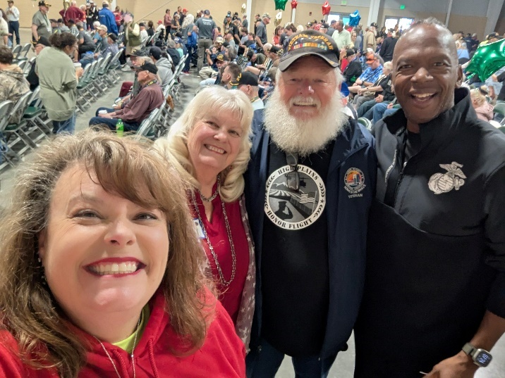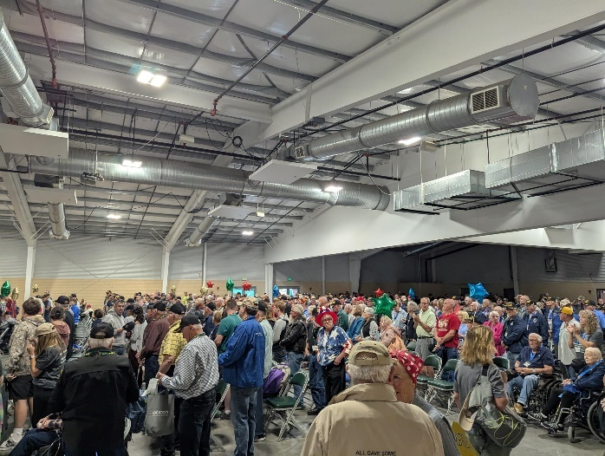

Hope for Heroes

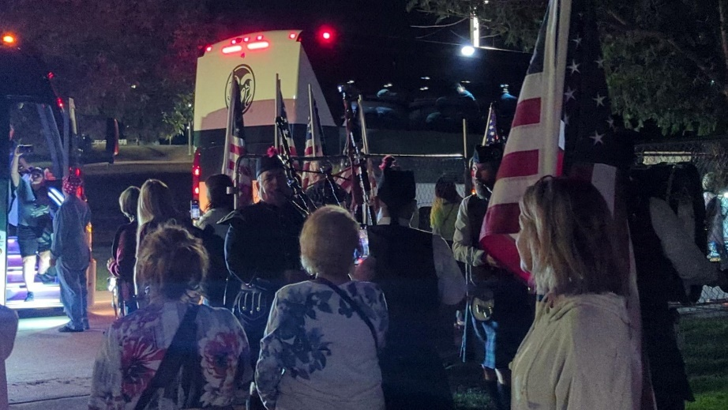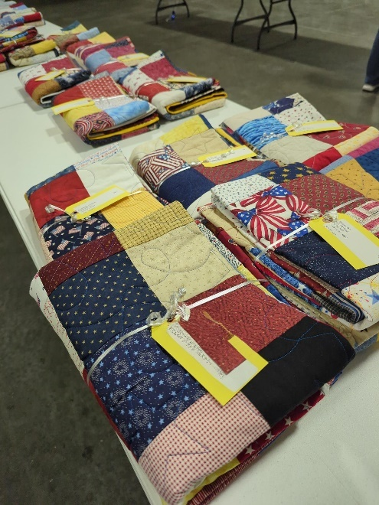

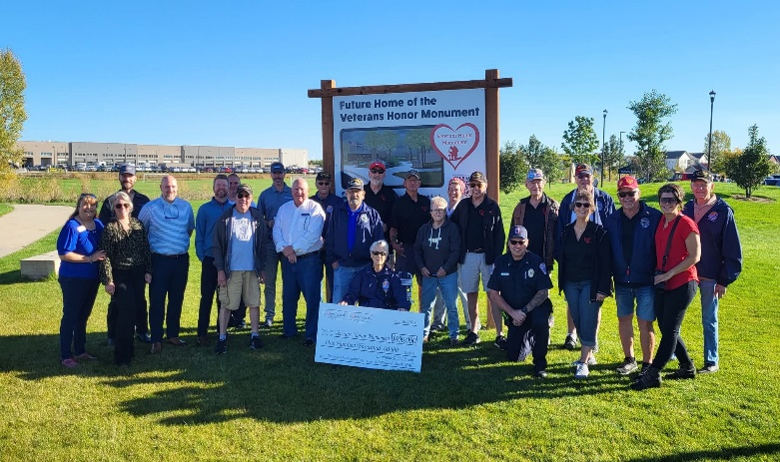

St. Jude News
It was great seeing all of you at Fall Board. It was a beautiful trip over and going back home. The trees were magnificent.
Here are a few things I mentioned at Fall Board.
- ALSAC is working on a better system to track those of you who donate to Partners in Hope, to show you are an ESA member so ESA can get the credit.
- New fundraising program. ESA has pledged 5 million in the next 4 years, starting the fiscal year of 2025-2026. It is called “From My Birthday to Yours”. There are ideas on the St. Jude page on the ESA website.
- On that same page there is information on; a) What is a cash event, b) Setup online fundraising, c) Volunteer Management System (VMS) how to use it, d) Submitting Partner in Hope donations.
Recently Gamma Chi gained four new members. Judi Swartz, one of those new members, told us this story and I wanted to share it with all of my Colorado sisters.
Why my name is Judi
My parents were married after my dad returned from World War II in 1945. They tried to have children right away as back then my mom was in her 30s and considered old to bear children. They tried for 5 years and couldn’t get pregnant. One of her best friends was entering the convent and back then you got to make some ‘wishes’. She prayed to St. Jude, the patron saint of ‘hopeless cases’ and shortly after my mom became pregnant with me. I was born premature and in 1951 they didn’t have the technology as we do now. My mom and dad named me Judith after St. Jude, as she believed his divine intervention brought me here!
She is in the photo with black hair serving food.

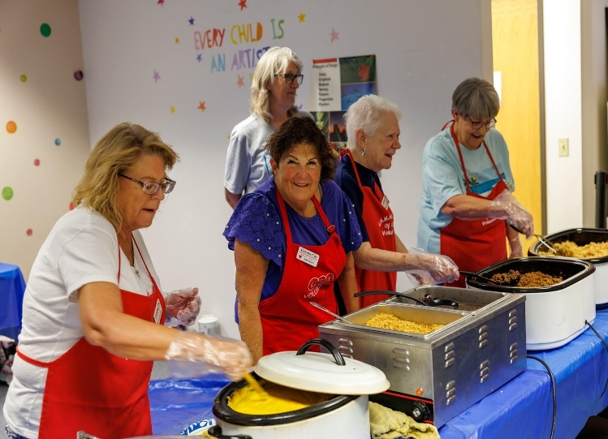

I hope you have a great Halloween and Thanksgiving. I want chapters to let me know what projects you are doing for St. Jude. We always need to share our ideas.
Pam McGee
Colorado State St. Jude Coordinator
-8-

Easterseals Report

I am happy to report that we successfully raised $100 on the Fall Fling Easterseals
basket! A heartfelt thank you to all who donated.

Here are ways you can get involved and support the ongoing mission of Easterseals:
Support the Rocky Mountain Village Camp: You can specifically support the camp in a
few ways; Fulfill specific needs by checking the Amazon Wish List for the camp:
https://amzn.to/4fTZnlF.

Purchase for a camper: a copy of “The Magic of Rocky Mountain Village” (written by
two former counselors) for every camper. Click here to purchase.

Additionally, you can participate in events like the Christmas Tree Cutting, volunteer on
site, or simply spread the word. The next event coming up is the 15th Annual Colorado
Gala at the Ameristar Casino in Black Hawk on October 25th.

You can always help Easterseals in general by contacting your Representatives and
Senators about disability rights and funding. The easiest way is to visit the Easterseals
Action Center online at https://easterseals.quorum.us/.

Please donate what you can, speak up to your elected officials, and help us raise
awareness. I’m always here to answer questions and help where needed. You can
reach me at dodgeball5@yahoo.com.

Much ESA love,
Ginger Dodge
Colorado Easterseals Coordinator 2025– 2026

Sigma Rho #5014, Loveland

-9-


Winterizing your Flower Beds

I have lived in my present house for 6+ years. When I moved here, the front flower bed had been covered by that fabric you use under rocks, to stop weed growth. You know the stuff, seems like a good idea, but the weeds find a way to get through it! Well, it covered my bed and I wanted to grow flowers. When I pulled up the fabric, I found they had merely covered up the weeds, instead of pulling them up. As a result, I have been fighting these buggers ever since! I have done my fair share of gardening over the years and I’ve pulled a lot of weeds! But the weeds on this lot are the most aggressive weeds I have ever met. There are so many different varieties of weeds and they are so hard to stop! But the king weed is this incideous vine that wraps itself around every branch on a bush and wraps around every flower it gets close to. The result is that it chokes off the plant and kills it.

I started off by “saving” the one bush growing in the flower bed. I added a few more bushes and planted annuals to give it some color. I was constantly pulling these weeds to let my beauties grow. Each year, I planted a few perinnials and watched to see if they would reappear the next spring. And after 6 years, I finally am gaining ground! My bed is now full of perinneals except the very front. Next year, I will plant more perinneals. The petunias and other annuals will only be planted in flower pots.
Now, it is important that these lovely plants survive the winter so that I can enjoy them next Spring. I’ve done a little research. And here’s what I will be doing this weekend…

The basics of putting the perennial garden to bed:
- Do not fertilize. Encouraging new growth now doesn’t help the plant get ready for winter. Adding compost, however, is a good thing for soil nutrition. The plant will respond to this slowly as needed.
- Keep removing spent flowers and dead and dying foliage.
- Keep the base of plants free of dead leaves and debris particularly before frost.
- Keep watering until the ground freezes. This is the most important factor for how plants weather the winter.
- Apply a layer of mulch or mulched leaves in late fall. Begin gathering leaves now! Don’t add the mulch until mid-November, but this way you’ll be far ahead if you begin mulching leaves as they fall. This protects the crowns of plants. Note: Don’t mulch bearded iris.
- For *tender plants (one that don’t like our Colorado winters), water well, add compost for nutrients and make a small cage from chicken wire and fill with mulch or chopped up leaves. Thanks to Faddegon’s Nursery for the great article.
Karen Addison, Colorado Educational Director
ESA Membership Corporation Update

Here’s a few updates presented at IC:
• Headquarters – NO LONGER A THING – use ESAMC or ESAMC Staff.
o Refer to ESA as a nonprofit service and leadership organization, not a
sorority; we have male members too.
• ESA / ALSAC Relationship Change:
o ESA St. Jude Naming Event – We’ve been challenged to raise $5M in 4
years.
▪ ESA will then have a naming opportunity for an outdoor public space.
o The tier system for the credit we receive has been retired. ESA was the only
organization using the tier system that no one completely understood.
o Members, Chapters, and States will continue to be recognized for cash
dollars raised at ESA hosted events.
o ALSAC Event volunteer hours will be reported through the Volunteer
Management System (VMS) to be tracked separately starting right after IC
Convention in July. We are using VMS for the Dream Homes.
▪ Shai Hendricks, our Executive Director, is working with ALSAC on how
ESA will receive the credit. They completely understand the
uniqueness of CO.
o Watch for a Recognition and Impact Program:
▪ ESAMC Staff is working on the new recognition portal.
▪ They’ve been working with the IC President and Philanthropic Chair to
roll it out.
▪ You’ll receive an e-blast when it’s launched.
▪ The Essential Edge and Philanthropic Reporting Guidelines will also be
updated.
o 2025-2026 Campaign is called “From My Birthday to Yours”
▪ Host a birthday party and ask for donations in lieu of gifts.
▪ Donate on behalf of a friend or family member’s birthday.
▪ Celebrate your Chapter or State Council’s birthday with a fundraiser.
• ESA Leadership Change
o Starting in 2026, Leadership will be conducted by the IC Executive Board.
o It will be a virtual one-day event on February 7, 2026. The cost is yet to be
determined; it will be between $75 to $150.
• Great News!! March 2027
o Weekend event at St. Jude Children’s Hospital in Memphis TN.
o More to follow; anyone may attend.
• Membership:
o Stats from 2014 to 2024, shows membership has declined from 8,903 to
5,450 or 39%.
o This includes all traditional, collegiate, and life active members.
• Long Range Planning Committee:
o The purpose of this committee is to have a strategic group of leaders to
create a collection of ideas and recommend changes that will enhance the
membership experience in ESA.
▪ “Keeping ESA as an organization that thrives well beyond 100 years.”
o There are 11 members and subcommittees representing ESA Foundation,
ESAMC, IC Exec Bd, and Ex Officio Members:
o A new Mission Statement and Vision Statement were developed. Susan
Bloss was a member of this committee.
▪ The Mission Statement reads: The ESA International Council inspires a
culture of authenticity, respect and confidence, building strong community
connections and empowering every member to flourish through purposeful
service, bold leadership, meaningful networking, and lifelong learning.
▪ The Vision Statement reads: Epsilon Sigma Alpha strives to be a diverse
community where every member rises confidently, leads with heart, and
learns passionately in a shared commitment to impactful service.”
• ESAMC Staff is also developing various policies:
o A Website Policy for ESA Groups; more to follow.
o ESA’s “Organizational Framework: How It All Fits Together;” it will be in the
next Journey Magazine; it refers to:
▪ ESA Membership Corporation (ESAMC) that delivers core programs,
infrastructure, and services.
➢ The ESAMC Board of Directors is made up of ESA members and
provides strategic guidance, oversight, and fiduciary responsibility for
the organization.
➢ The ESAMC Staff (formerly referred to as ESA Headquarters) delivers
ESA’s programs, manages internal systems, supports members, and
keeps things running day to day.
▪ ESA International Council (ESAIC) fosters leadership and tradition.
▪ ESA Foundation (ESAF) supports education and charitable giving.

Brand Guidelines & Language
Check out the Brand Guidelines &amp; Language on the epsilonsigmaalpha.org website
under Organization. There are tips on logo guidelines, merchandise and printing, social
media, website, and language. A couple term updates to be aware of are:

• ESA is a service organization and should not be referred to as a “sorority or
fraternity.”
• ESA is a co-ed organization; always use the term members. Do not use the term
sisters.
• Refer to a new member rather than a pledge.
• Use Chair and Co-Chair, not chairman, chairmen, chairwomen, chairperson, etc.
o As a result of reviewing this document, the Bylaws were updated using those
terms and uploaded on the CO website. This is a housekeeping item, no need
for a vote.
o Our Colorado forms are being updated to reflect the change.
o The Guidelines will also be updated. Updates are made as a result of a Bylaw
change.
Ensure your email address is up to date to receive the monthly updates from the
ESAMC Staff.

Mary Humphrey
ESAMC Secretary 2024-2025

-12-

ADI’S FUNDRAISING UPDATE
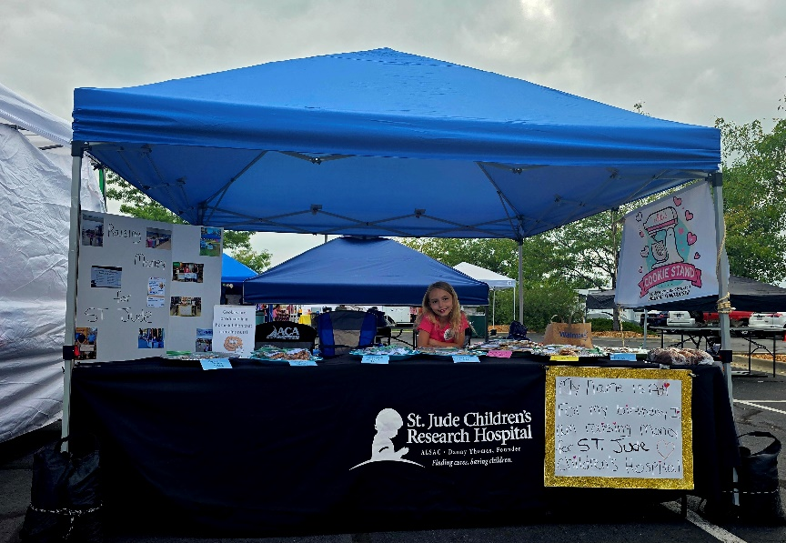
I want to give you all an update on Adi’s St. Jude Children’s Research Hospital Fundraising.
For 2025 she set a goal of $20,000. She did a Spaghetti Dinner (with a bake sale, drawings, silent
auction and a 50/50 drawing), a Pampered Chef Party, Bunco Party with the Gamma Chi Chapter
(with a cookie sale, 50/50 drawing, and other drawings), a bake sale, numerous cookie stands, and a
5K walk.
High Country Beverage in Johnstown, CO donated $25,000 to Adi’s fundraiser and we are forever
grateful to Steve and Lidia with HCB.
This year we traveled to Johnstown, Colorado Springs, Loveland, and Denver for different
fundraisers.
We also took Adi to Memphis TN where we toured the St. Jude Campus and went to an awards
banquet in the Domino’s Event Center also on the campus where Adi was presented an award for
winning the 2026 Jerry Nicholson Award.
I am so excited to announce that DeAnna Steele with ESA recently reached out to Adi asking her to
be the face of ESA’s “From My Birthday to Yours” campaign. Which Adi was excited to say yes to!!!
This year has been nothing but a great fundraising year. Adi worked hard to reach her goal, we
worked with amazing people, met new people and got to travel a lot.
Adi was able to raise $53,184.00 for 2025. Which brings her grand total in the last few years to over
$78,000.
Next year is going to be even more eventful, she has recently decided that she wants her goal to be
$75,000.00 and she is already working on ideas and has booked a few meetings for fundraisers.
Adi did a couple interviews last month. One on Great Day Colorado and on Fox 31 news. All her
interviews are on her Facebook page just search Adi’s cookie stand. If you don’t have Facebook, you
can google Adi Mazza Salida, CO and they will come up for you to watch.
Next weekend we go to Colorado Springs where Adi will interview with Lindsey Grewe on KKTV11 (I
am not sure what Friday, but that interview will air on a Friday for The Good News Friday Segment)
From Adi:
I want to thank everyone who has helped me with my fundraising for St. Jude, I couldn’t do any of it
without people like you. I was able to go to the St. Jude Campus this year and my favorite part of our
tour was getting to go inside the hospital, and it was all because we got lost. It was my favorite thing
of our whole trip. I can’t wait to keep helping the kids at St. Jude. My big goal is to raise one million
dollars for them and I can’t wait to share my fundraisers for next year.

-13-

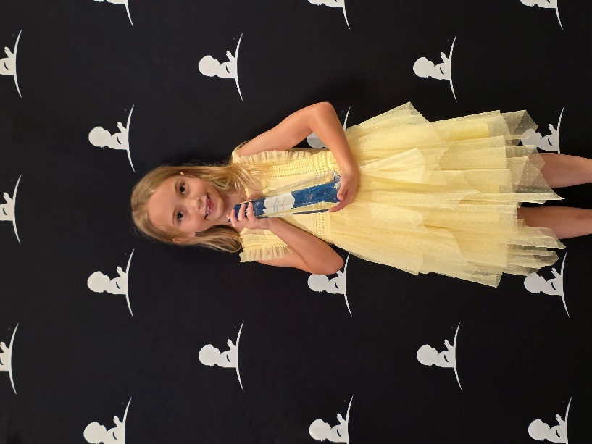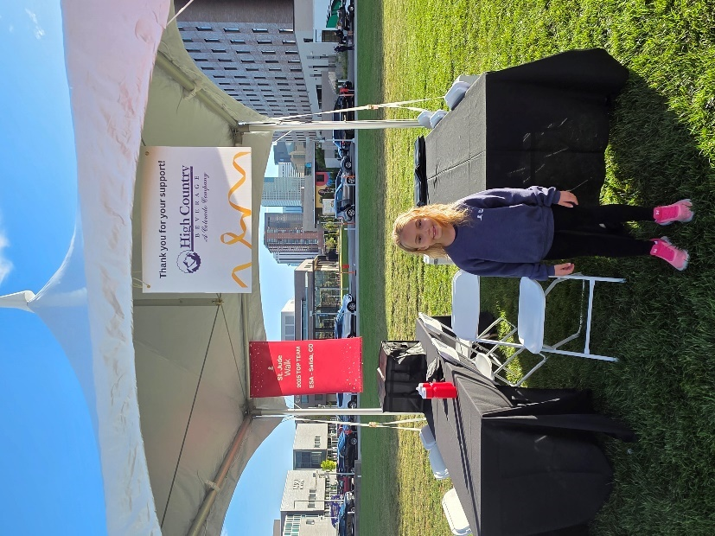
Adi and her award at the St. Jude awards banquet Adi at St. Jude 5K walk. Adi's 5K team is ESA – Salida
and she was top fundraiser of 2025 5K walk

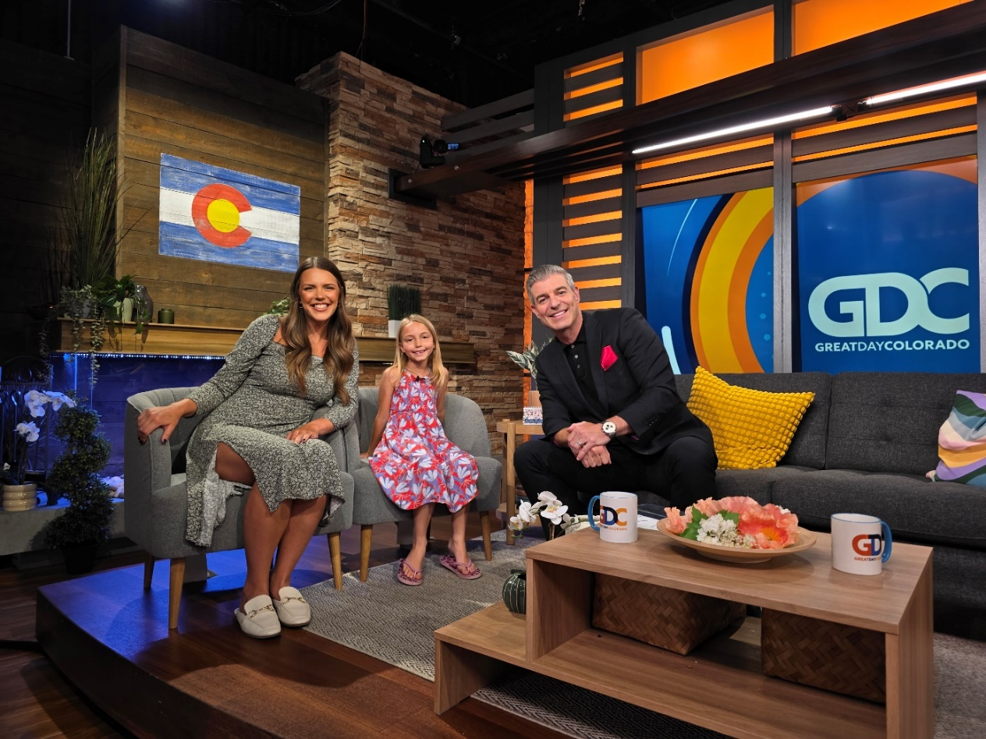
Adi and Maddie (with St. Jude) on the set of Great Day Colorado

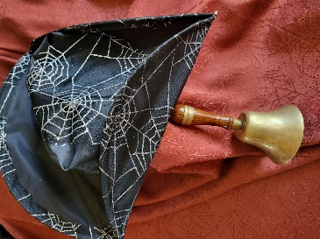
Colorado Web Team
esacolorado.org

Hear ye, Hear ye, Hear ye!
Gather around and you shall hear
Of the 25 years
Of our Website dear
Colorado State Council Web was approved by its membership in the Spring of 2001and launched in a very simplistic form that fall. Each year, expansions provided more and more additional information and resources for members.
Today this website offers:
- 12 main pages  - Events Calendar  - 17 Colorado specific forms  - 43 guidelines  - 2025-26 yearbook | - Bylaws & Standing Rules  - 5 years of Golden Lamp issues  - History page  - Award winners  - Past CSC presidents  - . . . and lots more.

At this year’s Fall Fest, members agreed that this website provides a valuable service for the Colorado State Council. The CSC website will continue to offer updates, materials, and information.
The CSC Zoom account was also discussed. While this account originally began during COVID, it remains a very useful device. A committee has been formed to see how this account can be used even more advantageously.
Thanks to all who continue to make these tools successful.

Mahalo,
The CSC Web Team
Bonnie & Candie

Chapter Report  Kappa Iota #5442


Hello Colorado ESA!!!!
Coming up on one of my favorite Holidays!!!! Already got the scary movies downloading!
Both members of Kappa Iota attended the Fall Fling in Salida and what a wonderful time it was!! We didn’t get in till 7 PM, always holdups, but we made it and BLESS Alpha Omicron for keeping dinner out, ‘cause we were STARVING when we finally got there! What a remarkable meal those ladies do! YUMMY SALADS AND DESSERTS!
We were treated to a demonstration on the fine art of making SANGRIA from Past State President, Karen Addison, and sample(s) of that demonstration!! WEE HAW! Was a great way to kick off Kappa Iota’s Bunco (with a twist) party! Not going to tell ya what the “twist” was! Ya gotta come to the Bunco to get the whole “experience”!!! But FOR SURE, there were lots of laughs and giggles!
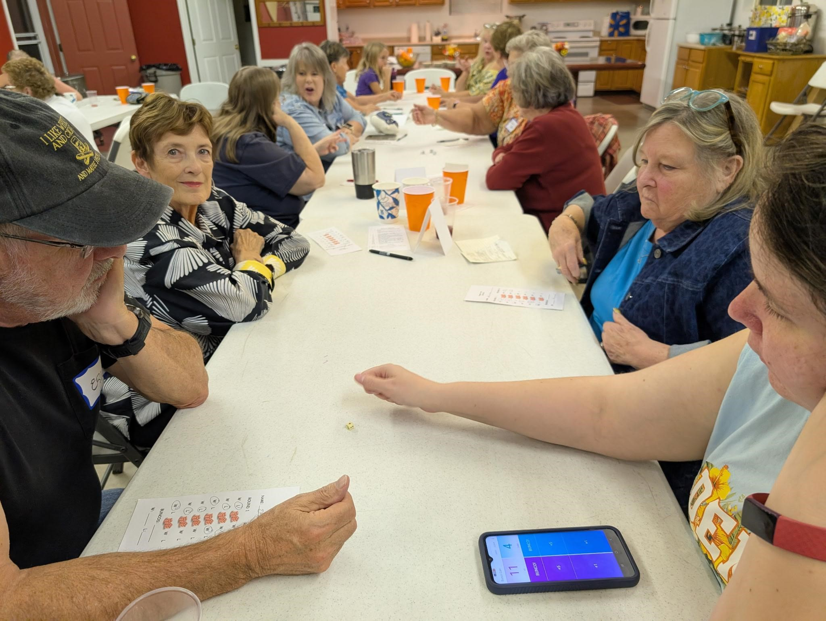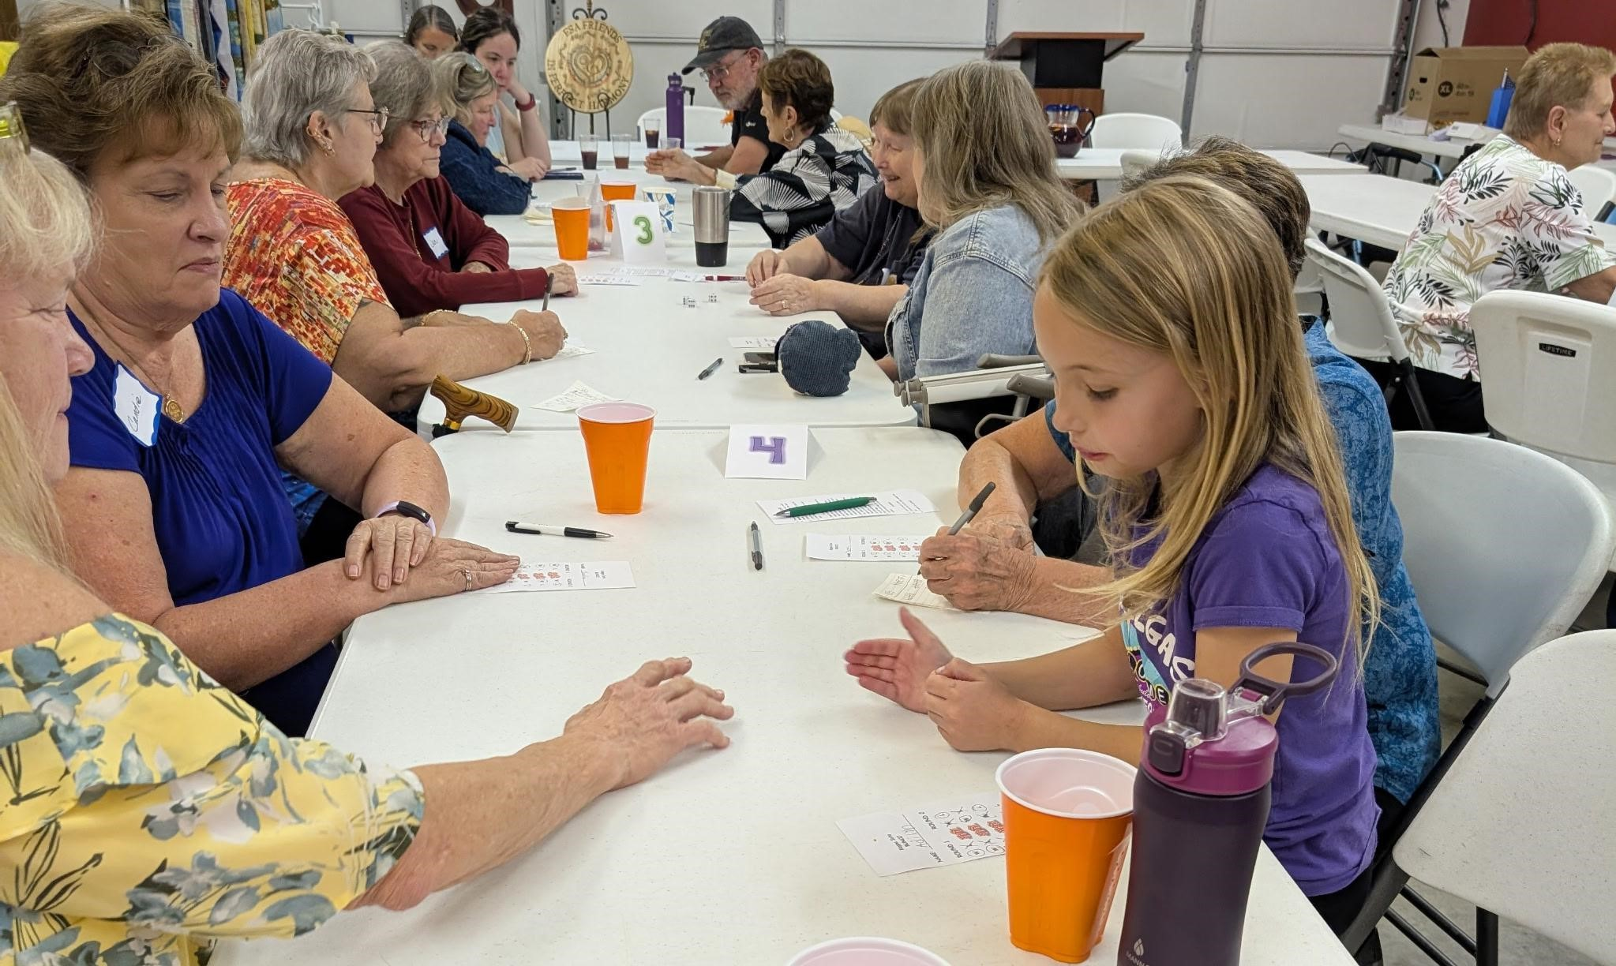
MOST BUNCOS!! Had a tie, so we gave them the option of doing a ROLL OFF, or SPLITING the CASH PRIZE! They chose to split the money with each receiving $37+!
They were Pam McGee and Ginger Dodge! 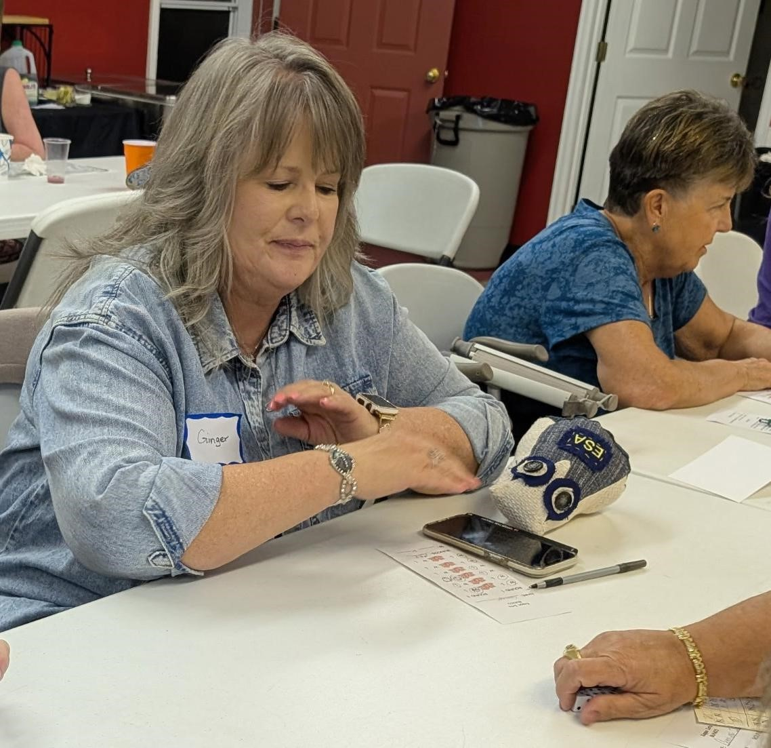
MOST WINS: AGAIN, we had a tie, so we did a Roll Off. It was tight competition between the teams of Chloe McClantoc & Yvonne Farrell or Candie Patino and Addie Mazza! (I saw Addie roll 11, sixes in a row during one of her games!!!) Winners were: Addia Mazza and Candie Patino who won the yearly, “flapping ear”, hats!

-16-

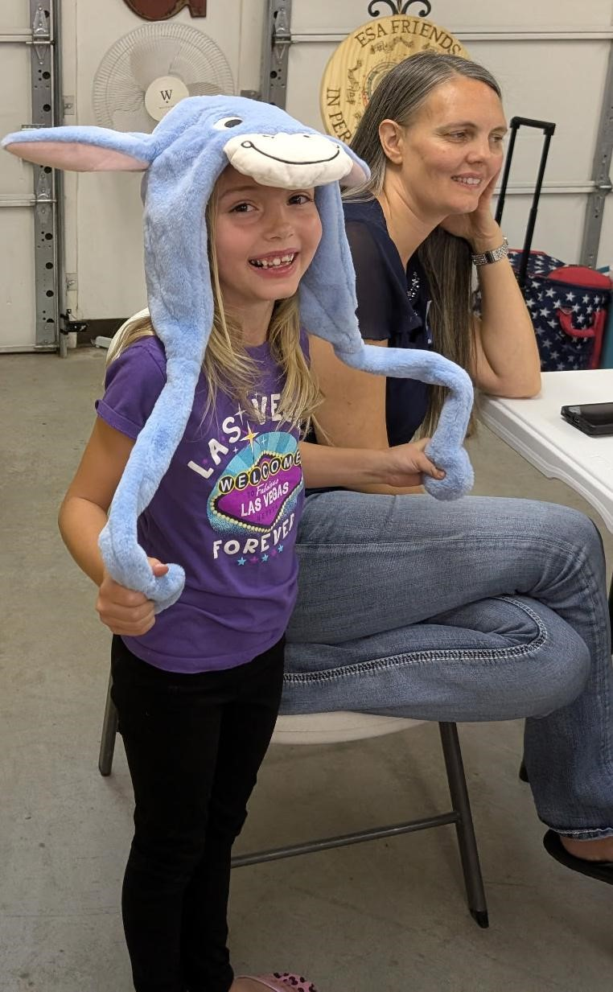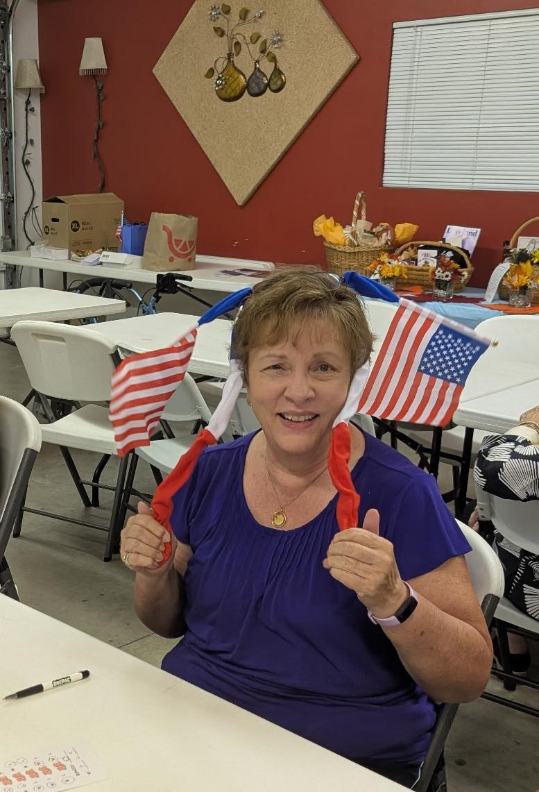
Then, of course we had the MOST LOSSES!! Didn’t have a tie for that one! The team BOTH won a big, ol, bag of White Cheddar, Ranch Popcorn!!!
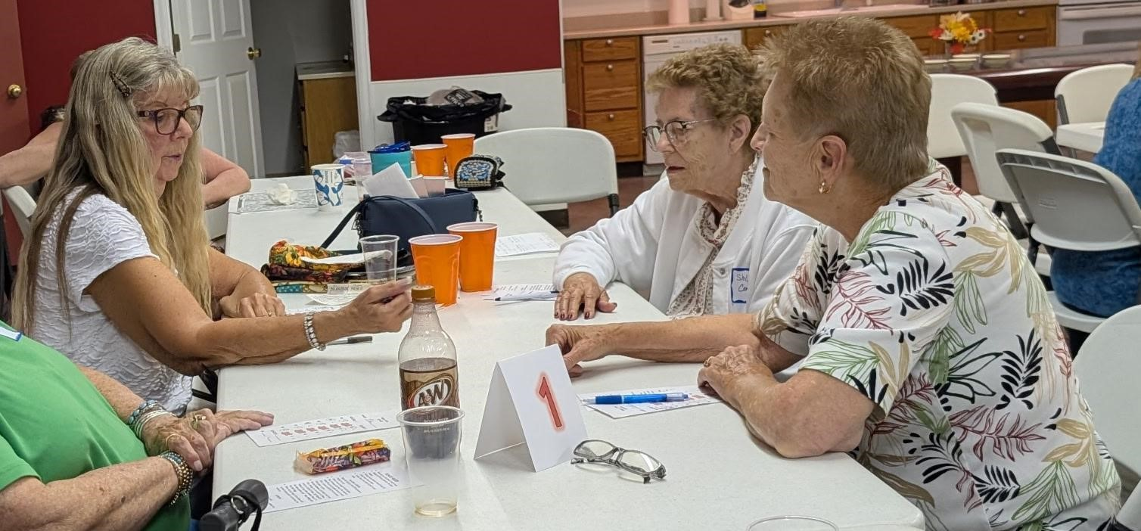
That was Chris Dostel and Joan Schlaffer!!!
We want to THANK everyone who played and supported our donation to the Convention City
Funds, which was a total of $240.00!!! What a GREAT way to start off our year!
CONGRATULATIONS to all our “winners” and CONGRATULATIONS to our President, Lori for a GREAT first meeting!!!
Thank you to all our Alpha Omicron members for the absolutely decadent meals and desserts! Ya all are AMAZING!!
Kappa Iota is furiously working on Troopons and looking into some other “new adventures”!

Be safe this Halloween!
Kappa Iota, Golden


.I.P.
June
2013
-
Sept.
2025
Thank
you
for
13
years
of
joy,
friendship,
laughs,
love
and
all
those
PUPPIES!!!
June Bug
(Momma dog)
You are GREATLY missed!

Chapter Report Beta Zeta #3149

October is always a busy time in Canon City, getting in those last bits of fun before cold
and winter weather sets in. Last weekend was an Oktoberfest event, the Rim-to-Rim
Run Walk at the Royal Gorge, as well as Apple Day in Penrose.
In spite of all the other events, Beta Zeta had a very successful fundraiser, our annual
Soup, Salad and Shopping Auction Luncheon. The soups were delicious as always,
with a choice of chicken and wild rice and a new addition, beef vegetable and barley.
The “crafty” gals of Beta Zeta auctioned many items, ranging from holiday décor to
treats and care packages.
Our chapter will be able to once again give $740 to St. Jude Children’s Hospital from
the proceeds of Nancy T.’s beautiful quilt.
We are looking forward to enjoying the Pledge Banquet with Omega Chi in November.

Carol Dunn, Sue McMillin, Publicity Committee
Beta Zeta Chapter #3149
Canon City

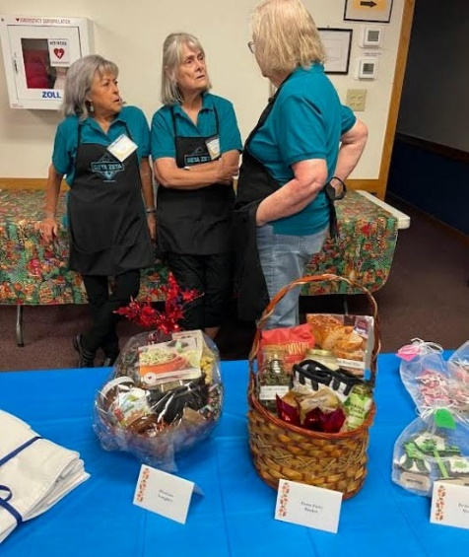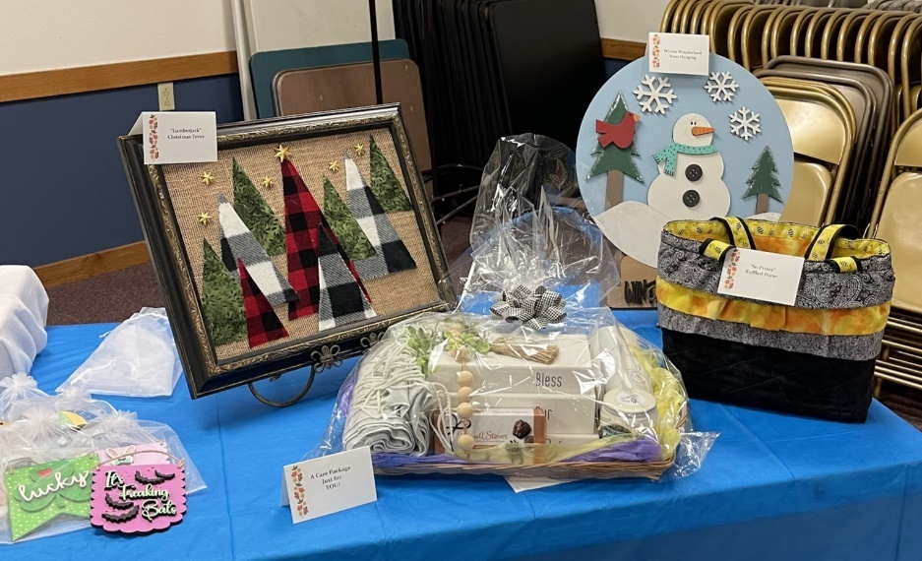

-18-
Chapter Report Alpha Phi #327

The newly elected officers for 2025-2026 are President, Sandy Alexander, Recording
Secretary, Susan Winton, and Treasurer, Linda Noell. We have five members on the
ESA Colorado State Council so our chapter activities will be scaled back to
accommodate their obligations.
Five individuals attended the Colorado State Convention, where Lori Anderson-Havelick
became President and Susan Winton became Treasurer. Eric Havelick will be
Communication Coordinator, Sandy Alexander ESA Foundation Counselor and Linda
Noell is on the Nominating Committee.
Lori, Eric, Sandy, and David attended the International Council Convention in Cary,
North Carolina. We had a wonderful time and learned about the changes happening in
ESA. ESAMC and the ESA International Council along with the Long-Range Planning
Committee has worked diligently to focus on growth. Attending members received a
new mission and vision statement.
Summer activities for our chapter included Lori and Eric once again promoting ESA and
St Jude Children’s Research Hospital at the Ridgeway Farmers Market. As you know
David and Sandy travel in their fifth wheel throughout the summer. Sandy is the IC Audit
chair and has spent countless hours auditing the IC Books, Disaster Fund Books, and
the IC Convention books. Susan volunteers at Second Chance Dog Rescue in
Ridgeway. Pictured is the Alpha Phi team volunteer day with Susan, Lori, Bill, and Eric.
Lori, Eric, and Susan worked diligently on the CSC yearbook and fall meeting held in
Salida. Linda had a special family reunion this summer. She attended her inaugural
Rocky Mountain Regional Council Roundup, which took place in Idaho.
Happy Fall to all,
Sandy Alexander
Alpha Phi

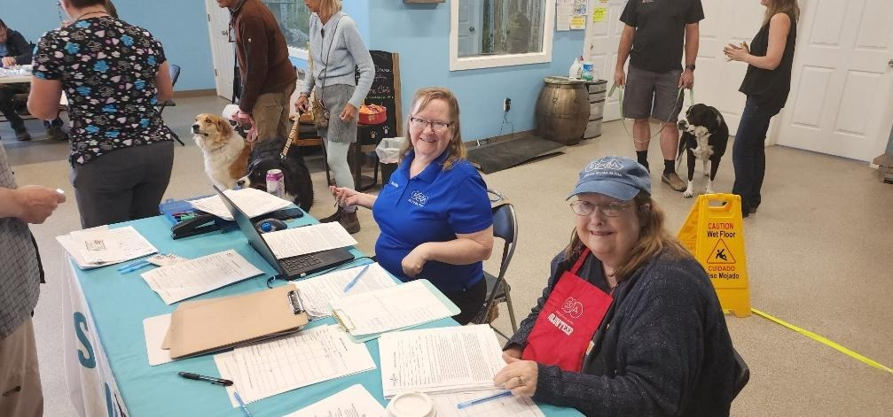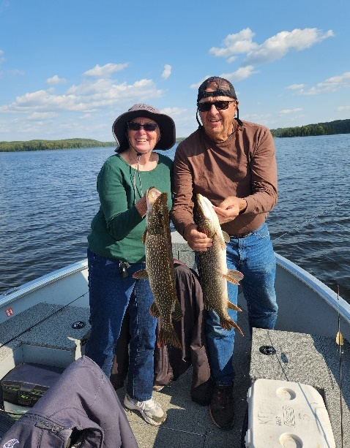
-19-
Chapter Report Gamma Chi #3668

Gamma Chi September News

Finally Fall is in the air. We continue to have beautiful weather, but the nights are a little cooler and leaves are falling to the ground.

As I mentioned in our last newsletter on August 1st, Deena, Lisa, and Ruth Mary volunteered at the annual Wild West Relay. They had 40 relay teams registered. We always help at Exchange 3 just west of Wellington at Waverly Fire Station.

During August and September members continued to volunteer, handing out bread and vegetables at the Veterans Loveland Clinic, helping at the Food Bank monthly, and weekly at the Community Kitchen. We also maintained flowers in the sculpture garden. Some of us volunteer at local schools helping with various activities.

On September 5th Kelly, Tammy, Judi, Kathy F., and Kerry served lunch at the annual fundraiser for Alternatives to Violence, Pastels on 5th. It is always fun to chat with all the artists as they take a break from drawing their chalk art on the sidewalks.

At our first meeting in September, we enjoyed pizza, salad, and Culver’s custard for dinner before the start of the meeting. Our four new members joined us and one guest who is also interested in joining. We spent a lot of time discussing the plans for our annual Mahjongg Tournament on October 11th.

On September 24th we had a potluck and invited some of the Culver’s crew including Dillon the owner to thank them for honoring us with their generous donation. They are always enjoyable to visit with. The picture also includes our President Lisa Weeks. We held a Pledge Ceremony for Tammy Muzzo and Judi Swartz, two of our new members.

That’s the news for now. Enjoy the Fall and who knows we may have snow for Halloween.

Pam McGee
Gamma Chi

-20-

Gamma Chi

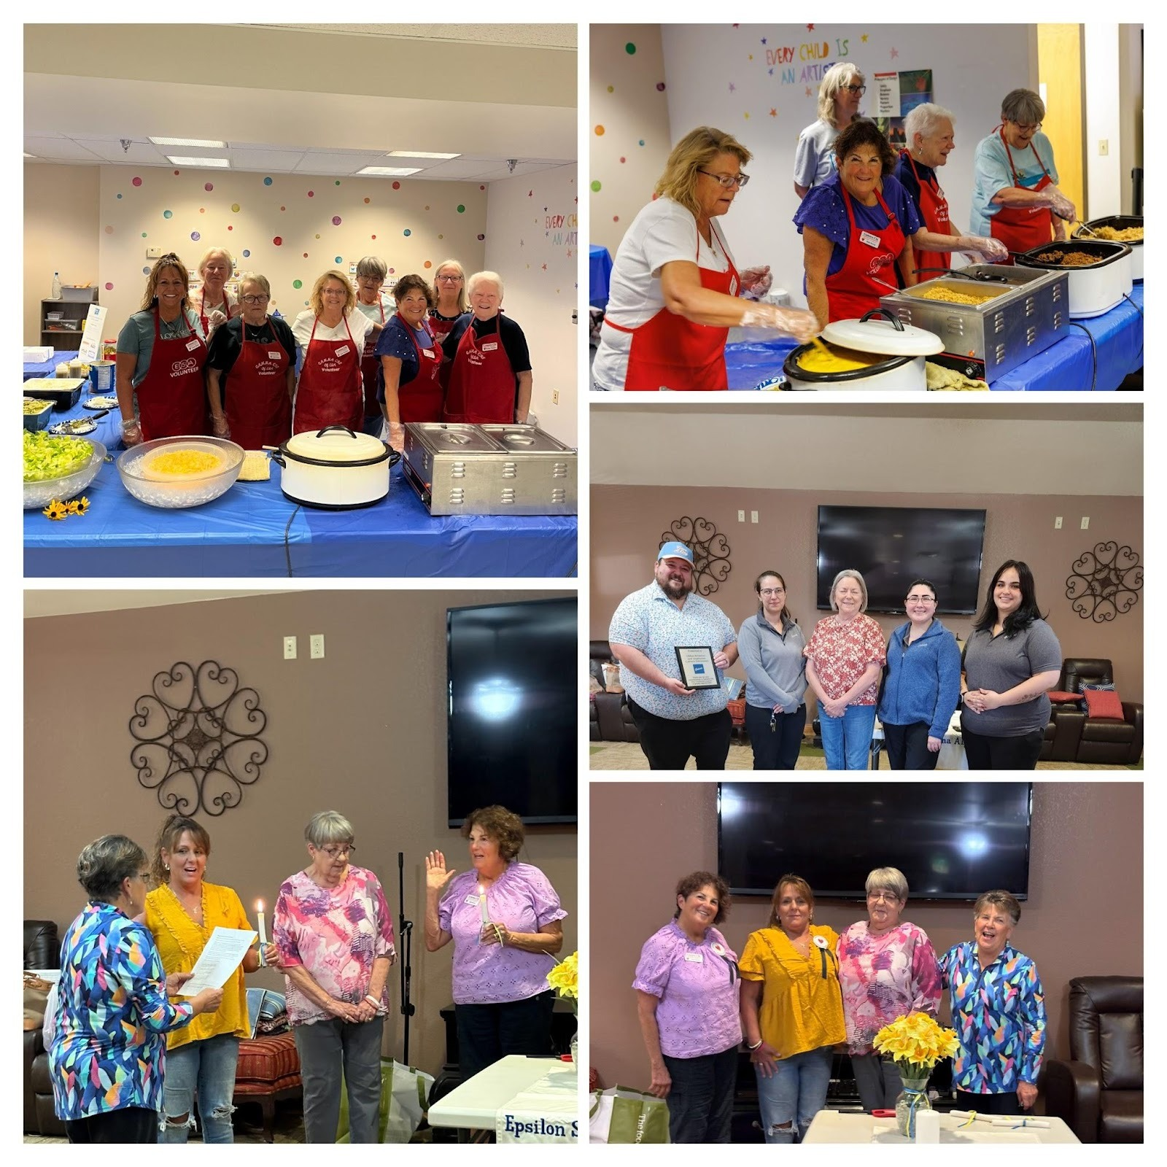

-21-

Chapter Report Sigma Rho #5014

Hello from Sigma Rho #5014, Loveland! We're hard at work and want to give you an update on our activities this fall and our plans for the holidays and beyond.
We're busy planning our Blingo fundraising event for November 12th and finalizing details for all our fall fundraising efforts. Looking ahead, we're prepping for the holiday season with fundraising events that include partnering again with Barnes and Noble and Planks and Paint and planning community volunteering.
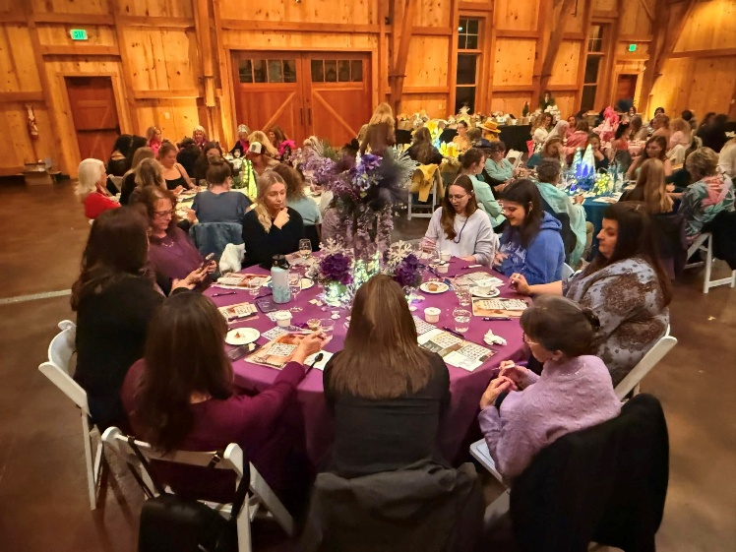
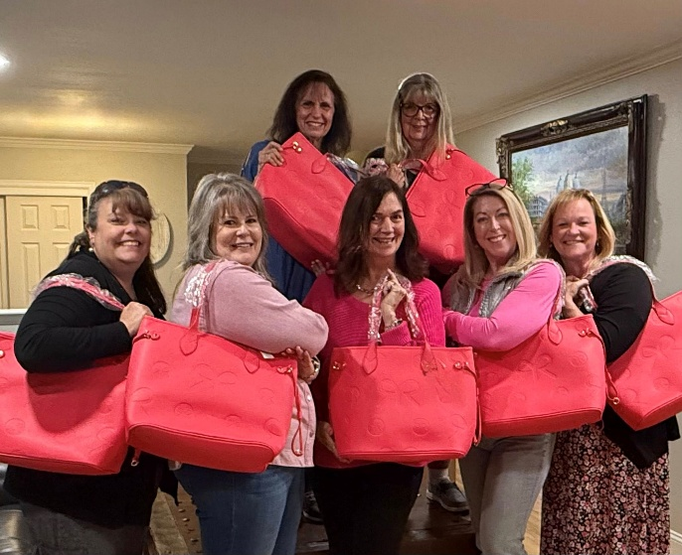
On a much bigger note, we are very busy planning for the State Convention to be held right here in Loveland next April. Look for more information coming soon!
Blingo 2024
Blingo Planning Meeting

-22-

Chapter Report Zeta Nu #5608

The members of Zeta Nu in Colorado Springs recently had a booth at a local craft fair. We needed to raise money for the meals we provide at the Ronald McDonald house. We heard about the planned craft show just 5 weeks before it was slated to happen. It was free to vendors at the 55 and over residence in Banning Lewis. So we scrambled with our various projects and with the help of some dear supporters, we had a good variety of goods to sell. Our friends, two women who do craft shows themselves, donated some of their goods with 100% of the sales going to our Ways and Means fund. The turnout was much better than anticipated and we sold about ½ of our products. It was a fun day and everyone came together to help. 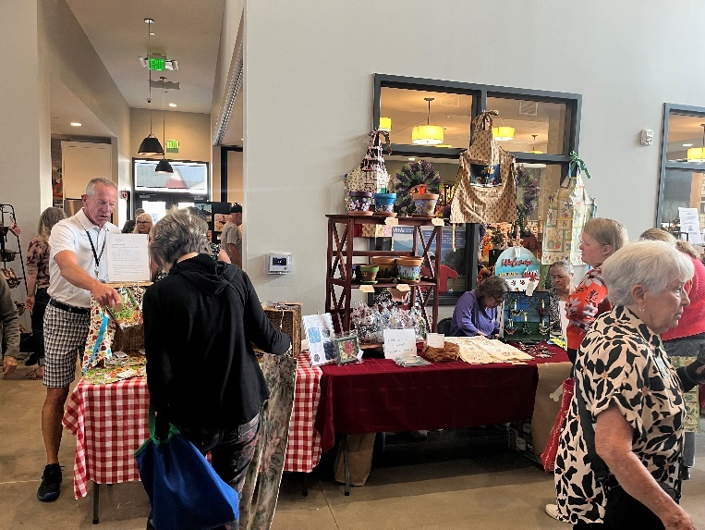 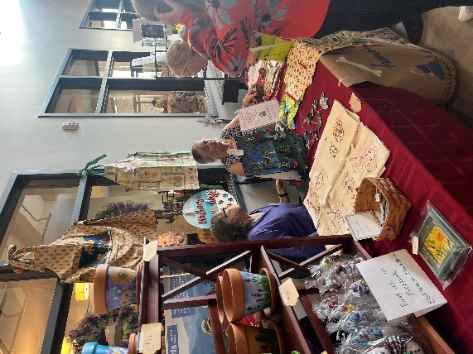

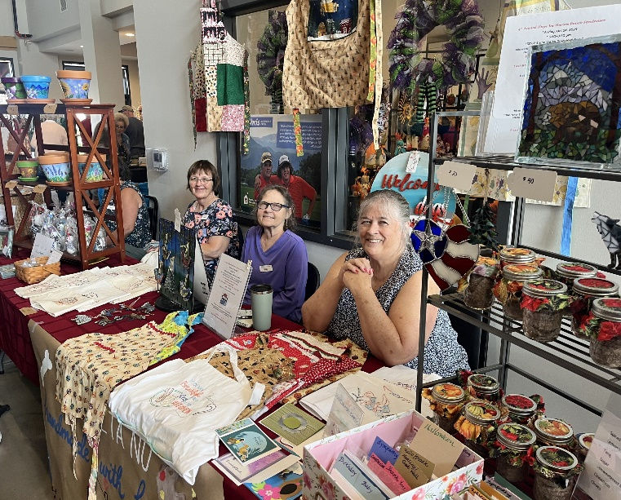

Our next event is our 4th Annual Hope for Heroes Bunco night scheduled for October 24. We have decided to support the Honor Bell, Susan Bloss’s chosen project from last year. If you find yourself in the Colorado Springs area, please join us!

-23-

If you missed the fall leaves, Lori and Eric took these
beautiful pictures on their way from Salida to Montrose.




-24-

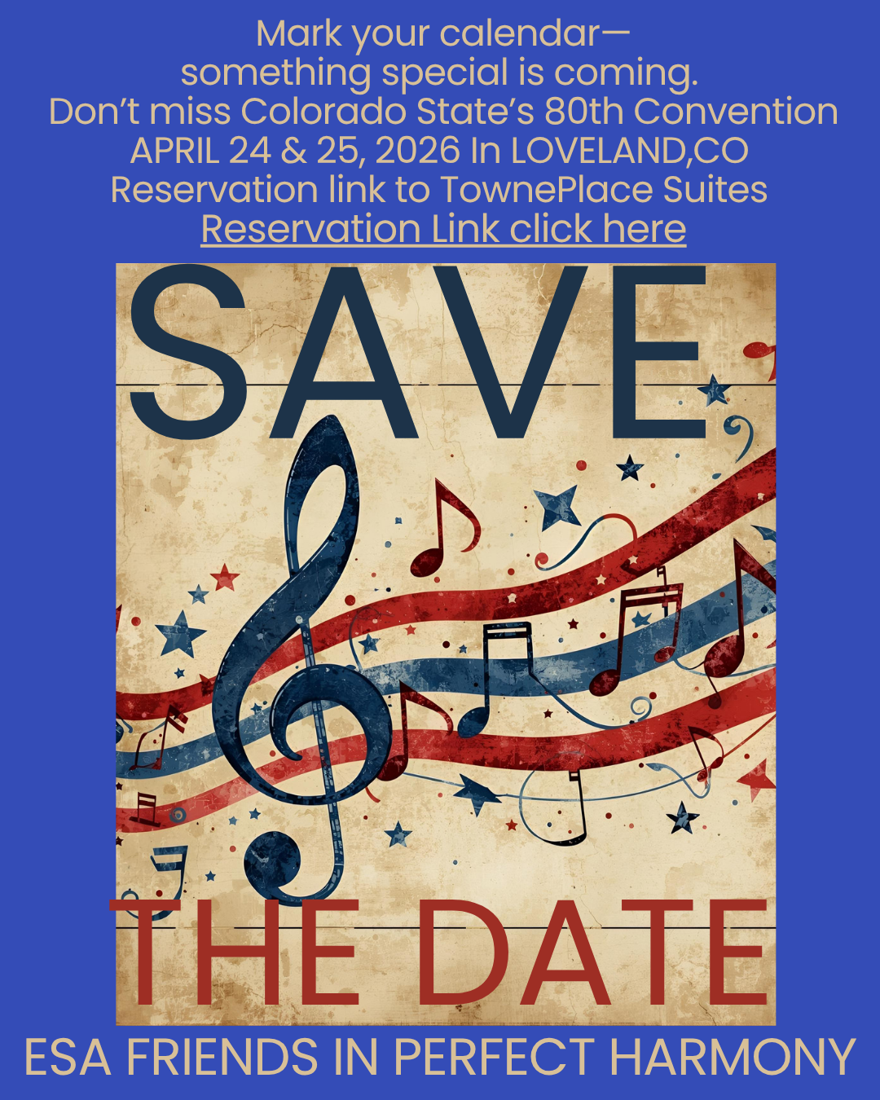

4th Annual Hope for Heroes Bunco Fundraiser
* Friday, Oct 24, 2025
* 5:30-8:00 pm
*12787 Stone Valley Dr in Meridian Ranch
Join us for a night of fun and games at our 4th Annual Bunco Fundraiser benefiting our Military and Veterans
$20 to play -Cash, check or credit card
(Credit cards may incur a usage fee)
Cash Prizes for Most Bunco, Most Wins, Most Losses
Chance Drawings
heavy hors d’oeuvres and drinks provided

This year we are supporting The Honor Bell Foundation.
**The Honor Bell provides a unique funeral honor to deceased military veterans through the slow tolling of a ceremonial bell.

Hosted By ESA Zeta Nu
Please RSVP by calling or texting 719.482.5820

~For a Laugh~
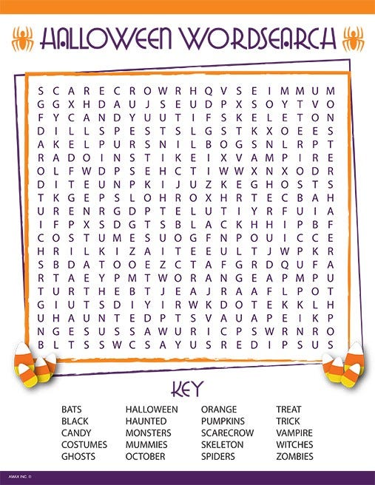
Chiseling with Fear
Two men were walking home after a Halloween party and decided to take a shortcut through the cemetery just for laughs. Right in the middle of the cemetery, they were startled by a tap-tap-tapping noise coming from the misty shadows.
Trembling with fear, they found an old man with a hammer and chisel, chipping away at one of the headstones. "Holy cow, Mister," one of them said after catching his breath. "You scared us half to death -- we thought you were a ghost! What are you doing working here so late at night?"
"My family are such fools!" the old man grumbled. "They misspelled my name and here I have to correct it!"

-27-

Real Tombstones

