
ESA Colorado  Golden Lamp |  | December 2025 | Volume 79 | Issue 9
ESA Friends
In
Perfect Harmony

Lori Havelick-Anderson

Colorado State President 2025-2026

Editor’s Corner  By Karen Addison  Not to sound “cliché” but can you believe it’s already December?!  I have been enjoying the Indian Summer weather this Fall.  This past week, we finally started feeling a bit of cold weather and even a little bit of snow. I know some areas got a lot last week, but here in Colorado Springs, it wasn’t too bad.  What plans does your chapter have for the coming year? I’d love to hear from everyone about upcoming events. My chapter always has something in the works. We have a social event every month and do different fun things. We hold about 4 fundraisers each year, always good for a fun time. Please share what your chapter is doing!  May your holidays be filled with warmth, love, and laughter, and the New Year bring you happiness and success |  | WHAT’S INSIDE
PAGE 2
President’s Message

PAGES 3-7
Officer’s Pages

PAGES 8-14
Chapter News

PAGES 15-19
Fun Pages


Letter from the President  We had a great time visiting with my mom in Grand Junction for Thanksgiving. She will be turning 91 years old in Feb. She still gets around and walks for an hour for exercise.  I hope everyone spends time with family and friends during the holidays.  A reminder to Sponsor a Wreath for Wreaths Across America. “Keep Moving Forward” Dec is coming up fast. The date they will be putting them out is Dec 13th. They even do this in  Montrose at the Cemetery. You can also sponsor a Wreath at any time, and they will put it out for next year.  In further research I have decided not to go along with my original post concerning serving food at Veterans Hospital. In learning more about the Veterans Hospital, you must jump through a lot of loopholes, testing and have certain food temperatures to keep the food hot or cold.  Lori Havelick-Anderson  Colorado State President |  |  | Operation Gratitude Care Packages  I’d like to recommend sending care packages to the Troops. I think we need more emphasis within our charity group to help the Veterans and Active Military. Please post pictures on Facebook of your chapter’s accomplishments and send an article to the Golden Lamp.  .  My favorite project is still Operation Gratitude. Check out the site at operationgratitude.com.  There you will find guidelines on how to pack the donated items. The directions are on the website. You can send sudoku, word search, and crossword puzzle books to Operation Gratitude. The puzzle books need to be new, preferably 5 x 7 books. Other items they are collecting: new and sealed protein snacks - packaged jerky, Slim Jims, nuts, peanuts, dried fruit and hard candies, Trident gum, Instant coffee Singles. Personal Care items are accepted as well.  There is a Product Donation Form to fill out. Complete the Form before you ship the items.  https://www.operationgratitude.com/product-donation/  Include Barcodes: After completing the form, you receive printable barcodes via email. You  must include a copy of these barcodes in every box you ship to ensure your donation is tracked.  Send your puzzle books and other items to this address:  Operation Gratitude  9409 Owensmouth Avenue  Chatsworth, CA 91311
Did you know?  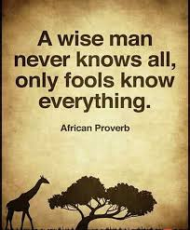 | There is actually a word for someone giving an opinion about something they know nothing about. An 'ultracrepidarian' is someone who voices thoughts beyond their expertise. Hmm, I think I know a few of them.

-2-

My wish for you at tnis Christmas Season LOVE & PEACE

Nancy Cameron
President Elect
.

MY WISH FOR Colorado State Council (& ME)
Please help by filling my mailbox, email, voicemail or phone call with NOMINATIONS!

Chaplain
LAIN
ESAF
E
SEALS

TREAS/DISASTER FUND PRES ELECT SECRETARY HOPE 4 HEROS ST JUDE PHILANTHROPIC


COMMUNICATION COORDINATOR GOLDEN LAMP EDITOR
With GREAT BIG hugs, Nancy

-4-


The Holidays are here and I am wishing a season of health, friendship and COOKIES for
everyone.
As we wind up the year, I’d like to share a little about the Pikes Peak Honor Bell which was my
President Philanthropic Project:
In 2014 a team of veterans founded the Honor Bell Foundation driven by their desire to
honor those who made the ultimate sacrifice or served with valor for their nation by
paying a final tribute. The first bell, the Fort Logan Honor Bell went into service
Memorial Day 2016 and since that time has tolled over 8,000 times. Over the years, the
Fort Logan Honor Bell was brought to Pikes Peak National Cemetery once monthly to
provide Bell Honors in our community.

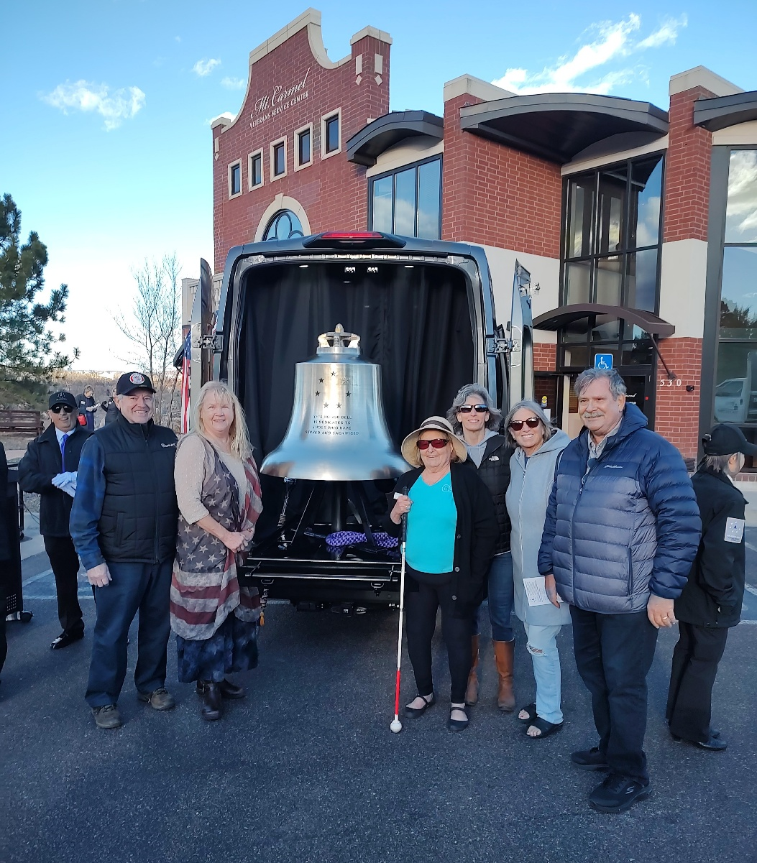

As the number of Honor Bell requests increased, the Honor Bell Foundation recognized
the need for a second Bell and the Capital Campaign for the Pikes Peak Honor Bell
began. In 2025, ESA Colorado joined this Campaign and contributed throughout 2024-
2025. Funding goals were far enough along by May 2025 to select artifacts from the
families of 12 different southern Colorado veterans to be cast into the Bell. Honor Bell
Foundation members hand-carried the artifacts to The Netherlands for the casting. After
casting, the Bell was returned to Ohio where it was polished and tuned, then driven to
Colorado Springs by Honor Bell Foundation members. The Pikes Peak Honor Bell
dedication was held on November 17, 2025. The Honor Bell is now in service at the
Pikes Peak National Cemetery.
Thanks to each and every one of you that helped make this happen. The Bell is beautiful, and
ESA was mentioned as being donors for the Bell’s funding. Way to go ESA Colorado
Soon it will be January and a New Year starting. As you continue to serve your community in all
the ways you do, please keep track of all your hours/events/monies and triumphs as we all
deserve BIG PATS ON OUR BACKS come State Convention.
I am looking forward to sharing all we do with all of our members.

Keep on hootin’ ------

Susan Bloss
Past President

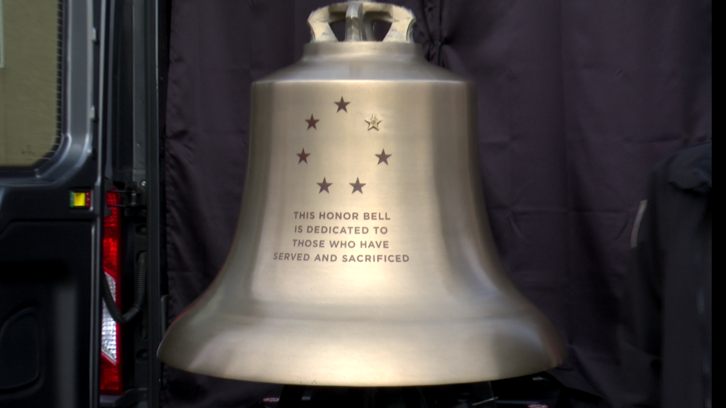



ESA Foundation
Golden Lamp Article
December 2025

Winter greetings,
I know you are experiencing cold and snowy days in Colorado. So sorry!
Hope you enjoyed Thanksgiving with great food and company!

ESA Foundation Reminders:
Scholarship applications are due at 11:00pm MST on February 2, 2026.
To maintain your Foundation membership and ensure your eligibility to vote in
2026, please be sure your annual dues are received by December 31 st . If you do not
remember, I have a current list.

The ESA Foundation would like to thank three members of the CSC for their Plateaus of
Achievement in 2025. At the Bronze level, $250-$499, Chris Dostal and Shirley
Conway. Receiving the Silver level, $500-$999, Yvonne Farrell. Congratulations Ladies,
your contributions make a difference.

DID YOU KNOW:
State of the Foundation Report provides a good overview of the Foundation’s activities
and programs. The State of the Foundation Report can be found on the ESA website.
Click on the pull-down menu under Scholarships &amp; Grants, click on ESA Foundation, scroll down to the second paragraph, and click on State of the Foundation 2024 Report.
This report addresses key financial questions.
Wishing you a Blessed Christmas Season.

Sandy Alexander
2025-2026 ESAF Councilor
Chapter News  Gamma Chi #3668

It is cold this morning as I write this. Maybe winter is finally here, though I did enjoy the weather the last two months.
October started off with our annual Mahjongg Tournament at High Country Beverage. We had a full house. Lisa Weeks always puts a lot of time and energy into this project. We made a lot of salads which were well received. The fundraiser for St. Jude was very successful as we raised $5,400. There were drawings donated by some of the Mahjongg players. Then on to the end of the month. October 29th a few members helped make blankets for the Feel Love Blanket making event for Children’s Hospital. On Halloween we held a Blood Drive again in the parking lot of the Golden Corral. We were able to fill up all 25 slots. We appreciate all the people that make it so successful.
Our November days filled up quickly. On November 11th Veteran’s Day began with Phyllis as the Keynote speaker at Dwayne Webster Park after the Veteran’s Parade. It was a great speech. We are very proud of her. Then starting at 4pm one team started busing tables at Golden Corral during the Veteran’s Day dinner. At 6pm the next team came in. It is always a great time, hard work, and we get to talk with a lot of special people. Then on the 20th a team of 7 Gamma Chi members helped with the Tour de Turkey at the Orchards parking lot. People drop off turkeys for the Food Bank to hand out before Thanksgiving. It was a little chilly, but they collected 150 turkeys. Then on the 24th members met at Kerry’s house to fill coffee mugs to hand out on December 1st at the Veteran’s Clinic. We have been doing this for many years. To round out the month Phyllis’s house was the drop off point for the Kayla Foundation food and toy drive. You will see by one of our pictures looking into her house from her front door people brought 600 pounds of food and toys. Besides all this, candy making has begun and we will be boxing it very soon

-9-
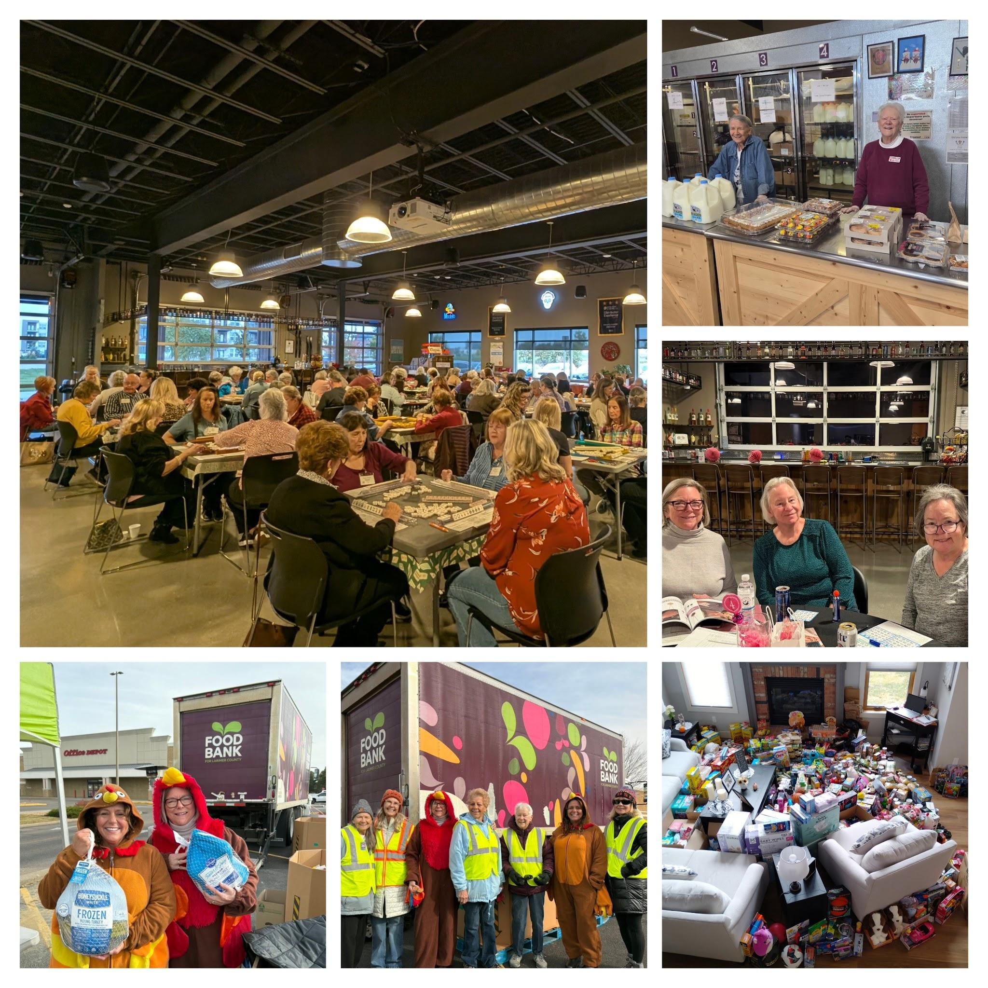

As always we continue to volunteer at the Community Kitchen, the Food Bank, and Phyllis attends the weekly PAMVETS breakfast on Saturday mornings. Also a couple of members attended Sigma Rho’s fund raiser.
Besides getting ready for the holidays, Gamma Chi does have a few projects going on in December.
Merry Christmas to all our friends and Happy New Year.
Pam McGee

Chapter News Zeta Nu #5608
This has been a busy year for Zeta Nu! We meet every month throughout the year and hold a social almost every month. We plan four fundraisers each year, but sometimes we do a little more. This is a view into the past year with Zeta Nu.

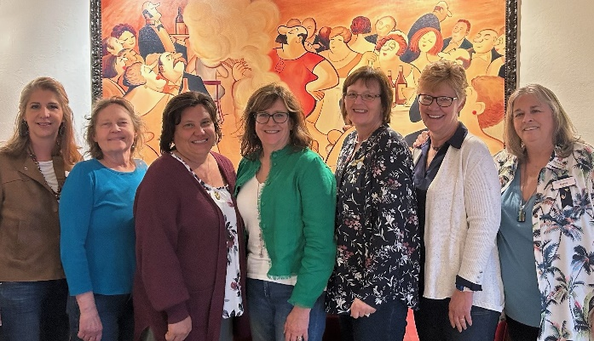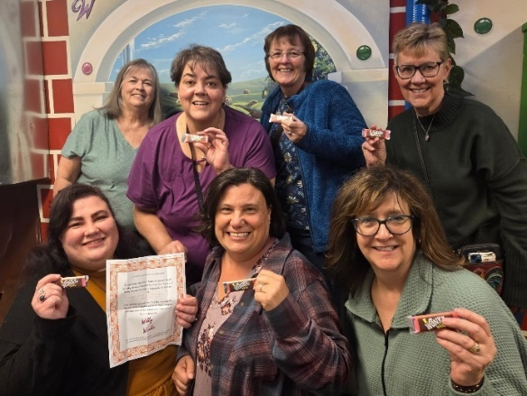
Social – Dinner at Mimi’s Social – Willie Wonka Escape Room
Our social events are very important to us. We look for fun things to do, such as dinner out, movies, axe throwing and escape rooms.
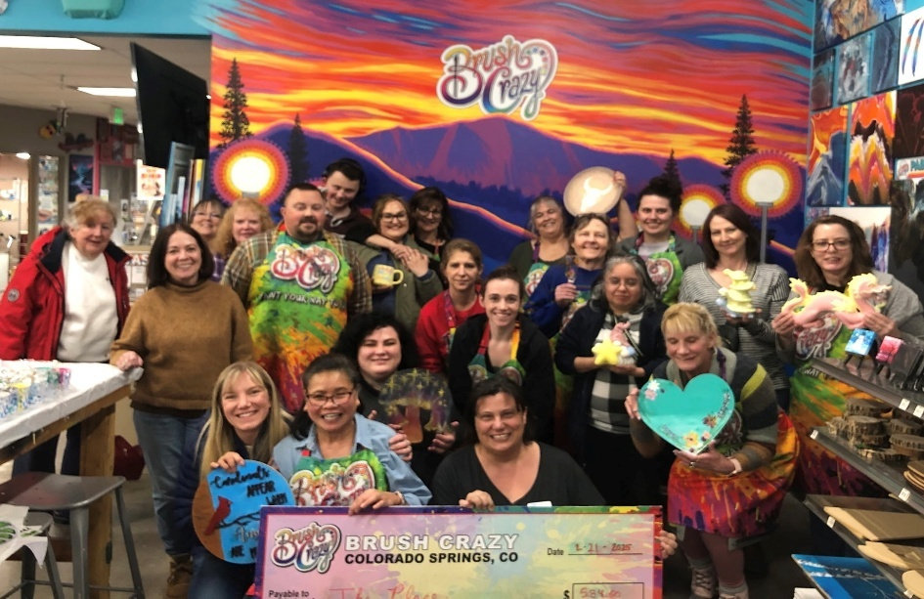
Brush Crazy Fundraiser
-11-

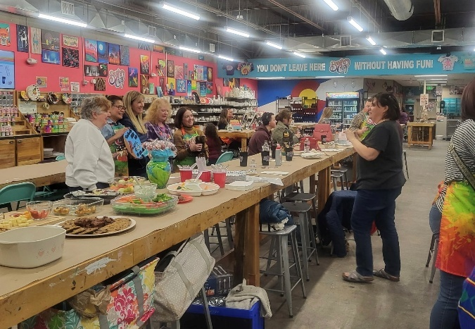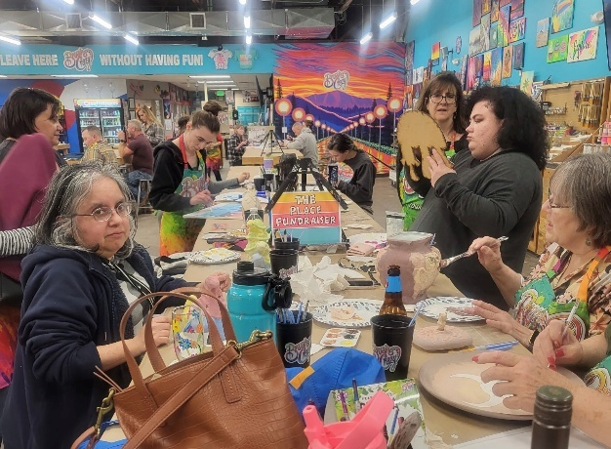
The Brush Crazy Fundraiser is our favorite! We invite people, bring food to feed them, and Brush Crazy donates a portion of all proceeds to our chosen charity! It is always a great turnout!

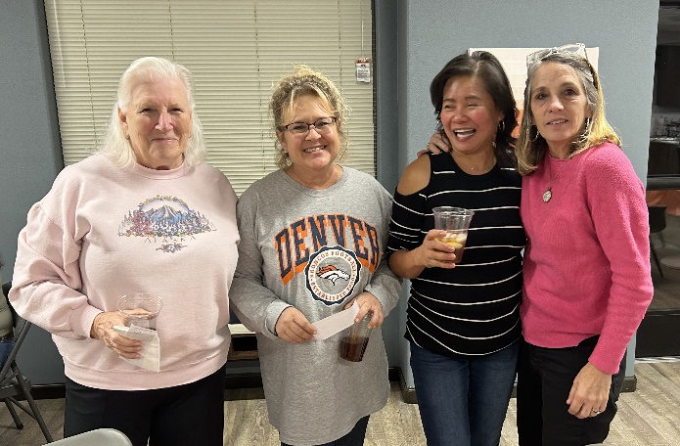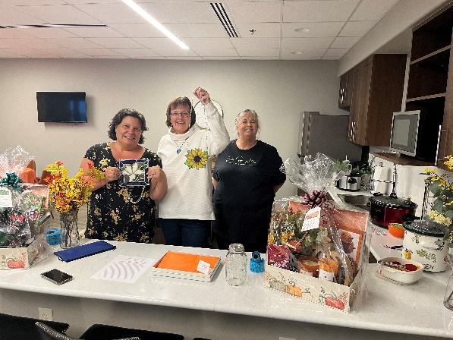
Hope for Heroes Bunco Fundraiser
We have hosted our Hope 4 Heroes Bunco Nights for 4 years. It’s always a popular event.

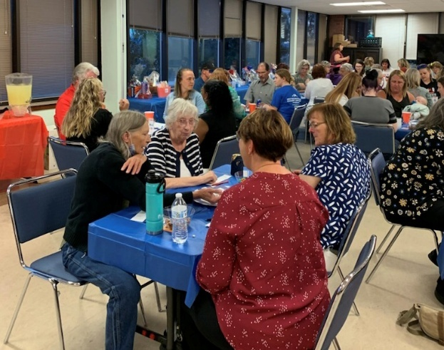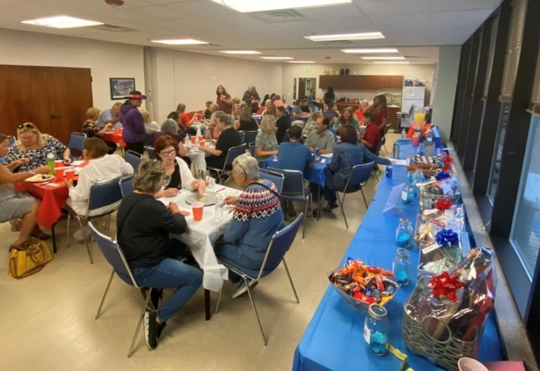

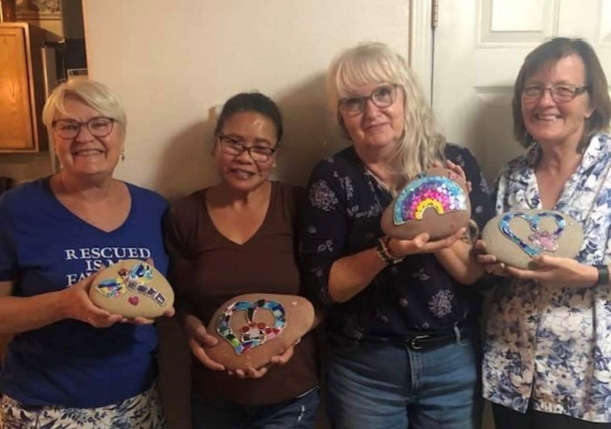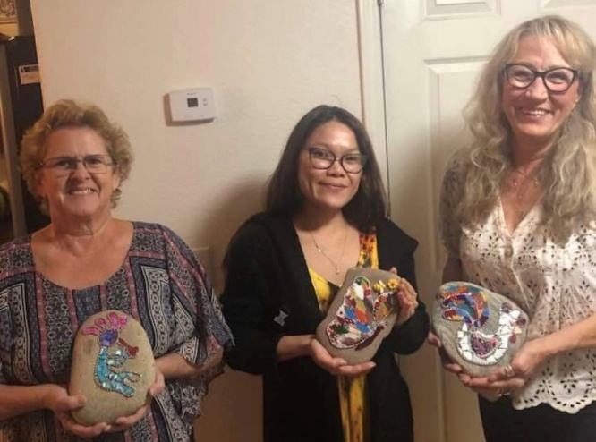

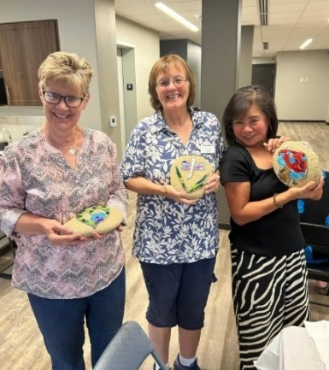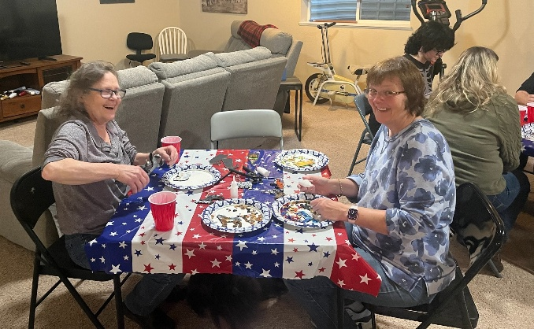
Crafts are popular with our group. We have mosaics classes and even did a social to make mosaic ornaments for our friends.
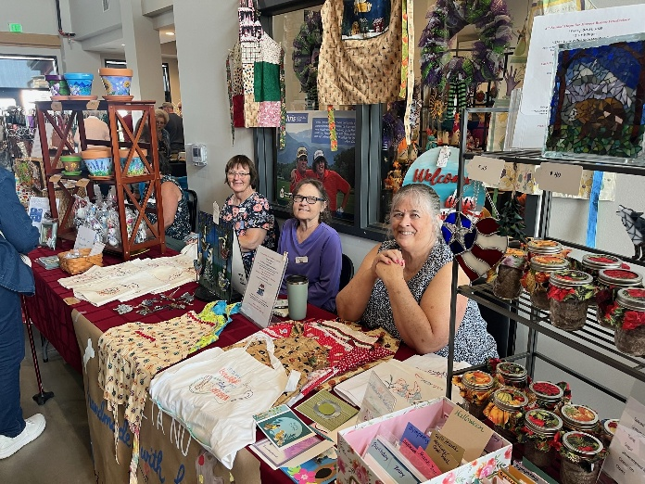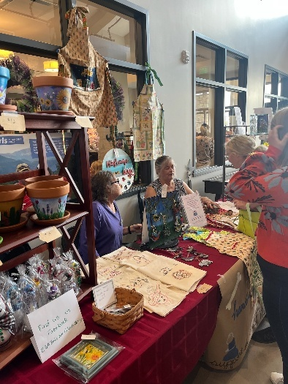
We even did a craft show in September for our Ways and Means fund, to help us pay for the Ronald McDonald House meals that we provide. It was a lot of fun!
Here’s to an awesome 2026! 

-13-

Chapter News Beta Zeta #3149

Beta Zeta has had a fun, productive fall!
Of course, our Soup, Salad and Shopping Auction was a great success again.
And next years event is in the planning stages!

Educational Directors have provided us with a variety of fun, interesting programs and
activities related to President Mary’s theme for the year, “Connecting to..”

We connected with our creative side to paint some cute little purse pouches.

The local Colorado Parks and Wildlife officer Zac Holder connected us to the “Nature” in
our local wild places. He displayed a couple of bear skins from both a brown bear and a
very scary Grizzly. Zac discussed the habits of the bears we sometimes see in town and
how to stay safe with these visitors. Our Nancy B. has always loved everything about
bears and she and the rest of the group enjoyed the program.

Local Rotarian, Linda Carlson, talked about a recent trip to Greenland. The fascinating
program explained the interesting culture, climate and people of the island. Her slide
show featured some of the food (dried, fermented, whale—YUK!), the beautiful crafts
made from yak hair and pictures of the indigenous people. We discovered what a
beautiful but harsh place Greenland is.

Ready for a New Year full of interesting discoveries!
Beta Zeta would like to extend Holiday Wishes to all our Colorado friends.

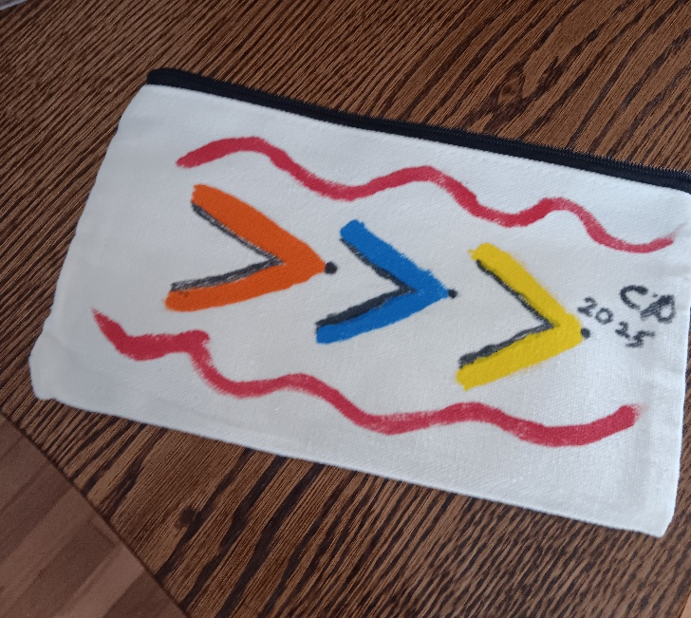

These are always a hit at Holiday parties. I like to use hot pepper jelly instead of the cranberry sauce. (See below)

Cranberry Brie Bites

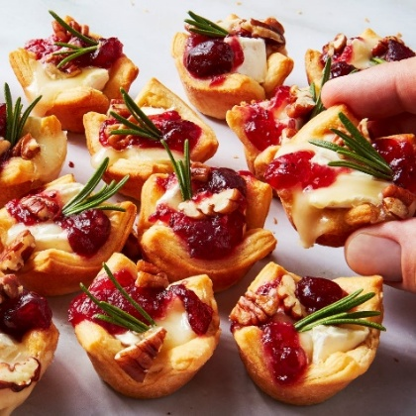

Ingredients
Cooking spray
All-purpose flour, for dusting
1 tube crescent dough sheet
1 wheel of Brie
1/2 cup whole berry cranberry sauce
1/4 cup coarsely chopped roasted, unsalted pecans
6 rosemary sprigs, cut into 1" pieces.

Directions
  - Arrange a rack in center of oven; preheat to 375°.
  - Grease a mini (24-cup) muffin tin with cooking spray.
  - On a lightly floured surface, roll out crescent dough and pinch together seams. Cut into 24 squares. Press squares into prepared cups. (I pre-cook them about 5 minutes to be sure the bottoms get done.)
  - Cut Brie into small pieces and place inside dough.
  - Top with a spoonful of cranberry sauce, pecans, and one piece of rosemary.
  - Bake bites until pastry is golden brown, about 15 minutes.
Variation – Substitute hot pepper jam for the cranberry sauce. Use thyme instead of Rosemary. Use candied pecans.
To make candied pecans, melt 6 T butter in a large saucepan. Line a cookie sheet with parchment paper. Add ½ c brown sugar to butter, stir and cook 1-2 minutes until melted. Stir in 2 c pecan pieces, cook 5-9 minutes stirring constantly. Mixture will thicken, get bubbly and sticky. Pour nuts onto cookie sheet and spread out. When cool, break into pieces.

-15-
Christmas Jokes to Share 

- Q: What do you call an elf wearing ear muffs? A: Whatever you want. He can’t hear you anyway.
- Q: I can travel all around the world just like Santa Claus without ever leaving my corner. What am I? A: A stamp.
- Q: What do you call a snowman with a six-pack? A: An abdominal snowman.
- Q: You can catch me easily, especially during the holidays, but you can never throw me. What am I? A: A cold.
- Q: What do you call it after all the gifts for Christmas have been opened? A: Christmess.
- Q: I am a plant seen every Christmas which people hang up above and then they stand beneath me and kiss someone they love. What am I? A: Mistletoe.
- Q: We traveled from the East, following a bright star, bringing gifts to the newborn King. Who were we? A: The three wise men.
- Q: Why do you go to bed on Christmas Eve? A: Because the bed won't come to you.
- Q: What did Adam say on the day before Christmas? A: It's Christmas, Eve.
- Q: What do you have in December that you don’t have in any other month? A: The letter D
- Q: What has many keys but can’t open Santa’s sleigh? A: A piano
- Q: How was the snow globe feeling on Christmas Eve? A: A little shaken.
- Q: Sometimes cubed. sometimes with a knot. Forever a secret this is not. Sometimes with thought this thing is bought. Sometimes by skill this thing is wrought. Most often with bright colors adorned. This might be carried, displayed, or worn. A: A present.
- Q: What do you call an elf who rhymes? A: A wrapper
- Q: I am tall when I am young, and I am short when I am old. What am I? A: A Christmas candle.
- Q: What’s the hardest thing about learning to skate? A: The ice.
- Q: What is the best Christmas gift you can give someone? A: A broken drum because it cannot be beaten.



According to the Alaska Department of Fish and Game, while both male and female reindeer grow antlers in the summer each year, male reindeer drop their antlers at the beginning of winter, usually late November to mid-December.
Female reindeer retain their antlers till after they give birth in the spring. Therefore, according to EVERY historical rendition depicting Santa's reindeer, EVERY single one of them, from Rudolph to Blitzen, had to be a girl.
We should have known... ONLY women would be able to drag a fat man in a red velvet suit all around the world in one night and not get lost.

Christmas Spirit
It was just before Christmas, and the magistrate was in a happy mood. He asked the prisoner who was in the dock, 'What are you charged with?'
The prisoner replied, 'Doing my Christmas shopping too early.'
'That's no crime', said the magistrate. 'Just how early were you doing this shopping?'
'Before the shop opened’ answered the prisoner.

Buy Your Own Gift
Last Christmas, grandpa was feeling his age and found that shopping for Christmas gifts had become too difficult. So, he decided to send checks to everyone instead.
In each card he wrote, "Buy your own present!" and mailed them early.
He enjoyed the usual flurry of family festivities, and it was only after the holiday that he noticed that he had received very few cards in return. Puzzled over this, he went into his study, intending to write a couple of his relatives and ask what had happened. It was then, as he cleared off his cluttered desk that he got his answer. Under a stack of papers, he was horrified to find the gift checks which he had forgotten to enclose with the cards.

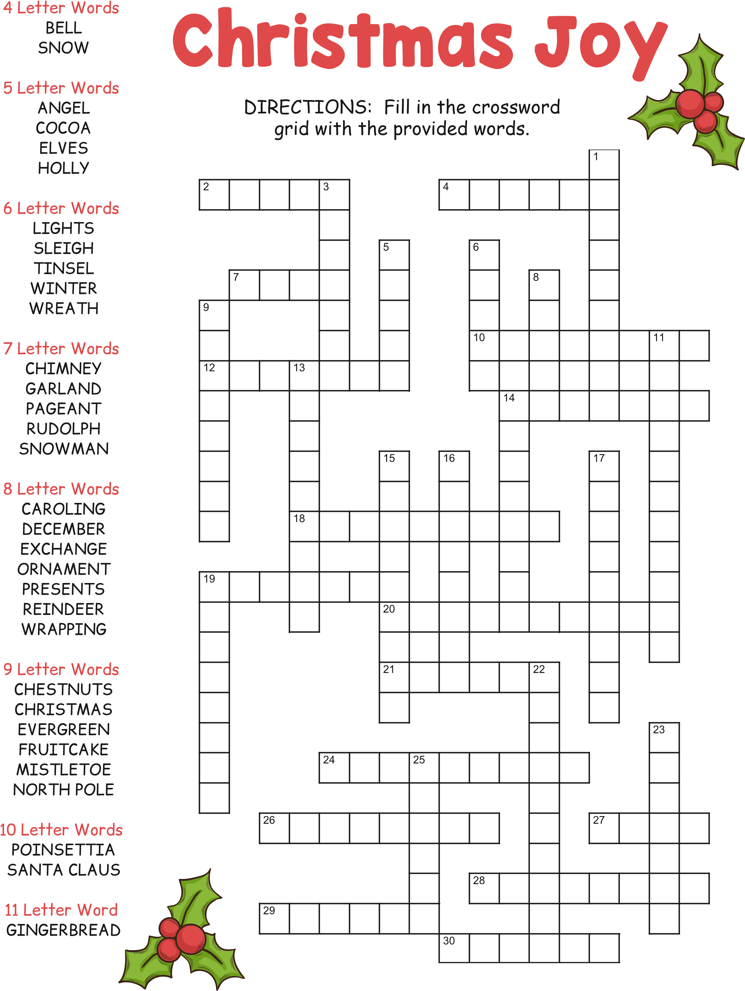
© 2020 puzzles-to-print.com


Fireworks off Pikes Peak in Colorado Springs
See you next year!

