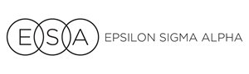

COLORADO STATE COUNCIL

**STATE YEARBOOK CHANGE FORM**

**We apologize for any errors. Please send corrected information as quickly as possible. Thank you for your patience and understanding.**

#### SEND COMPLETED FORM TO: Communication Coordinator

#### ESA Colorado State Council

|  |
| --- |
| **Page(s) - Identify by Title of Page** |
| **Corrected Information** |