COLORADO STATE COUNCIL
HOPE FOR HEROES PROJECTS
Due April 1
(Reporting period: April 1 through March 31)
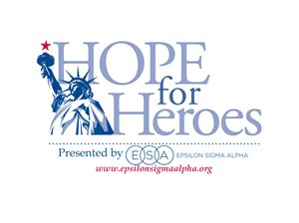
Date:

SUBMIT TO: Hope for Heroes Chair (H4H)
ESA Colorado State Council
The form may be emailed or mailed.

Chapter Name and Number: ________________________ City: _____________________
Chapter H4H Chair or Philanthropic Chair: _______________________________________
Phone: __________________ Email: ________________________________

List Projects

NOTE: Report hours and combined monies for Hope for Heroes projects and Hope for Heroes Coupons on the CSC Annual Philanthropic Report Form.

