**COLORADO STATE COUNCIL**

**HOPE FOR HEROES PROJECTS**

**Due April 1**

(Reporting period: April 1 through March 31)

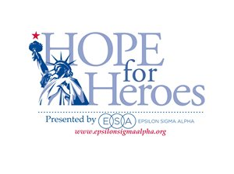

**Date:**

**SUBMIT TO: Hope for Heroes Chairman (H4H)**

**ESA Colorado State Council**

**The form may be emailed or mailed.**

Chapter Name and Number: ________________________ City: _____________________

Chapter H4H Chair or Philanthropic Chair: _______________________________________

Phone: __________________ Email: ________________________________

|  |
| --- |
| **List Projects** |
|  |
|  |
|  |
|  |
|  |
|  |
|  |
|  |
|  |
|  |
|  |
|  |

**NOTE: Report hours and combined monies for Hope for Heroes projects and Hope for Heroes Coupons on the CSC Annual Philanthropic Report Form.**