ESA Colorado
1929-1979
From ESA 50th Celebration publication – 1979
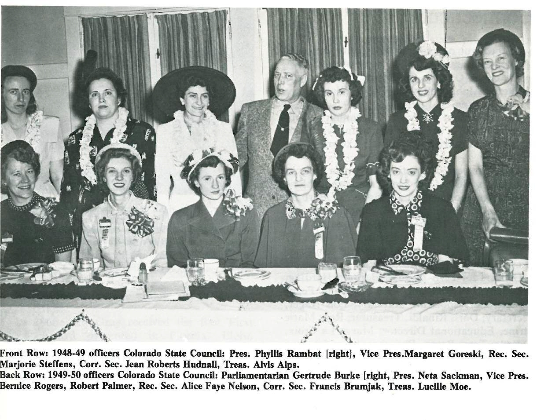
Epsilon Sigma Alpha sorority held its first Colorado State convention in September, 1930. It was in the Cosmopolitan Hotel, Denver with 150 members representing 19 chapters. No record can be found of any further conclaves in those early days, but Colorado had 24 chapters in 1932 with an active Denver City Council.
Unfortunately, ESA suffered during the depression years, and all Colorado chapters disbanded. It was not until the Spring of 1941 that ESA was revived in Colorado By Bob and Dixie Palmer with the formation of four chapters.
The first officers of the Colorado State Council were installed in Denver on May 18, 1947 by Bob Palmer. Agnes Clark accepted the presidency. Membership consisted of 49 chapters.
In 1959, the Lamplighters, an organization of Past Colorado State Presidents was formed. Officers of the group are elected every two years.
Other beginnings in the State Council were: “ESA News” was first published in 1961 (named changed to Golden Lamp, 1966); Girl of the Year was first presented to Kay McLaughlin in 1961; the Circle of workshops was introduced in 1964; the Volunteer Program began in 1975 and a Coat of Arms was designed by Jan Bowland in 1977.
In 1978 there were 78 active ESA Chapters in the State with a membership of 1,127. Officers of the state council are elected and installed at state convention which is held the third weekend in May. Convention sites in all parts of the state are selected two years in advance. Sandie Crosier, Akron, served as president during the Golden Year of ESA. Officers serve as liaison between the council and chapters as in-service officers.
On September 23, 1978, St. Jude Children’s Research Hospital was adopted as the State philanthropic project. Previous projects were Cerebral Palsy, introduced in 1951, and March of Dimes in 1971. During the 1977-78 year a total of $67,000 was donated to many worthy projects by Colorado ESAers.
There are eight area councils in the state, two in Denver and the remaining in other areas. Not all chapters belong to councils. Some prefer to belong only to state council.
Colorado hosted the 1967 I.C. Convention and celebrates ESA’s Golden Jubilee I.C. Convention at Denver in July 1979.

