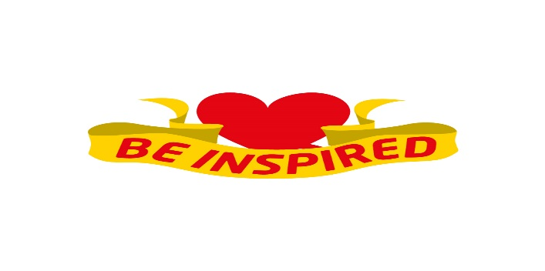
Colorado State Council
Spring Leadership

Country Steak Out
19592 E 8th Avenue ~ Ft Morgan Colorado
March 17 & 18, 2017

Registration $50 per person
Name________________________________ Phone_________________
Street________________________________________ Chapter_________
City________________________ Zip____________ Chapter #_______

Special Dietary Needs________________________________________
Make Checks Payable to: Kathy Ellingson
Mail registration form to: Phyllis Minch
Registration due 3-1-17 1805 Bonny Drive
Loveland, CO 80538
Best Western—Brand New Property!!
1410 Barlow Rd (right off I-76 @ exit 82)
970-370-2322
Call by February 17th to reserve your room for special rate of $105.99 includes complimentary hot breakfast. Room block under Colorado ESA

