Alpha Lambda Chili Supper
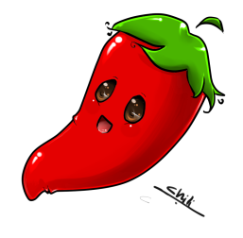
Please join Alpha Lambda for their annul Chili Supper. Lots of companionship, fun, food, door prizes and a grand prize drawing.
Chili Supper - $10.00
Proceeds to go to: Local Charities, St. Judes and Childrens Hospital
Grand Prize drawing: tickets $1.00 each or 6 for $5.00
Crafts will be available for purchase

When: Thursday; March 23, 2016
6:30 PM – 8: PM

Where: Farr Library
1939 61st Avenue, Greeley, CO 80634

RSVP: RuthMary Lyons
Rm80620@hotmail.com
970-405-0263

Ula Rae Adler
Ularae72@hotmail.com
970-330-4962 or 970-302-6572

