

Registration Fee: $140

Rooms per night: 2 in a room $108

3 in a room $130

4 in a room $155

Pay for rooms at registration, May 19, 2017

NOTE: Facility is handicapped accessible w/elevator

**Registration form – ONE** form per member

Name: ______________________________Phone:___________

Address: ______________________________________________

Chapter Name & Number: ________________________________

Check all that apply:

Voting Delegate _____ 1st Time Attendee _____

State Officer _________ Lamplighter __________

ELAN _______________ MAL ________________

Special diet: ________________________________

Registration **DEADLINE**: April 10, 2017

NO Partial registrations

Make Checks Payable to: **Colorado State Lamplighters**

Mail forms & checks to: Bonnie Gillmore

3909 Jefferson Dr.

Loveland, CO 80538

PH 970.669.6717

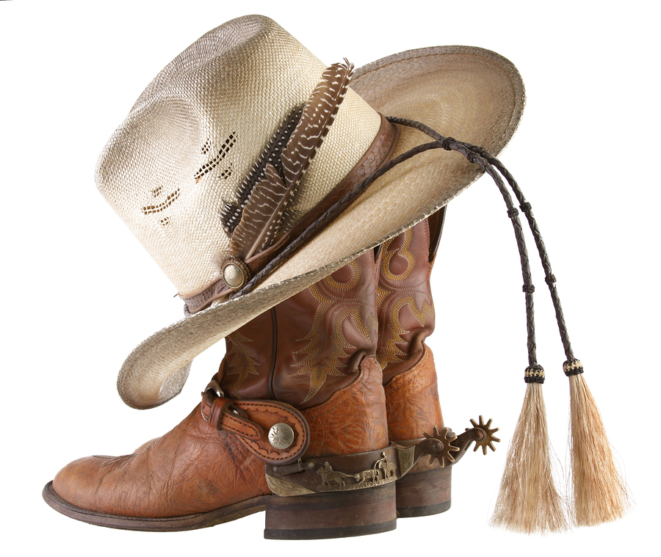

Colorado State Council  
State Convention  
“ESA – Best of the West”  
  
Chairwomen: Joyce Fuller, Cindy Powers, Gertie Chapin

Date: May 19-21, 2017

Place: Highlands Camp & Retreat Center, Allenspark, CO