ESA Colorado State Council
2016-2017 Candidates

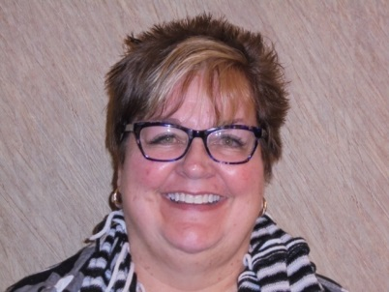
For the Office of President
Kathy Ellingson
Kathy joined ESA in 1999 and is a member of Gamma Chi #3668 Loveland.
She has been President of her chapter for 2 years and has held the offices of Vise President, Parliamentarian, Corresponding Secretary, Philanthropic Chair, Ways and Means Chair, Jonquil Girl and is currently Treasurer.
Kathy is a member of Northern Colorado Council and held offices of Vice President and Philanthropic Chair.
Kathy has served on the state level as President Elect, Vice President, Recording Secretary, Treasurer, Parliamentarian, Corresponding Secretary, ESA Foundation Counselor and Convention Co-Chair.
Kathy has also been an International Council Foundation Scholarship Coordinator for 6 years.
Kathy has received her 4th degree Pallas Athene.
Kathy has been Women of the Year 2 times for her chapter and one time for her council. She has attended 10 state conventions.
Kathy has been a Practice Manager in the healthcare field for many years. Her strength is in helping people reach their maximum potential through coaching and developing skill sets.
Kathy’s dues are paid and she is in good standing with her chapter, state and IC. She is also a member of Foundation.

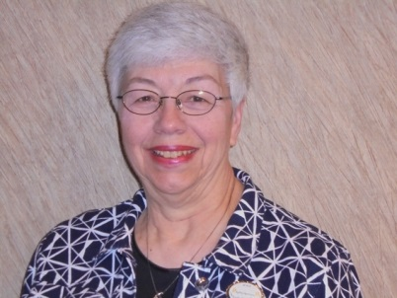
For the Office of President Elect
Kathy Garrison
Kathy joined ESA in 1992 and is a member of Epsilon Epsilon #1896 Denver.
Kathy has been her chapters President 5 times, Vice President 4 years, Parliamentarian 5 times, Recording Secretary 2 times, Treasurer 4 times, Scrapbook Chair 3 times, Publicity 5 times, Educational Director 10 times, Philanthropic Chair 4 times, Ways and Means, and Christmas Tea Chairman 6 times, Founders Day, Jonquil Girl, Chairman 2 times..
Kathy has served on Epsilon Council as President 2 times, Vice President 2 times, past President 2 times, Parliamentarian 2 times, Philanthropic Chair, Historian 2 times Yearbook 3 times, and Founders Day Chair 2 times, Recording Secretary, Corresponding Secretary.
Kathy has served on the state council as Vice President, ESA Foundation Counselor, Education/Workshop Director, receiving first place for Educationals, Distinguished Athenian award, placed in the top ten at IC in 2014, second place May E. Wells Award for Outstanding State Educational Director 2014, Chaplain, Recording Secretary, Parliamentarian, Minutes Review Committee, Convention co-Chair, Games Manager 4 years, first Dream Home office and record keeping.
Kathy has her 4th Degree Pallas Athene and her First Pearl and is a Life Active Member.
Kathy has been Woman of the Year for her chapter 3 times, council twice and third runner up for state 2014.
Kathy has attended 16 state conventions and 1 international convention.
Kathy has worked in trust and estate for eleven years, established client relationships retained over many years, worked with attorney regarding estate issues. She believes in building lasting relationships with our sisters to ensure that ESA continues to offer our sisters a place to grow and develop their talents. Kathy experienced many of the offices in state and has acquired knowledge of how the state council performs.
Kathy’s dues are paid and she is in good standing with her chapter, state and IC.

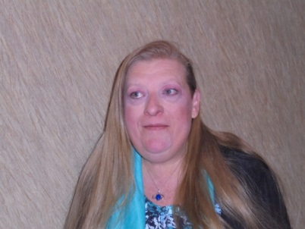
For the Office of Vice President
Leslie Stevens
Leslie joined ESA in 1984 and is a member of Kappa Iota #5442 Golden
Leslie has held all chapter offices, and committees. She is currently Publicity Chair, Chaplain and Educational Chair for Kappa Iota.
Leslie is a member of Denver Alpha Council.
On the state level Leslie has been Recording Secretary, Corresponding Secretary, Gold Lamp Editor 3 years, Membership Jr and Sr, Membership - Western Slope, Publicity, Philanthropic, Educational Director, Jr. and Sr. St Jude Coordinator, and 1994 Convention Co-Chair.
Leslie has her 4th Degree Pallas Athene and her First Pearl +1
Leslie has been to 25 state conventions and 8 international conventions.
Leslie has received the Distinguished Athenian award, 3rd place for IC Newsletter – first year as Golden Lamp Editor, received the May E. Wells Award for Education Director, 1st Place and has chartered one chapter with 5 members.
Leslie’s dues are paid and she is in good standing with her chapter, state and IC.
Leslie is a Life Active member and she is a member of the Foundation.

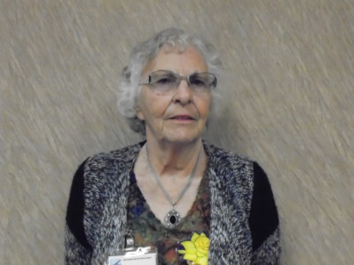
For the Office of Treasurer
Loydette Knight
Loydette joined ESA in 1968 and is a member of Zeta Rho #1774 Aurora.
Loydette has held all chapter offices multiple times.
She is a member of Denver Alpha Council and as held the offices of Parliamentarian, Treasurer, Vice President and was the President of Northwest Area Council.
Loydette has served on the state council as Membership Director, Jr. and Sr. St Jude Coordinator, Recording Secretary and Treasurer.
Loydette has received her 5th Degree Pallas Athene and her First Pearl and is a Life Active Member.
Loydette has been Women of the year for her chapter and was 1st runner up for state women of the year.
Loydette has attended 28 state conventions and 1 international convention.
Loydette has a keen attention to detail with her career as a bookkeeper in charge of Accounts Payable, Receivable, Payroll as well as being an Office Manager.

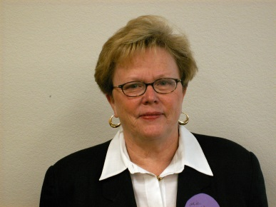
For the Office of Corresponding Secretary
Phyllis Minch
Phyllis joined ESA in 1970 and is a member of Gamma Chi #3668 Loveland.
Phyllis has been President of her chapter for 2 years and served as Vice President, Corresponding Secretary, Educational, Philanthropic Chair, Ways and Means Chair, Publicity, Chaplain, Jonquil and Currently Recording Secretary.
Phyllis is a member of Northern Colorado Council and is currently serving the 1st year of a 2 year term. She has held the offices of Vice President, Philanthropic Chairman and Ways and Means Chairman.
On the state level Phyllis has been Jr. and Sr. St Jude Coordinator, Philanthropic Chair, and Jr. and Sr. Easter Seals.
Phyllis has received her 4th degree Pallas Athene and received her First Pearl.
Phyllis has been Woman of the year for her chapter 3 times and her council 2 times.
Phyllis has been to 15 state conventions and 1 international convention.
Phyllis served her country in the Navy many years ago and her community is still benefiting from that service today. She is well known by many veterans in the region as is a constant advocate for them. She has served as an Honor Guard 6 times for the Honor Flight in Northern Colorado.
Phyllis’s dues are paid and she is in good standing with her chapter, state and IC. She is also a member of Foundation.

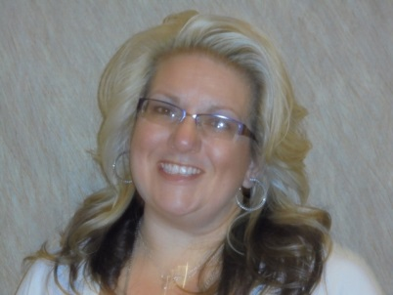
For the Office of Recording Secretary
Kelli DeCoronado
Kelli joined ESA in 2013 and is a member of Kappa Zeta #5571 Colorado Springs.
Kelli has been President of her chapter for two years. She has also co-chartered a new chapter in Colorado Springs.
She has served on the state board as Publicity Chair and ESA Foundation Counselor.
Kelli has her 1st degree Pallas Athene and her First Pearl.
Kelli charted a new chapter in her first year and became a Live Active Member.
She holds various positions in her community as a volunteer and on their philanthropic leadership teams that include the American Cancer Society’s Relay for Life and their Look Good Fell Better program, and The Mountain Shadow Riders Breast Cancer Awareness Ride.
She regularly volunteers at her church and works closely with the youth.
She has experience in speaking publicly and knows various types of media outlets that include computer programs and AV workings.
Kelli is a go getter and a self-starter.
Kelli’s dues are paid and she is in good standing with her chapter, state and IC and is a Life Active Member and is a member of the Foundation.

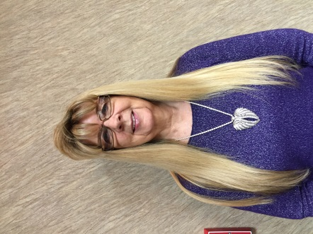
For the Office of Parliamentarian
Chris Dostal
Chris joined ESA in 2006 and is a member of Sigma Rho #5014 Loveland.
Chris is President of her chapter. She has been Vice President, Secretary numerous times, Educational Director numerous times, Publicity, and Ways and Means.
Chris is a member of Northern Colorado Council and is currently the Vice President. She has also been Publicity for NCC.
Chris has received her 4th degree Pallas Athene and her First Pearl.
Chris has been Woman of the Year for her Chapter and her Council.
Chris has attended 7 state conventions.
Chris is recently on the Committee to revise her Chapter’s By-Laws and Standing Rules. Completed the final revision and published to all chapter members. She has helped plan and organize many fundraisers. She also has hosted many fundraisers in her home. Chris is a key member in her chapter with the support and consistency in her participation. She can always be counted on to participate in other chapters’ events and fundraising events. It is hard to find a person in Chris’s community that does not know her or know of her countless hours she has given to many philanthropic causes.
Chris’s dues are paid and she is in good standing with her chapter, state and IC. She is also a member of the Foundation.

