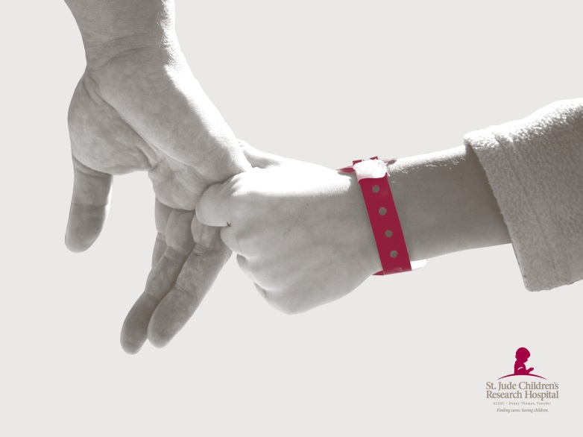
BECAUSE OF COLORADO ESA
- We had 7,469 guests visit our St. Jude Dream Home houses this year and learned about St. Jude.
- In the last year, St. Jude has been able to treat 4 patients with acute lymphoblastic leukemia, the most common form of childhood cancer, at no cost to their families.
- We sold 20,000 St. Jude Dream Home tickets, raising $2,000,000 for the kids of
St. Jude.
- St. Jude has been able to provide 3,875 hours of physical therapy to our patients over the last year.
- St. Jude has been able to provide 7,843 red blood cell transfusions to patients over the last year.
- 1,234 people became Partners in Hope and St. Jude supporters during radiothon events this year.
- St. Jude has been able to provide 347 days of inpatient care to our sickest patients recovering from bone marrow transplants and other procedures.
- ALSAC staff members in the Denver Office have made new friends in ESA members!

